Bridge between research in modern physics
and entrepreneurship in nanotechnology

Quantum Physics
The physics of the very small
with great applications

Part 2
QUANTUM PROPERTIES & TECHNOLOGY
Learning Station XI:
From quantum mechanics to nanoparticles and their applications

Quantum Spin-Off is funded by the European Union under the LLP Comenius programme
(540059-LLP-1-2013-1-BE-COMENIUS-CMP).
Renaat Frans, Laura Tamassia
Contact: renaat.frans@khlim.be
LEARNING STATION XI: FROM QUANTUM MECHANICS TO NANOPARTICLES AND THEIR APPLICATIONS

Introduction 3
1. Elementary particles in nanotechnology 3
2. Size matters 4
3. Can we observe this phenomenon in a real-life experiment? 4
3.a Emission spectrum of single atoms 4
3.b How can we observe the emission spectrum? 5
3.c Step-by-step instructions to make your own spectrometer 5
3.d What can we observe and investigate with our spectrometer? 9
3.e How does fluorescence spectrometry work? 9
4. Quantum dots 9
5. Some examples of nanoparticles 12
5.a Metallic nanoparticles 12
5.b Core-shell or Nanoshell 13
5.c Carbon nanomaterials 13
5.d Energetic nanocomposites 15
5.e Nanofoam 16
5.f Nanomeadow 17
Conclusions 18

Attribution-Non-commercial-Share Alike 4.0 International (CC BY-NC-SA 4.0)
Under the following terms:
- Attribution — You must give appropriate credit, provide a link to the license, and indicate if changes were made. You may do so in any reasonable manner, but not in any way that suggests the licensor endorses you or your use.
- Non-commercial — You may not use the material for commercial purposes.
You can:
- Share — copy and redistribute the material in any medium or format
- Adapt — remix, transform, and build upon the material
The licensor cannot revoke these freedoms as long as you follow the license terms.

You have to refer to this work as follows:
Reivelt, K., Vlassov, S. (2015) Quantum SpinOff Learning Station: From Quantum mechanics to nanoparticles and their applications. Centre for School Physics and Laboratory of Low Temperatures, University of Tartu, Estonia

Introduction
So far we have investigated very simple quantum mechanical systems, such as photons, electrons, and hydrogen atoms. We have also learned about some quantum-mechanical phenomena like light emission and tunneling. However, realistic quantum mechanical systems consist of many atoms or molecules, and we are not able to investigate those systems by exact mathematical formulae. In general, even when we have quantum mechanical systems that consist of tens of atoms, such an analysis is too complicated even with the most advanced computer systems we have or can ever build.
In this Station we look for a smooth transition from quantum mechanics to the study of complex quantum mechanical systems, or nanosystems. We will do this by introducing nanotechnology, which is currently an area of intense scientific research due to a wide variety of potential applications. This is because of the physical properties of nanosystems: the physical properties of materials, which should normally be constant, change as the size approaches the nanoscale and as the percentage of atoms at the surface of a material becomes significant. These properties can be used for several applications, as we will see in sections 4 and 5.

1. Elementary particles in nanotechnology
In nanotechnology, a particle is defined as a small object that behaves as a whole unit in terms of its transport and properties. More specifically, a nanoparticle (or nanopowder or nanocluster or nanocrystal) has at least one dimension less than 100 nm.
Particles are classified according to their size:
- Fine particles cover a range between 100 and 2500 nm.
- Nanoparticles are sized between 1 and 100 nm; they are synthesized on purpose and the size limitation can be restricted to two dimensions.
- Ultrafine particles (UFP) are also sized between 1 and 100 nm, but the term “UFPs” has traditionally been used to describe nanometer-size particles that have not been intentionally produced but are the incidental products of processes involving industrial, combustion, welding, automobile, diesel, soil, and volcanic activities.
Naturally occurring ultrafine particles
  - Virus – 10nm to 60nm
  - Bacteria – 30nm to 10 micrometre
  - Dust from deserts – around 100 nm
  - Volcanic ash
Ultrafine particles in technology
  - Combustion soot – 10nm to 80nm
  - Paint pigments – 80nm to 100nm
  - Welding fumes – 10nm to 50nm
  - Diesel exhaust particles – 7nm to 40nm
  - Carbon black for photocopier toner – 10nm to 400nm

- Nanoclusters are comprised of an exact number of atoms, from several to dozens. In nanoscience, nanoclusters in a size range from subnanometer to several nm are of particular interest. The properties of nanoclusters are well defined. The unique electronic and surface properties of metal clusters make them very promising in developing a new generation of catalysts that have extraordinary activity and selectivity for a wide range of industrially important chemical processes.
- Nanopowders are agglomerates of ultrafine particles, nanoparticles, or nanoclusters.
- Nanometer sized single crystals are often referred to as nanocrystals.

2. Size matters
The size of an atom is about one angstrom (corresponding to 0.1 nm).
Exercise:
1. How many atoms are there in a nanometer?
2. How many atoms are there in hundred nanometers?
From this small exercise it should be clear that a nanoparticle is not a particle in the sense we have learned in quantum mechanics, but it is in fact a cluster of atoms. On the other end, it is not like a solid we learned about in learning station number VII (Semiconductors) either, as the number of atoms in a particle is not as huge.
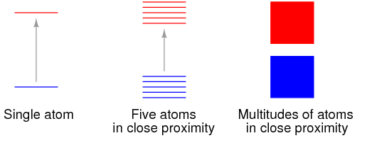
We already know how the number of atoms in a system changes the structure of a single atom: if many atoms are together we will get a densely packed set of possible energy states that form an energy band. We will see this kind of effect also in nanoparticles. Moreover, if we recall the picture from learning station VII, we understand that the properties of the nanoparticles should depend on their size – as the number of atoms increases, the energy levels will be packed more closely, the width of the energy band gap changes, etc.
Figure 1. If we take a very large number of atoms the shifted energy levels will really form a densely packed set of possible energy states.

3. Can we observe this phenomenon in a real-life experiment?

3.a Emission spectrum of single atoms
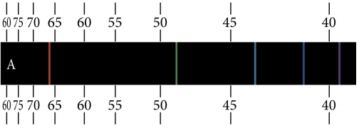
We already know that in the transition of atoms from a state with higher energy to a state with lower energy a photon is produced with energy equal to the energy difference. Therefore, in atoms the energy levels are quantized, i.e. the possible quantized energy levels of the electron in an atom – for instance, the hydrogen atom – can be seen as a ladder of possible states. This means that the light emitted by a single molecule has only certain colours (emission lines) determined by the possible transitions between energy levels. We say that single atoms have a discrete emission spectrum.
Figure 2. Emission spectrum of hydrogen atom

3.b How can we observe the emission spectrum?
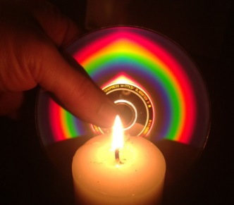
Generally you have to use a device called spectrometer to observe and measure a spectrum of light. In the previous stations we already mentioned that a glass prism can be used to separate emission lines of the hydrogen atom. In Figure 3 we see a simple and spectacular way to observe the emission spectrum of a candle. We can see that the spectrum is not composed of discrete emission lines any more. Why? Maybe it is due to the quality of this simple spectrometer?
If we take another look at Figure 1 it is quite obvious that electrons in closely packed atoms can have transitions between closely packed energy levels, i.e. energy bands; therefore, their emission spectrum does not have to be discrete any more. In fact, most of the light around us has a continuous spectrum.
Figure 3. Emission spectrum of light from a candle

3.c Step-by-step instructions to make your own spectrometer
One can easily build a simple spectrometer to observe emission spectrums of different light sources. Public Lab (http://publiclab.org) has developed a Do-it-Yourself Spectrometer made from simple materials:
- stiff black card paper,
- a clean DVD-R,
- a USB webcam (preferably HD),
- a type LB conduit body (basically a light-proof box with a couple of holes),
- double-sided foam tape and a box cutter,
- the DVD's tightly packed grooves act as a diffraction grating – like a prism.

By following the instructions below you can also build your own spectrometer.
Take a piece of black cardboard, cut along the outer edge:

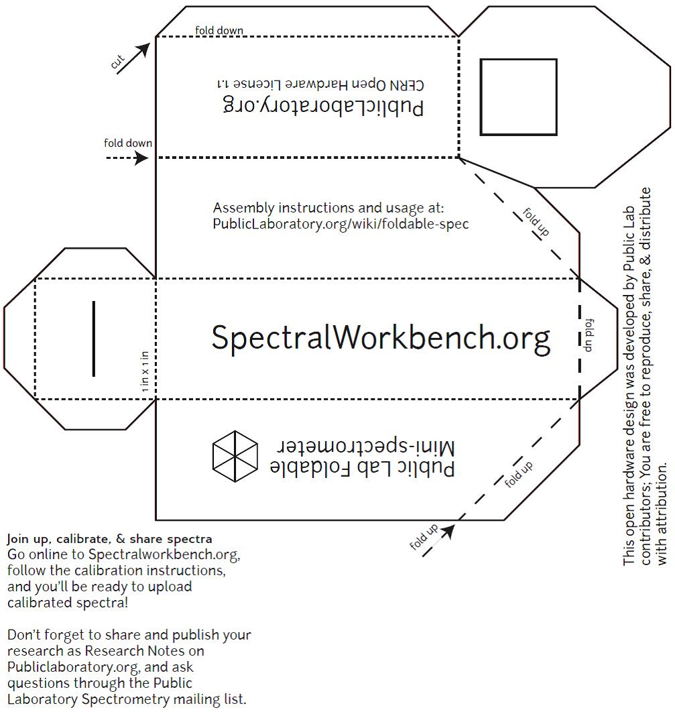

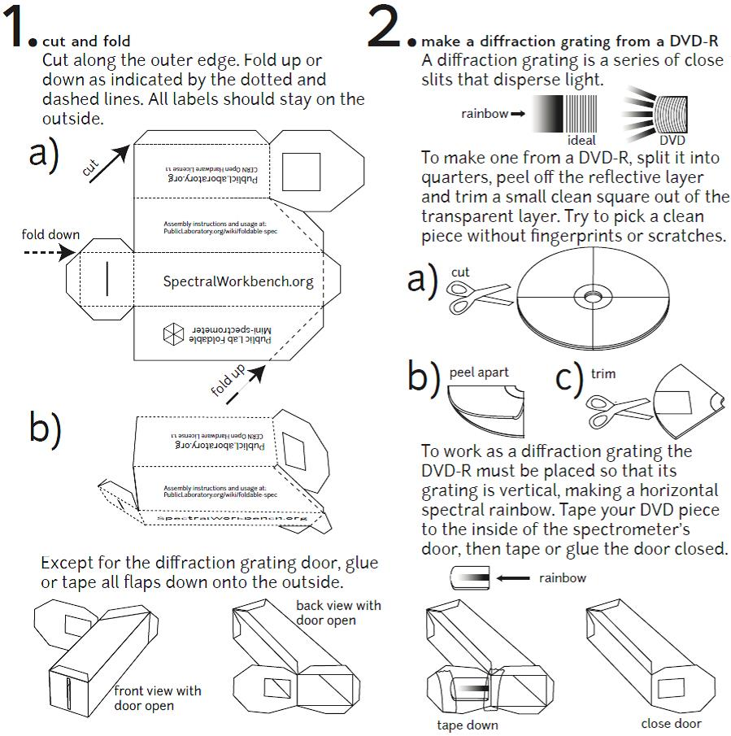
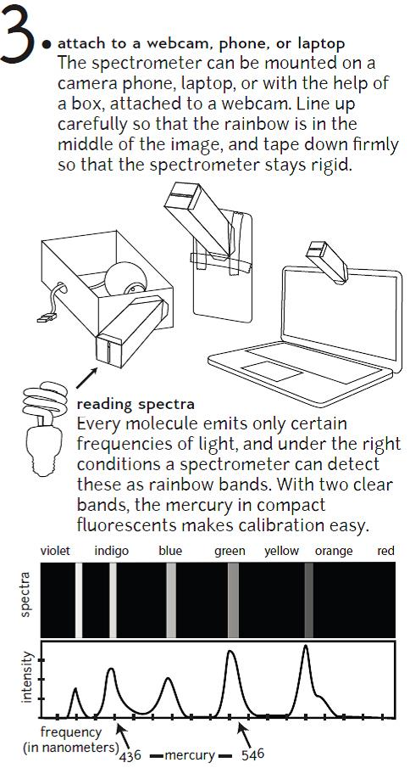
Figure 4. Instructions on how to make your own spectrometer (source: Public Lab – Spectrometer [http://publiclab.org/wiki/spectrometer])

3.d What can we observe and investigate with our spectrometer?
- Ask your physics teacher for a gas discharge lamp. With this kind of lamp you can observe the emission spectrum of single atoms;
- Find as many different types of light sources as you can (Sun, LEDs, light bulbs, laser light) and observe their emission spectrum with your spectrometer.
- What do you think, why are most of the measured spectra continuous, not discrete?

3.e How does fluorescence spectrometry work?
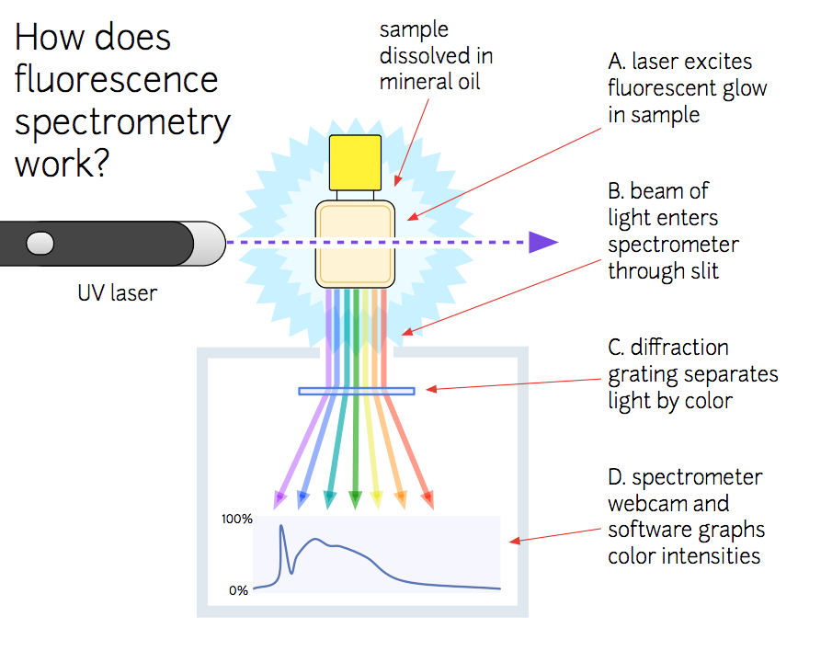
Figure 5. Work principle of spectrometer (source: Public Lab – Spectrometer [http://publiclab.org/wiki/spectrometer])
- Find a green or blue laser. (Avoid direct exposure of the eyes to laser light!)
- Find a “neon” marker and light its ink with the laser.
- What is the colour of the light the marker ink emits?
- Ink in this kind of markers consists of several complex chemical compounds. Can you sketch the system of energy levels of this ink and describe how a blue/green light can produce a yellow or fluorescent light from the ink?

4. Quantum dots
Now we are prepared to meet the first nanoparticles of this learning station – quantum dots. The following text is written for undergraduate students, but you should be able to understand most of it if you use your knowledge received from this and the previous learning stations, in particular learning station VII (Semiconductors). Try it out!
Quantum dots are nanoparticles usually made of semiconductor materials with fluorescent properties (CdSe, …). They are made of a semiconductor nanostructure that confines the motion of conduction band electrons or valence band holes in all three spatial directions. This confinement can be obtained with electrostatic potentials, the presence of an interface between different semiconductor materials, the presence of the semiconductor surface or a combination of these. Any semiconductor has a characteristic band gap, but when the diameter of a piece of the material is shorter than the quantum-mechanical wave function of its electrons (or in other words smaller than the Bohr radius), the "squeezed" electron wave function makes the band gap wider. For an electron to jump from the valence band to the conduction band now more energy is required.
Quantum dots are usually sub 10 nm in size and have electronic properties intermediate between those of bulk semiconductors and those of discrete molecules. Stated simply, quantum dots are semiconductors whose electronic characteristics are closely related to the size and shape of the individual crystal. A quantum dot has a discrete quantized energy spectrum that depends on its size.
An immediate optical feature of quantum dots is their coloration – quantum dots of the same material but with different sizes can emit light of different colours. Generally, the smaller the size of the crystal, the larger the band gap and the greater the difference in energy between the highest valence band and the lowest conduction band. Therefore, more energy is needed to excite the dot, and concurrently, more energy is released when the crystal returns to its resting state. E.g., in fluorescent dye applications, this equates to higher frequencies of light emitted after excitation of the dot as the crystal size is smaller, resulting in a colour shift from red to blue in the light emitted. The larger the dot, the redder (lower energy) its fluorescence spectrum. Smaller dots emit bluer (higher energy) light (Figure 6).
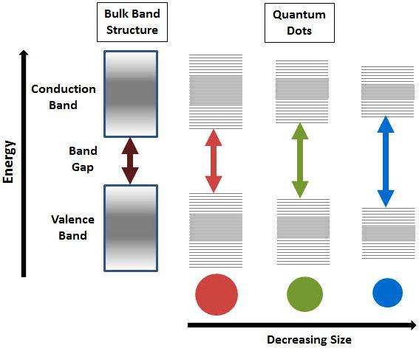
Figure 6. Splitting of energy levels in quantum dots due to the quantum confinement effect, semiconductor band gap increases with decrease in the size of the nanocrystal. See more at http://www.sigmaaldrich.com/materials-science/nanomaterials/quantum-dots.html#sthash.93KSj2fZ.dpuf.
To date, chemistry, physics and materials science have provided methods for the production of quantum dots and allow tighter control of factors affecting particle growth and size, solubility and emission properties (please see Figure 7). Moreover, quantum dots are up to 1000 times brighter and glow longer than conventional fluorescent dyes.

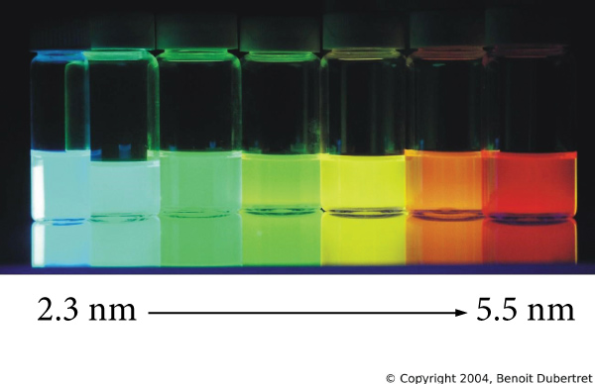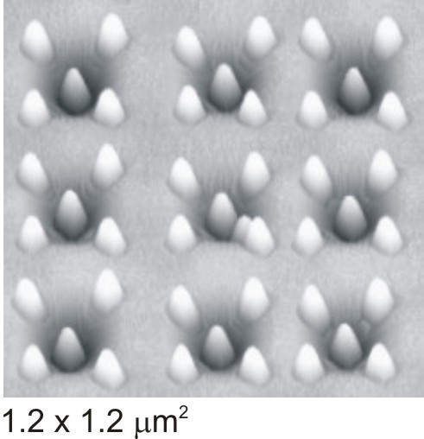
Figure 7. Fluorescence at different wavelengths from a single UV light due to quantum confinement in semiconductor quantum dots of different size (left). Site-controlled groups of Ge islands are grown on pit-patterned Si substrates (Zhong et al., Appl. Phys. Lett. 87, 133111 (2005))

Quantum dots of semiconductors, metals and metal oxides have been at the forefront of research in the recent years due to their novel electronic, optical, magnetic and catalytic properties. The ability to tune the size of quantum dots is advantageous for many applications. For instance, larger quantum dots exhibit less pronounced quantum properties. Conversely, the smaller particles allow one to take advantage of quantum properties. Quantum dot technology is one of the most promising candidates for use in solid-state quantum computation. By applying small voltages to the leads, one can control the flow of electrons through the quantum dot and thereby make precise measurements of the spin and other properties therein.
Possible research assignments:
- Look for more information about the crystal growing process and in particular what makes it possible to have a high level of control over it.
- Look for other possible applications of quantum dots.

5. Some examples of nanoparticles
In the last part of this learning station we try to give you an overview of different kinds of nanosystems and nanoparticles.

5.a Metallic nanoparticles
One of the most interesting aspects of metallic nanoparticles is that their optical properties depend strongly upon the particle size and shape. Bulk Au looks yellowish in reflected light, but thin Au films look blue in transmission. This characteristic blue colour steadily changes to orange, through several tones of purple and red, as the particle size is reduced down to ~3 nm.
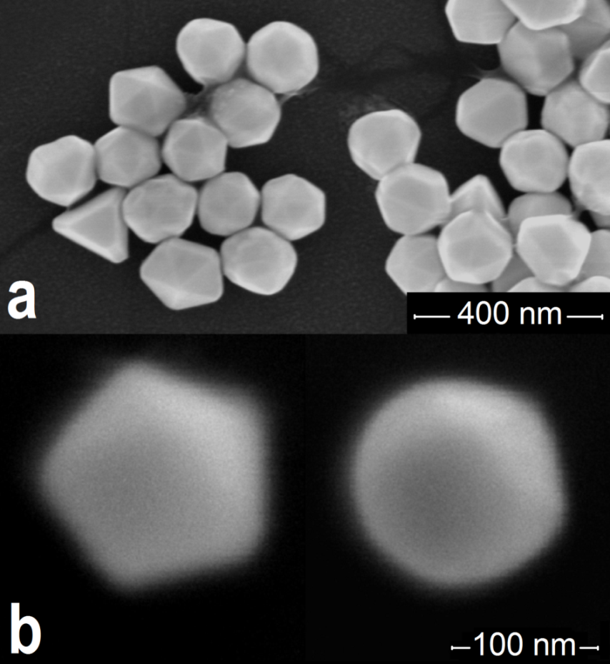
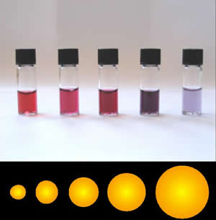
Figure 8. Picture on the left: Au particles of different shape deposited from solution (source: Vlassov et. al., Solid State Communications, 151, 688 – 692 (2011)). Picture on the right: solutions of gold nanoparticles of various sizes (source: http://www.nanoacademia.com)

Research assignment:
- Search for information about other examples of how the size of nanoparticles changes the properties of bulk material.

5.b Core-shell or Nanoshell
Core-shell is composed of a spherical core of a particular compound surrounded by a few nm thick shell of another material. In the US it is also referred to as "nanoshell".
One of the promising applications concerns the biological field. Research is being performed to create nanoshells with high absorptions at biologically useful wavelengths by altering the thickness of the shells. Particularly, the near infrared region of the electromagnetic spectra (from about 800 nm to 2500 nm), which corresponds to low absorption by tissue, may be useful.
In the literature, special attention is given to gold nanoshell with a dielectric core (gold sulphide, silicon dioxide, ...). Gold is a biocompatible compound, making it a useful material for medical applications.
Nanoshells are currently being investigated as:
- a treatment for cancer similar to chemotherapy but without the toxic side-effects;
- inexpensive, quick analysis of "samples as small as a single molecule".
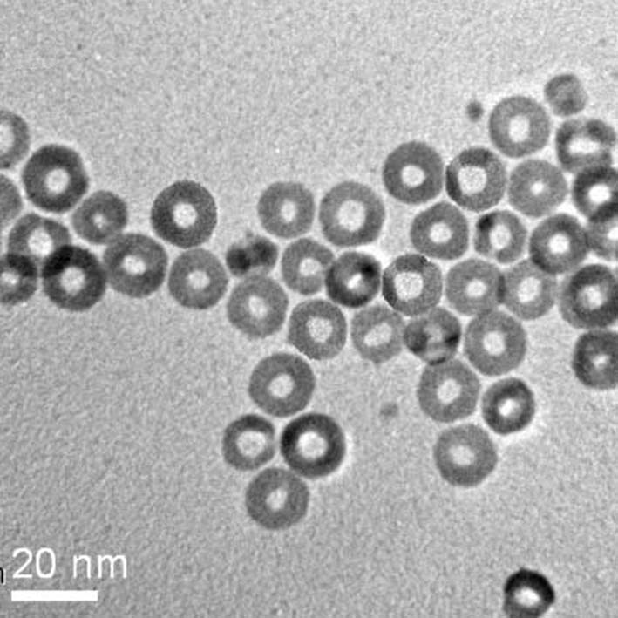
Figure 9. Nanoshells
Research assignment: look for the reasons why nanoshells could be used in treatment for cancer.

5.c Carbon nanomaterials
Carbon nanomaterials include fullerenes, nanotubes and carbon black. Fullerenes are a carbon allotrope with a polygonal structure made up exclusively of 60 carbon atoms. Carbon nanomaterials are characterized by having numerous points of attachment whose surfaces can also be functionalized.
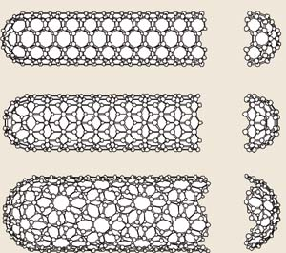
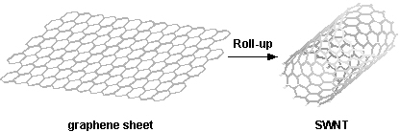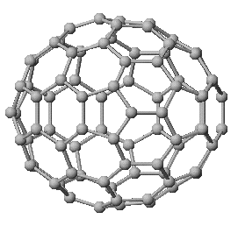

Properties of carbon nanotubes:
- one-dimensional sheets of hexagonal network of carbon rolled to form tubes;
- several nm in diameter;
- can be several millimetres long;
- essentially free of defects;
- ends can be “capped” with half a buck ball;
- varieties include single-wall and multi-wall nanotubes, ropes, bundles, arrays;
- structure (chirality, diameter).
Figure 10. Above graphene sheet and u SiC nanotubes grown at NASA Glenn

Research assignment:
- Can you think of ways to make small pieces of graphene at home?
- Search the Internet for possible applications of graphene and carbon nanotubes.
Carbon black is a form of amorphous carbon that has a high surface area to volume ratio and is one of the first nanomaterials that found common use. It is usually a highly agglomerated powder with particle size of the order of 100 nm. The total production was around 9 000 000 tons in 2006. Carbon black is produced by incomplete combustion of heavy petroleum products (such as fluid catalytic cracking tar, coal tar, ethylene cracking tar) and a small amount from vegetable oil.
Figure 11. Carbon black
The most common use (70%) of carbon black is as a pigment and reinforcing phase in automobile tires. Carbon black also helps conduct heat away from the tread and belt area of the tire, reducing thermal damage and increasing tire life. Practically all rubber products where tensile and abrasion wear properties are crucial contain carbon black, so they are black in colour.
Research assignment: look for an explanation to one of the above reported applications of carbon black.
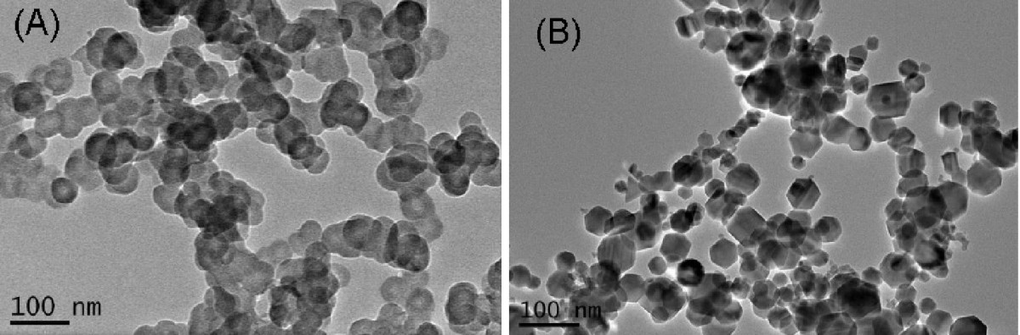
Figure 12. Transmission electron microscope images of (A) the carbon black nanoparticles and (B) the Fe2O3 nanoparticles (for comparison).

Carbon black particles are also employed in some radar absorbent materials and in printer toner. About 20% of the world production goes into belts, hoses, and other non-tire rubber goods. The balance is mainly used as a pigment in inks, coatings and plastics. Carbon black of vegetable origin is used as a food colouring, known as additive E153 in Europe.

5.d Energetic nanocomposites
Energetic nanocomposites are a class of materials that have both a fuel and oxidizer component intimately mixed and where at least one of the component phases meets the nanosize definition.
Pyrotechnics produced from nanoparticles are an example of an energetic nanocomposite, in which metal oxide nanoparticles react with metals and/or other fuels in very exothermic reactions. The fuel resides within the pores of the solid matrix while the oxidizer comprises all, or at least a portion, of the skeletal matrix.
Research assignment: search the Internet for uses of nanocomposites in pyrotechnic applications. What are the possible advantages of this technology over conventional ones?
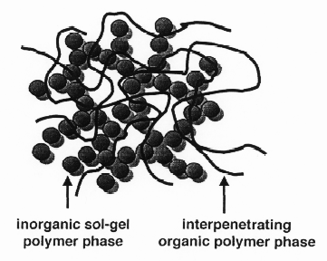
Figure 13. Schematic representation of the microstructure of a sol-gel derived F_{2O3}/Viton hybrid material

5.e Nanofoam
Nanofoams are a class of nanostructured, porous materials, foams, containing a significant population of pores with diameters less than 100 nm. Aerogels are one example of nanofoams.
In 2006, Dr. Bryce Tappan at Los Alamos National Laboratory discovered a technique for producing metal nanofoams by igniting pellets of energetic metal complexes. Nanofoams of iron, cobalt, nickel, copper, silver, and palladium have been prepared through this technique. These materials exhibit densities as low as 11 mg/cm³ and surface areas as high as 258 m²/g. These foams are effective catalysts and are being investigated for other applications.
Research assignment:
- Search the Internet for applications of nanofoams.
- Suppose we have magnified a typical complex in a nanofoam to have a diameter of 1mm. What could be the approximate distance between two neighbouring complexes?
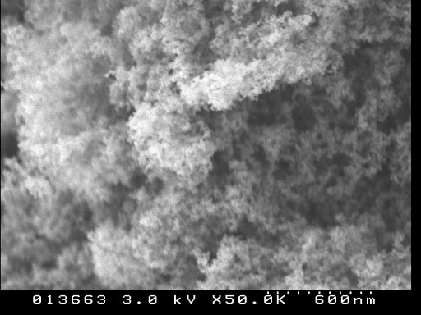
Figure 14. Scanning electron microscope image of carbon nanofoam. The lightest known solid (density = 2 mg/cm3), this novel allotrope of carbon has complex magnetic properties which reflect its unusual structure. The foam is a dendritic aggregate of ca. 6 nm spheres, each of which contains convoluted, hyperbolically curved carbon sheets in which some carbon atoms have unpaired electron spins.

5.f Nanomeadow
A supercapacitor (SC), sometimes ultracapacitor, is a high-capacity electrochemical capacitor with capacitance values up to 10,000 farads at 1.2 volt that bridge the gap between electrolytic capacitors and rechargeable batteries. They typically store 10 to 100 times more energy per unit volume or mass than electrolytic capacitors, can accept and deliver charge much faster than batteries, and tolerate many more charge and discharge cycles than rechargeable batteries. They are, however, 10 times larger than conventional batteries for a given charge.
In supercapacitors, energy is stored because the electrodes are coated with a porous material that soaks up ions like a sponge, usually activated carbon. Nanomeadow supercapacitors store ions in manganese oxide (MnO), a material with a much greater capacity for ions than activated carbon. As a result, the nanomeadow performs 10 times better than MnO alone and can store twice as much charge as the carbon-based electrodes in existing ultracapacitors.
Research assignment: how could supercapacitors be combined with solar cells or windmills to get a solid power supply?
The Research Institute of Chemical Defence in Beijing, China, and colleagues at Beijing University created a nanomeadow of microscopic structures, fuzzy flowers of MnO each about 100 nanometres across on a field of messy carbon nanotube grass grown on a tantalum metal foil (see figure below).
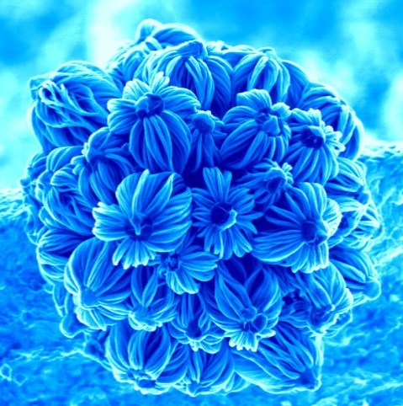

Figure 15. The winning image in the photo competition 2004 at the Department of Engineering was taken by Ghim Wei Ho at the Nanoscience Centre. The 3-dimensional nanostructure in her photograph is made up of silicon-based material. It was grown using a chemical vapour deposition process. The material is both amorphous and crystalline in nature. The image was taken with a scanning electron microscope.

Conclusions
In this Station we studied a class of quantum mechanical systems called nanoparticles. Nanoparticles consist of many atoms or molecules and we are generally not able to investigate those systems by exact mathematical formulae. However, nanoparticles can be produced and investigated experimentally. The properties of nanoparticles allow many promising applications, some of which are already realized.

Concepts in Learning Station XI
Complete by adding the missing concepts

Classical concepts
……………………………

Quantum concepts
See also learning station VII
Physical properties of materials change as the size approaches the ……………………………..
Because nanoparticle are made of many atoms, but not so many as in solids, their properties depend on the …………………………………...
Quantum dots have electronic properties between bulk semiconductors and discrete molecules. They have a ……………………………………………. energy spectrum. This happens because the electron waves are confined: when the diameter of the piece of material they are made of is ……………………… than the Bohr radius, the "squeezed" electron wave function makes the band gap wider.
As the size of the quantum dots ………………………….. the frequency of the emitted light becomes higher.

