Business Model

Quantum Spin-Off is funded by the European Union under the LLP Comenius programme
(540059-LLP-1-2013-1-BE-COMENIUS-CMP).
Renaat Frans, Hans Bekaert, Laura Tamassia
Contact: renaat.frans@khlim.be
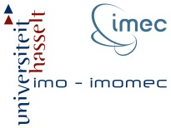
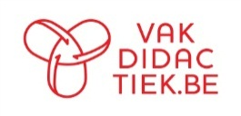

Table of Contents
1 Introduction 3
2 The Business Model 4
The Business Model Canvas 4
The Canvas for the Business Model 4
Toelichting bij het Business Canvas Model 5
3 More information on Business Canvas Model 6

Attribution-NonCommercial-ShareAlike 4.0 International (CC BY-NC-SA 4.0)
Under the following terms:
- Attribution — You must give appropriate credit, provide a link to the license, and indicate if changes were made. You may do so in any reasonable manner, but not in any way that suggests the licensor endorses you or your use.
- NonCommercial — You may not use the material for commercial purposes.
You can:
- Share — copy and redistribute the material in any medium or format
- Adapt — remix, transform, and build upon the material
The licensor cannot revoke these freedoms as long as you follow the license terms.
You have to refer to this work as follows:
Frans R. (2014) Quantum Spin-Off: Business Model, KHLim Katholieke Hogeschool Limburg, Diepenbeek, Belgium

Introduction
Quantum Spin-Off is an inspiring project. You will learn about today’s quantum physics and then use what you’ve learned to understand an application (a high-tech patent) in order to
- design a new high-tech product or service.
- draw up a plan for a spin-off enterprise that will supply the product or service
But a product or service, no matter how clever or high-tech, can only continue to exist if
- the product or service can be supplied
- the product or service creates an added value for the client
- clients can be reached
- the revenues exeed the costs.
Every team participating in quantum spin-off will have to propose a business model, like real high-tech entrepreneurs searching for venture capital. Filling out a Business Model Canvascan be a useful tool.

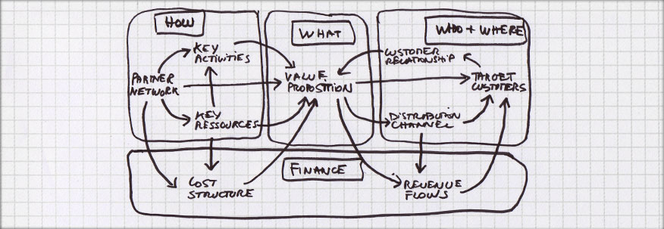
Figure 1 The Business Model Canvas (Source figure: consulteam.be)

The Business Model

The Business Model Canvas

The Canvas for the Business Model
In the diagram below you can outline the structure (how will it work?) of your business. It’s best to start with a brainstorm session, fill out post-its and such. Gradually you’ll come to a more definitive form. It might be useful to print out the Canvas on A3 sized paper. You can download the Canvas at: http://www.vakdidactiek.be/spinoff .
Produce what?
Produce for who?
Use what?
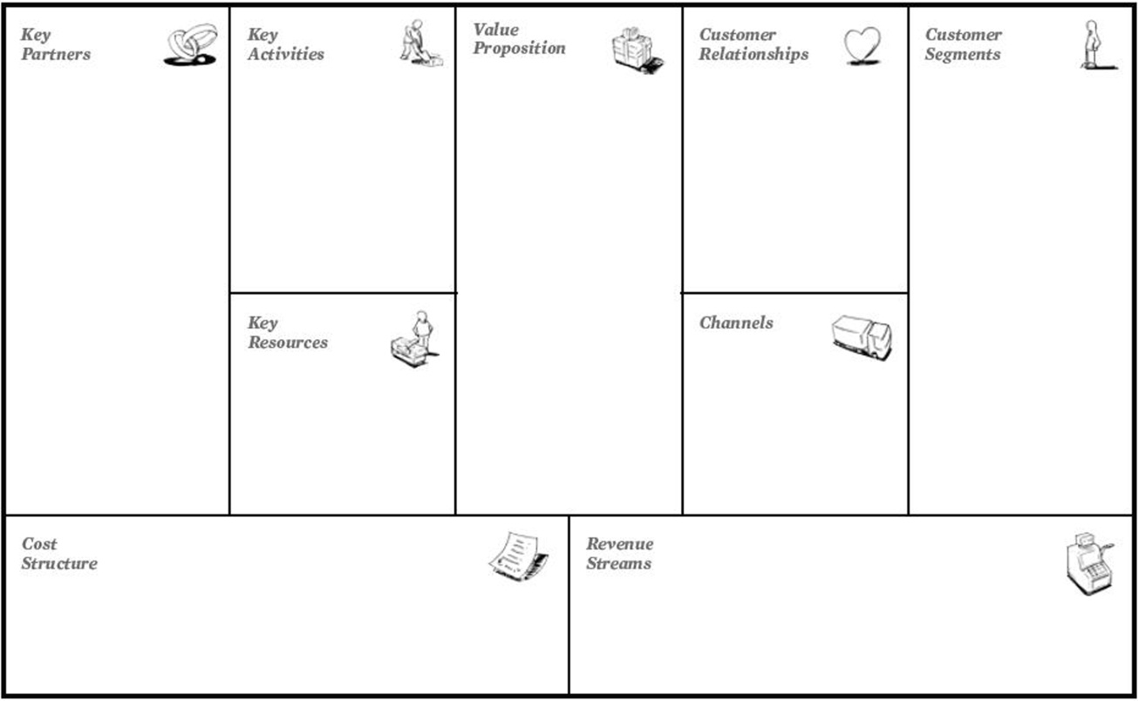
Revenue?
Cost?

Once your canvas is filled you can eliminate elements and ask yourself: ”What if…?”For example, what if the client no longer exists or what if the resources become unavailable. On the other hand you might also be able to add elements that previously weren’t part of your business model, for example an extra sales channel or a partner you hadn’t thought of before. Then you’re talking about business model innovation. With a little practice, you’ll get the hang of it in no time.

The following internet clips are an introduction to the Business Model Canvas:
- Business Model Innovation
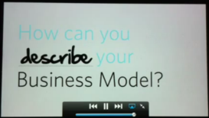
This clip shows a nice introduction to the Business Model Canvas: http://www.youtube.com/watch?v=VfqEhQRMG1s or http://www.youtube.com/watch?v=-sAByDfJ_e0

- Interview with Alex Osterwalder on the topic ‘To plan or not to plan’
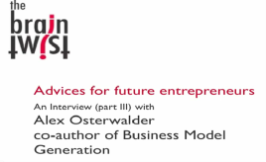
Alexander Osterwalder talks about the sense and nonsense of a good model and plan.
See http://www.youtube.com/watch?v=WHk0VTCIbCM&feature=related

Explanation of the Business Canvas Model
What will you produce?
What is the added value of your product?
What value does your product offer the client? Does your client really want the product? Which want or need are you resolving?
Who will you produce for?
Which clients or customers (segments) are you addressing (Customer Segments)?
Who are your clients? Map them out. Are there different types of customers? What are the needs of these customers?
How can you reach your clients (Channels)?
How will your clients get your product? Can they buy it in a store or online? How will the get information on your product?
How will you maintain a good customer relation (Customer Relations)?
Where can customers go if they have a problem? How will you contact customers? Ask yourself why you are doing it a particular way and is it the right way for your customers?
What will you use to make your product?
What are the key activities to make your product (key activities)?
What activities will you do exactly to make your product?
What will you need to make your product (key resources)?
What resources must be available to you so you can make you product?
What key partners will you need for production (key partners)?
Who will play an important role as partner in your business process? In other words, who will be by your side in the making of your product/service? What do they do exactly in the overall process? What resources do you get from your partners?
Revenue/Expenses?
What are the costs of production (Cost Structure)?
Using your resources will cost money: renting premises, computer equipment, etc. It’s the money you spend to harness your resources and develop your core activities.
What income will you generate (Revenue Streams)?
Is your revenue proportional to what the client will/expects to pay? Will your income cover the costs?

More information on Business Canvas Model
For more information on the Business Canvas Model:
- The Business Model Canvas explained with the newsmaker.com.au
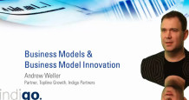
The model is explained and applied to the newsmaker.
http://www.youtube.com/watch?v=isvIOO3TEfo&feature=related

- The handbook which further illustrates the Business Canvas Model can be found at: http://www.consulteam.be/media/5985/businessmodelgenerationpreview.pdf

See http://www.businessmodelgeneration.com/canvas.
Source: http://www.basmennink.nl and http://www.businessmodelgeneration.com/canvas

