Bridge between research in modern physics
and entrepreneurship in nanotechnology

Quantum Physics
The physics of the very small
with great applications

Part 2
QUANTUM PROPERTIES & TECHNOLOGY
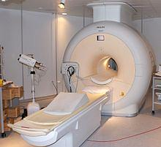

Learning Station IX:
Spin and its applications

Quantum Spin-Off is funded by the European Union under the LLP Comenius programme
(540059-LLP-1-2013-1-BE-COMENIUS-CMP).
Renaat Frans, Laura Tamassia
Contact: renaat.frans@khlim.be
Table of Contents
Part 2: Quantum Properties & Technology
Learning station IX : Spin and its applications 3
1 Undefined properties of matter 3
2 How does spin behave in a magnetic field 4
3 Quantum weirdness: consecutive Stern-Gerlach experiments 5
4 Application: Magnetic Resonance Imaging (MRI) 7
5 Application: Spintronics 9

Attribution-NonCommercial-ShareAlike 4.0 International (CC BY-NC-SA 4.0)
Under the following terms:
- Attribution — You must give appropriate credit, provide a link to the license, and indicate if changes were made. You may do so in any reasonable manner, but not in any way that suggests the licensor endorses you or your use.
- NonCommercial — You may not use the material for commercial purposes.
You can:
- Share — copy and redistribute the material in any medium or format
- Adapt — remix, transform, and build upon the material
The licensor cannot revoke these freedoms as long as you follow the license terms.
You have to refer to this work as follows:
Frans R., Boksenbojm E., Tamassia L. (2014) Quantum SpinOff Learning Station: Spin and its Applications. Centre for Subject Matter Teaching, KHLim Katholieke Hogeschool Limburg, Diepenbeek, Belgium

Learning station IX :
Spin and its applications

Undefined properties of matter
When you start learning physics you hear about properties of matter that seem familiar to you from daily life: mass, temperature, energy… But are these quantities really as familiar and as clear as you think? Would you be able to explain what temperature or energy really is? It turns out it takes some mental (and experimental) work to learn how reality works. And in science we try to be as accurate and precise about the statements which are being made. Which is why we try to define the words we use as often as possible. Nevertheless, not everything can be defined. We have to start somewhere, with words and ideas that just are what they are. And hope that we all agree on what they mean. It is possible to precisely define concepts like temperature, energy and force.
Mass on the other hand is a property that objects (think for instance of a ball or a car) simply seem to have. We do not really know what mass is (however, the recent discovery of the Higgs boson helps us a little further on our way to understand mass). Simply stated, mass is that property of matter which is measured in kilograms.
But we do know how this property of matter manifests itself. Can you think of formulae in physics in which mass plays an important role?
………………………………………………………………….………………………………………………………………

Figure 1: A manifestation of mass?
(source: ww.dlsweb.rmit.edu.au)

We often tend to relate the mass of an object to the amount of “stuff” present. But is this actually true?
If you take 2 identical buckets and fill one of them with water and the other with oil you will notice when weighing them that oil is lighter. Its mass is smaller. Does this mean there is less oil than water? yes / no
Because of this scientists think of mass in a different way.
They see that mass appears in several well-known laws of physics:
- Newton’s second law
- Gravitational force
And through these laws they give meaning to the word mass.It turns out mass plays 3 main roles in physics:
- The more mass there is, the harder it is to accelerate the object
- The more mass there is, the more it is attracted by the force of gravity
- The more mass there is, the more it creates a gravitational field around it
This is not a text about mass. But the main point is that there are some properties of materials that just seem to exist and, properties that causes interaction with surroundings.
Another such property is electrical charge which tells us something about how the object will interact with electrical and magnetic fields.
The property that we want to study in this text is called spin. It is one more property of matter which cannot be defined which is why we will not be able to tell you what it is!
You may complain about that. But just remember that you were happy enough to talk about the mass of an object without anyone ever telling you what it actually is.
But what can be learned about spin is how it affects the behavior of the objects. This is what we are going to discuss in the next sections.

How does spin behave in a magnetic field
It turns out that objects with spin behave like small magnets. Which means among other things that they will be affected by the presence of other magnets.
What happens when you take 2 magnets and bring them close to each other?
……………………………………………………………………
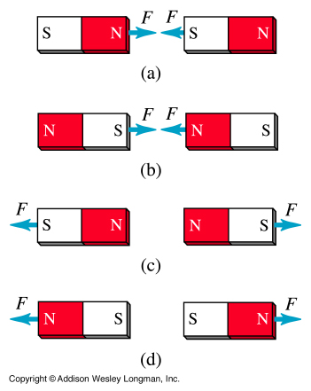
Does the result depend on which side of each magnet faces the other?
……………………………………………………………………
Every magnet has 2 sides, known as its north and its south pole. The interaction between 2 magnets is shown here on the figure. The strength of the attraction or the repulsion between them depends on the strength of the magnets themselves.
(Source figure: www.physics.sjsu.edu/becker/physics51/mag_field.htm)
In 1922 Otto Stern and Walther Gerlach did an experiment, known today as the Stern-Gerlach experiment, to find out how a magnetic field affects the motion of objects with spin.
It was known at the time that a moving electric charge in a magnetic field would be deflected. But even if the particle had no electric charge it would still be deflected in magnetic field if it had spin.
They took a furnace from which silver atoms are ejected. These atoms have spin so that they behave like magnets. The beam of silver atoms was passed through a magnetic field created by another magnet. Each silver atom was either attracted towards the north pole of the second magnet (deflecting it upwards in the figure), or repulsed by it (deflecting it downwards). Whether it is attracted or repulsed depends on the orientation of the spin in the silver atom. This means we can separate objects with different spin by letting them go through a magnetic field. Which is exactly what Stern and Gerlach did.
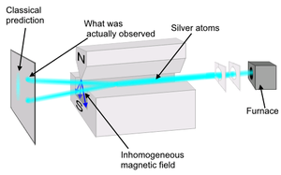
What do you think will determine the amount by which the silver atoms are deflected? ………………………………………………………………………………………………..
The amount by which it is deflected depends on the value of the spin (the strength of the tiny magnet). At first, it was thought that the spin could take any value, and so every possible angle of deflection should be possible. This would be seen as a vertical line (the blue line on the screen on the left of the figure).
Surprisingly, this is not what actually happened. On the screen there appeared only 2 dots. One up, one down.
What do we learn about spin from this?
………………………………………………………………………………………………………………………
It seems there are just 2 possible angles of deflection.
There was only 1 possible strength of the tiny magnet.
The quantization of the spin was thus discovered. We say the spin is either up or down. Half the atoms have spin up and half have spin down.
Spin is a quantum-mechanical property, which does not have a counterpart in classical physics.
But this is not the end of the weirdness.

Quantum weirdness:
consecutive Stern-Gerlach experiments
In reality, objects have more than 1 spin. They have 3 different spins: one in each dimension. The atom behaves as if it had 3 perpendicular magnets in it.
In the figure about the Stern-Gerlach experiment above the magnetic field is pointing vertically and thus separates spin up and spin down in the vertical direction. The experiment could be redone but with a magnetic field pointing from left to right instead.
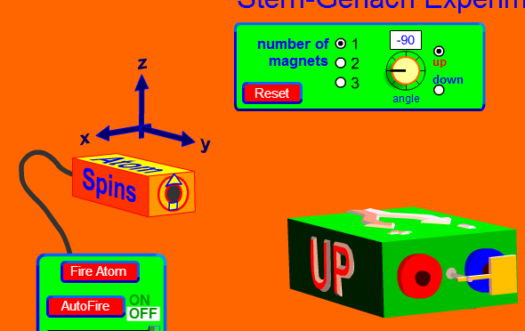
In the phet-applet (see figure hereby) you can rotate the magnetic field through which the beam passes to see what happens.
(Source Phet Colorado
http://phet.colorado.edu/sims/stern-gerlach/stern-gerlach_en.html)

On the left of the figure we have the furnace from which atoms are ejected. On the right of the figure we have the magnet in the green box. The spin up atoms come out of the left hole and the spin down atoms out of the right hole. We are thus separating spin ups and spin downs in the horizontal direction (they are still called up and down although it is known a separation of right and left).
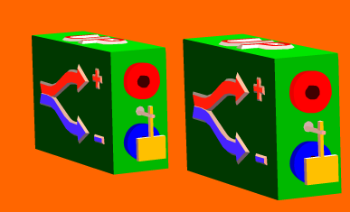
We now take 2 magnets one after the other. Out of the first magnets 2 beams will come out. One with spin up and one with spin down atoms.
If we now put a wall in front of the spin down beam, so that only the spin up atoms would enter the second magnet, what do you expect to see coming out of the second one?
…………………………………………………………………………………………
What is actually seen can be depicted by:
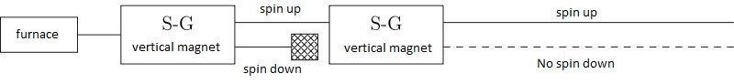
Because all the atoms going into the second magnetic field all have spin up it is not surprising that all of them are deflected upwards in the second magnet: there are no spin down atoms present in the beam coming out of the second magnetic field.
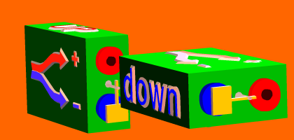
Let us now rotate the second magnet by 90 degrees (so that it becomes horizontal). What do you think will happen?
……………………………………………………

The result turns out to be:
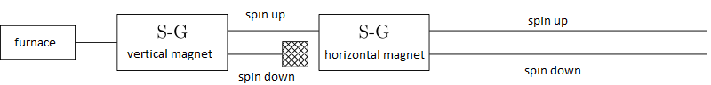
Although the atoms entering this second magnet all have spin up in the vertical direction, their spin in the horizontal direction is still random, which means 50% is spin up and 50% spin down. There are indeed two beams coming out of this second magnetic field.
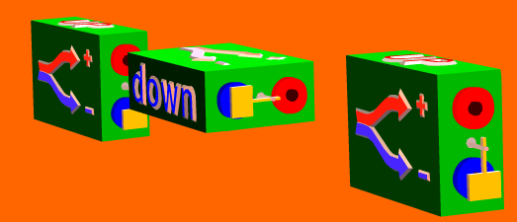
All of this may not seem too surprising to you, but look at what happens when we add one last magnet, so that it too points in the vertical direction.
Let us block this time also the spin down coming out of the second magnet. What result would you expect to see?
……………………………………………………………
Because the spin down in the vertical direction was blocked after the first magnet, you may expect to only see spin up atoms coming out of this third magnet.
But that is not what actually happens. What is observed are 2 beams coming out of this third magnetic field, still half of the atoms going up and the other half going down.
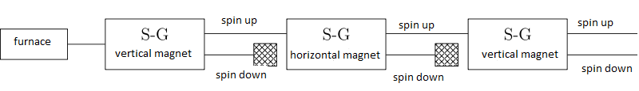

It seems that measuring the spin in the horizontal direction affects the presence of spin up and spin downs in the vertical direction.
This weird effect is a quantum mechanical phenomenon which cannot be understood with classical physics.
This quantum mechanical property of spin is not only very interesting, but it turns out to be of vital importance for several applications among which are medical imaging, and some aspects of electronics. Among many other applications of spin we should not forget to mention that electronic structure of chemical elements (the periodic table) uses the fact that electrons can have 2 different spins. Hopefully you ‘ve heard about that in your lessons of chemistry.

Application: Magnetic Resonance Imaging (MRI)
As mentioned above, spins behave like small magnets. What do you see when you walk around with a compass?
………………………………………………………………………………………………………………………………
Explain why this happens:
……………………………………………………………………………………………………………………………..
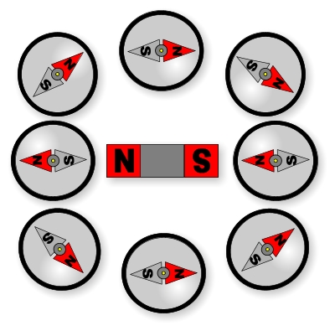
One of the properties of magnets is that they align with the magnetic field that surrounds them.
This is why the needle of a compass always point to the north. It follows the direction of the magnetic field created by the earth.

Now, in the human body there is quite a lot of water. Each water molecule H₂0 consists of 2 hydrogen atoms. Within each hydrogen H there is a proton with a net spin.
When undergoing an MRI scan (Magnetic Resonance Imaging) the patient is put into a cylindrical shaft. Within the casing of this cylinder there are strong magnets.
The spins in the body tend to align with the magnetic field of the magnets in the machine. Contrary to the needle of a compass, the spins in the hydrogen atom can only point in 2 “directions”: up or down.
The spins in their turn also create a magnetic field which can be measured by the machine! Let us see how it works.
When the patient is inside the MRI scanner in fact a changing magnetic field is added which causes the spins in the body to follow the changing magnetic field. How many of the spins actually follow the changing magnetic field depends on the frequency at which it changes.
At one specific frequency the number of changing spins will be maximal. This phenomenon is called nuclear magnetic resonance (which is why such a scanner is also known as an NMR scanner).
You can try this out yourself with the following applet:
http://phet.colorado.edu/en/simulation/mri
The change in direction of the spins themselves can be measured because the magnetic field created by them also changes as they change direction. When the changing magnetic field of the machine is turned off again the spins will go back to being aligned with the non-changing magnetic field of the scanner. The time it takes for them to go back to this state is different in different kinds of tissue (it is for instance different in healthy tissue than it is in cancerous tissue). By measuring this so-called relaxation time doctors get a picture of the presence of absence of certain kinds of tissue (or tumors).
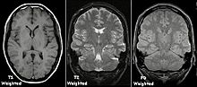
This is an example of a typical picture taken by an MRI scanner.

MRI is so important that the 2013 nobel prize for physiology or medicine was awarded to Paul Lauterbur and Peter Mansfield for their research on this topic.

Application: Spintronics
We use electronic devices all the time. But how does the device “know” what is has to do and when it has to do it? How does my computer “remember” the files it has in it? How does it access them and change them when necessary?
The answer to all these questions turns out to be quite complicated. But however complex it is, it boils down to electricity and magnetism.
You know that computers only work with zeroes and ones. The computer has a huge number of electric circuits and wires, and it is made in such that it reacts one way if a current goes through a certain wire, and it reacts differently when there is no current through the wire.
If we know call having a current 1 and having no current 0 (or the other way around), we can represent whatever the computer does in zeroes and ones. Also, on a hard drive the information is stored in tiny magnets. If their north pole points one way we call that 1 and otherwise we call it 0. The information is also stored in a binary way.
From the Stern-Gerlach experiment we learned that the spin of the atoms that were used can only take one of two values. Calling one of them 1 and the other one 0, the spin can now also be used to code information!
We also know from the double-slit experiment that quantum “objects” can go through both slits simultaneously. It can be in several states at the same time. Because spin is a quantum property, the spin of the atom can also be in a combination of both the up and the down state at the same time. This means that we can actually store more information in a spin than we could in a simple 1 or 0.
The field of electronics in which spin is also used is called spintronics.
The nobel prize in physics of 2007 was awarded for the discovery of an effect known as giant magnetoresistance (GMR), which is strongly related to spintronics. Thanks to this giant magnetoresistance effect, you can use ‘very small large’ hard disks. The effect for which Albert Fert and Peter Grünberg received nobel prize, is based on the dependence of electron scattering (resistance) on the spin orientation.

