

Bridge between research in modern physics  
and entrepreneurship in nanotechnology

Quantum Physics

The physics of the very small   
with great applications

Part 2  
QUANTUM PROPERTIES & TECHNOLOGY

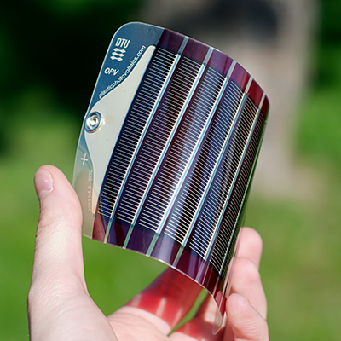

Learning Station VII:

**Semiconductors**

http://i.creativecommons.org/l/by-nc-sa/3.0/88x31.png

Quantum Spin-Off is funded by the European Union under the LLP Comenius programme   
(540059-LLP-1-2013-1-BE-COMENIUS-CMP).  
Renaat Frans, Laura Tamassia   
Contact: [renaat.frans@khlim.be](mailto:renaat.frans@khlim.be)

**Table of Contents**

Learning station VII : Semiconductors 3

1 Energy levels in atoms 3

2 Not all in the lowest state 6

3 Energy levels in solids: bands and band gaps 7

4 Conductors, insulators and semiconductors 8

5 Bridging the band gap: doping 9

5.a n-type doping 9

5.b p-type doping 10

6 Diode 11

7 Transistor 13

8 Application: LED 15

9 Application: Solar cell 15

10 Applications: further outlook 16

http://i.creativecommons.org/l/by-nc-sa/3.0/88x31.png**Attribution-NonCommercial-ShareAlike 4.0 International** (CC BY-NC-SA 4.0)

Under the following terms:

* Attribution — You must give [appropriate credit](https://creativecommons.org/licenses/by-nc-sa/4.0/), provide a link to the license, and [indicate if changes were made](https://creativecommons.org/licenses/by-nc-sa/4.0/). You may do so in any reasonable manner, but not in any way that suggests the licensor endorses you or your use.
* NonCommercial — You may not use the material for [commercial purposes](https://creativecommons.org/licenses/by-nc-sa/4.0/).

You can:

* Share — copy and redistribute the material in any medium or format
* Adapt — remix, transform, and build upon the material

The licensor cannot revoke these freedoms as long as you follow the license terms.

You have to refer to this work as follows:

Frans R., Boksenbojm E., Tamassia L. , Andreotti E. (2015) Quantum SpinOff Learning Stations. Art of Teaching, UCLL, Diepenbeek, Belgium

# Learning station VII : Semiconductors

At first Quantum Physics looks very theoretical and it took humankind quite a while to discover quantum physics and to use it. Gradually during the 20th century, it became clear that precisely the deep understanding of matter and light leads to astonishing applications no one could imagine before!

*Semiconductors* have the unique potential to control the current that passes through them. This makes them of utmost importance in devices such as transistors, solar cells, integrated circuits, microprocessors, and the like, where exactly current control underlies their operation.

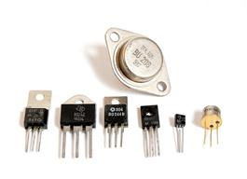Controlling electric current with semiconductors made it possible to create ***non-moving switches****.*The term transistor was used as kind of a contraction of "transfer resistor”. Thiswas a crucial step for mankind. Before that, all devices like calculating machines and the first computers had mechanical switches with *moving* parts. This made their dimensions huge and operation time slow. But with semiconductor transistors non-moving switches made fast and sure operations possible, under low power consumption. The first transistorwas made in 1947 by John Bardeen, Walter Brattain and William Shockley at AT&T's Bell Labs in the United States,

*A selection of discrete transistors in various housing forms* *(Source: Wikipedia public domain)*

Later on lots of transistors were integrated on a chip and this caused the present boom in electronic and telecommunications devices. None of these applications would have been possible without the insights of quantum physics. The practical use of this can hardly be over stated. You’ll find non-moving switches in medical instruments, in household appliances, in data storage equipment up to your smartphone. Without semiconductor applications practically nothing in our society will work any more.

Let us therefore try to understand **why some solids are conducting electricity** (like metals) and **others don’t**. And look to materials that we call semiconductors, and try to see how it became possible to let them play such an important role in all our electronic devices. To begin with,l it comes all down to the discrete energy levels of electrons in atoms.

## Energy levels in atoms

In learning station V you learned that, according to quantum mechanics, real objects (like tables, electrons and tulips) are both wave and particle. As a consequence, whenever an electron is ***confined*** within an atom, it cannot just have any wavelength. Like waves in musical instruments, *quantization emerges* because only ***waves that constructively superimpose*** *with themselves,* can exist. As a consequence the particle wavelength needs to obey the De Broglie condition:

$$n λ=2 π r$$

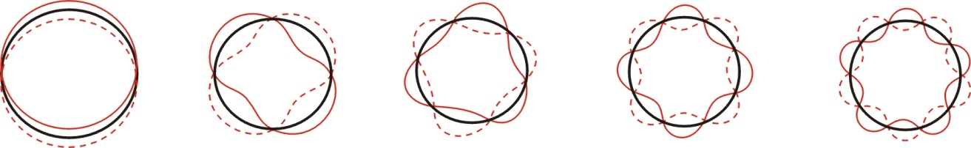

As you know, λ is the wavelength of the electron, r is the radius of the atom and n is a positive integer (called quantum number). The figure above shows the electron wave (the red line) for n=1, n=2, n=3, n=4 and n=5. Every one of these electron waves has a corresponding quantized energy. In learning station V you calculated this energy in the case of a hydrogen atom:

$$E_{n}= -\frac{1}{n^{2}}\frac{me^{4}}{8ϵ_{0}^{2}h^{2}}$$

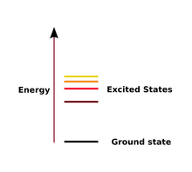Where e is the electric charge of the electron, h is the Planck’s constant, $ϵ_{0}^{}$ is a constant of nature known as the permittivity of empty space and n is again the corresponding integer quantum number of the envisaged energy level.

Instead of drawing electron waves all the time, we simply represent the **quantized energy levels** on a vertical axis as in the figure hereby (Source: Wikipedia Public Domain).

The lowest line corresponds to the electron wave with the smallest amount of energy possible, corresponding to the leftmost electron wave in the figure at the top of the page. The second line above corresponds to the second figure from the left and so on. These are called energy levels.

What are the energies of the 3 first energy levels of an electron in a hydrogen atom (in Joule)? Calculate by using the above formula.

E1= ……………………………………………………………………………………………………

E2= ……………………………………………………………………………………………………

E3= ……………………………………………………………………………………………………

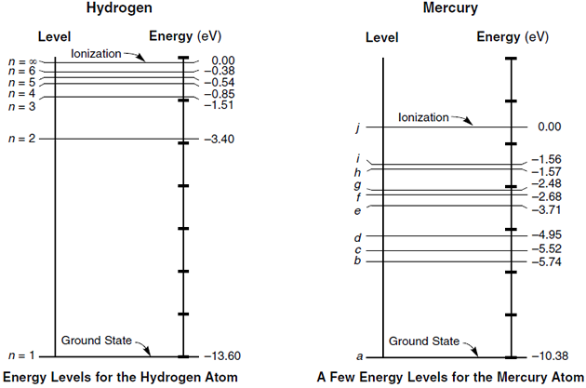Hereby are the energy levels of hydrogen represented on a vertical axis.

In the hydrogen atom the electrons can only have the energy levels depicted hereby. We thus get **possible energy levels** and a whole range of energies in between where the electron cannot be.

Note that the energy axis is in *units of electron volt*, noted as eV instead of Joules (which is the usual unit for energy). Because Joule is a tiny unit even for the energies of electrons, it is more practical to use electron volts instead.

*Quantized energy levels of hydrogen - source: www.aplusphysics.com/*

Look up: what is the meaning of an eV?

…………………………………………………………………………………………………………………………….

How many Joules equals one eV?

……………………………………………………………………………………………………

Every element in the periodic table has its unique “ladder” of electron energy levels. We call it the *energy spectrum* of that particular *element*. Every nucleus has indeed its own electric field in which the electron waves are confined to. Hydrogen is of course the lightest element: it has only …… proton in its nucleus and …… electron bound to it. Helium has …… protons and …… electrons. And so it goes up. And they all form discrete energy levels, specific for every element.

This gives rise to a configuration of allowed energies, specific for every element. This particular **configuration of allowed energy levels determine the chemical properties** of every element we observe in nature.

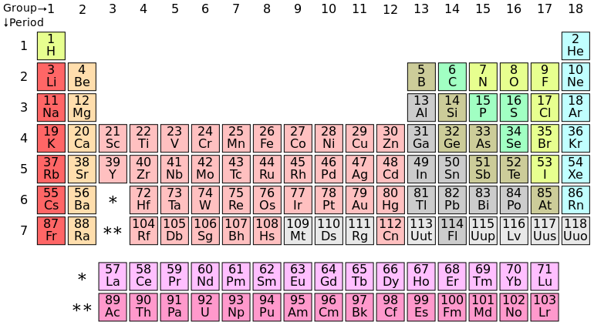

*(Source: Wikipedia Public Domain)*



Hereby you see the possible energy levels of mercury.

The Austrian physicist *Erwin Schrödinger* generalised the De Broglie particle-waves model. With De Broglie’s model after all *only the energy levels of hydrogen could be calculated*. The Schrödinger equation is more general and describes *3-dimensional electron waves* around the nucleus, known as electron “**orbitals**”.

The possible electron orbitals with their **quantized energies** could be calculated, not only for hydrogen but for *every chemical element in the periodic table*. Schrödinger’s equation turned out to describe fundamentally the wave-particles inside as well as outside the atom.

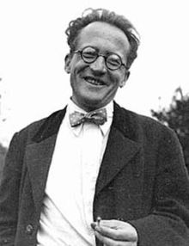

*(Erwin Schrödinger proposed in 1926 his equation that determines the so-called wave function fundamental for every quantum particle - Source: Wikipedia Public Domain)*

## Not all in the lowest state

Ok, due to the confinement in atoms and wave character of electrons the energies of electrons in atoms are clearly quantized. But a fundamental question that Niels Bohr already identified, remains: **why is the lowest energy state not occupied by all the electrons** of that particular atom?

It is clear that if all electrons of the elements were in the lowest energy level, the chemical properties of all the elements would be the same, there would be no spectral lines, no colors, one could hardly speak of different elements at all, leave alone molecules. Indeed a molecule is created out of separate atoms because the outermost electrons (thus the ones in the *higher* states) form a common wave mode with lower energy exactly bonding the separate atoms they came from. So, if all electrons would be at the lowest level, only hardly any chemical bond would be possible: we would live in a dull universe or probably there would be no life whatsoever!

This missing clue to understand the richness of the atomic and molecular structure we observe around us was given by Wolfgang Pauli with his *exclusion principle*.

The Pauli exclusion principle for electrons can be thought of a bit like students trying to find a seat in a big classroom. Many students tend to sit as far as possible away from the teacher. Unfortunately for some students, they cannot all sit in the seat farthest away from the teacher. What will a students do if he/she enters the class and the best seat is already taken?

…………………………………………………………………………………………………………………

Every incoming student has to be content with the farthest seat which is still available. If there are many more seats than there are students, the room will be filled from the back of the class up to a certain point.

Electrons behave in a similar way. *Every energy level has* a certain number of “seats”, so called ‘*states’*, where electrons can be. And if they are all full, an electron has to be in another, *possibly higher energy state*. The **prohibition for electrons to be in the same state** is indeed known as **Pauli’s exclusion principle**[1]. If we look at the energy bands available, electrons will fill them up from lower to higher energies. The lower band contains states of the lowest energy, these levels are preferably filled with electrons (under normal circumstances).

As you know from chemistry, the *outermost* electrons of an element are important for the chemical bond and are called *valence electrons*. Valence electrons of nearby atoms can indeed interact with each other to form a common bonding energy level. We peek deeper into the phenomenon of solids in the next paragraph.

## Energy levels in solids: bands and band gaps

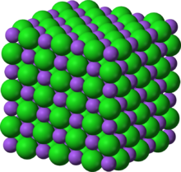The question we want to discuss now is what happens to the energy levels *when many atoms are together* like it occurs in a solid. Many solids are constituted of a huge number of atoms all arranged in a structured lattice to form a crystal. Which crystal is depicted here for instance?   
(hint: the blue and green atoms represent Na and Cl)  
…………………………………………………………………

*Source: Wikipedia Public Domain*

Let us start by considering a simpler case in which we only take 5 atoms in close proximity. Every atom has its own energy levels. The energy levels of the individual electrons *overlap with those of electrons confined to neighbouring atoms*. They form a new common orbital. Due to the Pauli exclusion principle, nature *does* *not allow* electrons in a crystal *to be in exactly the same state*. The result is that the *energy levels of atoms in a crystal are* ***shifted***. Some of them a bit upwards and other downwards.

Because of this shift, some energy levels are lowered, others raised. According to the Pauli principle the lowest possible states are filled first. Indeed these **low energy states** of the valence electrons hold together, bind the atoms in the solid itself. They cause the **chemical bond**[2]. That’s why a solid can exist in the first place!

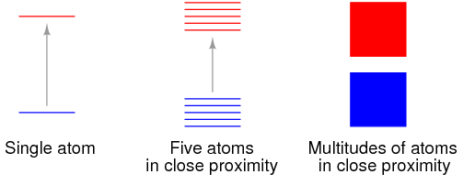Moreover, if we take a very large number of atoms the shifted energy levels will really form a *densely packed set of possible energy states* (the red and blue band on the figure on the right). With more atoms in the lattice, the energy levels of the individual atoms are no longer distinguishable: they form an **energy band**.

Source figure www.allaboutcircuits.com

Does this allow the electrons in the crystal to be in different states than the atomic ones? How?

…………………………………………………………………………………………………………………………

Moreover, in a crystal there is a repetition, a consecutive order of the atoms: a crystal is *periodic*. The electrons are confined in a periodical potential of the lattice atoms. This influences the energy levels in the way that some levels cancel each other out. The net result is the possible emergence of a **band gap**. So the *energy levels are grouped in bands* and more or less *separated by* ***energy band gaps***.

We get ranges of energy where the possible energies are located (the red and blue part in the figure) and a gap in between where there are no energies. This band gap is of crucial importance for the electric behavior of solids.

During the second half of the 20th century it became clear that we exactly can do electrical non-moving switches and “valves” by manipulating these band gaps. We will see further how this can be used in technology.

## Conductors, insulators and semiconductors

Thanks to this band gap we can understand too why some materials conduct electricity and others don’t.

Clearly energy is needed for an electron to escape from the lower **valence band** to the band above it: the so-called **conduction band**. In that higher energy band, electrons are *no longer bound to an atom* but are more or less *spread* out over the crystal. They can ‘move’ in the lattice and cause electric **conduction**.

In what ways could electrons receive energy and be brought into a higher energy level?  
…………………………………………………………………………………………………………………………

If this change of state (simply by shining light on the material) is due to receiving energy *in the form of light*, this is called the **inner photo-electric effect**. This effect is used in **photo-diodes** and in **solar panels**.

What should be the condition on the amount of energy of the light to be able to change an electron from the valence band into the conduction band?  
…………………………………………………………………………………………………………………………

Indeed because the gap is a *precise* energy gap, the light needs to give enough energy to the electron to overcome the gap. The smaller the band gap the easier it is for the electrons to get into the conduction band.

As you know some materials are better at conducting electric currents than others. Which materials are good electric conductors?

……………………………………………………………………………………………………………………

Which materials are bad electric conductors?

……………………………………………………………………………………………………………………

**Can electric conduction of materials be explained by the band gap quantum model?**

The difference between a conductor and an insulator is precisely due to the *size* of the band gap. Do you expect insulators or conductors to have a larger band gap? ……………………………………………………………………………………………………………………

**Metals** do not have a band gap at all, which makes it easy for electrons to get from the valence band into the conduction band. Because of this electrons can move easily within metals. **Insulators** on the other hand have a **large** band gap which makes it harder for electrical current to flow.

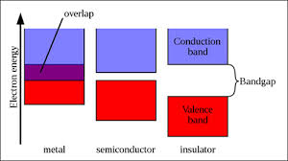A **semiconductor** is a material that does have a band gap but a **small** one. When very small amounts of energy are given to the electrons in it, it behaves as an insulator. But when larger amounts of energy are given semiconductors start to conduct electricity. Hence their name.

(Source: solarcellcentral.com)

In the periodic table you’ ll find semiconductors in group 14. Which elements are semiconductors?

…………………………………………………………………………………………………………………………

Before this group was called IV. What does that ‘IV’ mean in terms of valence electrons?

…………………………………………………………………………………………………………………………

In a pure semiconductor consisting of elements of group 14, each atom in the crystal is ……… times bound to the next one.

## Bridging the band gap: doping

The **band gap** of pure semiconductors is **too large** to really make current passing through the crystal: there are too few electrons that can bridge the band gap. In normal circumstances, in pure semiconductors only one atom in about a thousand million delivers electrons contributing to electric conduction. In a metal almost every atom contributes electrons to conduction. Could we make something in between?

### n-type doping

Could we make the band gap smaller? Could we add electrons with energy levels right in the band gap? We mean like pictured hereby.

This indeed can be achieved by doping the crystal with some ‘foreign’ elements **with one extra electron** (compared to group 14I). As you know electrons that are not chemically bound have a higher energy state compared to bounded ones. That’s why the new energy level caused by this doping is up there, higher than the valence band and a bit below the existing conduction band.

In which group do we have to find elements with one valence electron more?

…………………………………………………………………………………………………………………………

Which elements would be in principle suitable for this doping process?

…………………………………………………………………………………………………………………………

Usually one in every million atoms in the crystal is replaced. The new atom is often P (phosphorous). P has ……… electrons in its outer shell. …… of these electrons will form a bond with their neighboring atoms (Si or Ge). But the fifth one has no other electron to form together a bonding state. We lowered in fact the conduction band by introducing these unbound electrons. Electrons can use this new energy level to become unbound and move around the semiconductor and cause an electric current.

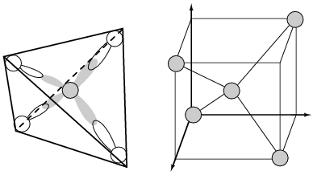Such a semiconductor doped with group 15 elements (extra electron) is called **n-type semiconductor** because negatively charged electrons contribute to the conduction in the material.

In high performance electronic applications silicon is used in its crystal form. The crystal form of Si is essentially that of diamond in which each silicon atom is bonded to its four nearest neighbours forming a tetrahedral.

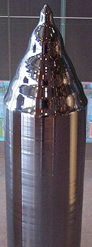*Tetrahedral bonding of Si atom leads to 1/4 of the cubic unit cell - Source: www.allaboutcircuits.com*

*Crystalline silicon ready to cut wafers from. (source: Wikipedia Public Domain)*

*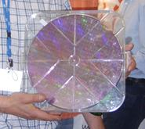Chip developers like Intel, fabricate their Very Large Scale Integration Microprocessors on a single-crystal silicon wafer (source: Wikipedia Public Domain)*

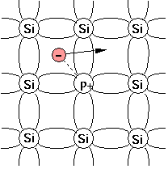*Although the crystal structure of Silicon is tetrahedral, the doped crystal is sometimes simply represented in a plane.   
(Source figure: Wikipedia Public Domain)*

### p-type doping

Could we make the band gap smaller by adding an energy level at the lower side of the band gap like pictured hereby?

Maybe we could now look for the opposite: instead of one electron in excess, look now for elements **with one electron** less (compared to group 14). In which group do we have to find elements with one valence electron less?

…………………………………………………………………………………………………………………………

Which elements would be in principle suitable for this doping process?

…………………………………………………………………………………………………………………………

These chemical elements have only…… electrons in its outer shell. …… of these electrons will bond with their neighboring atoms (Si or Ge).

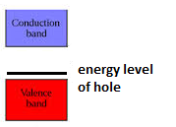Doping with group 13 atoms, causes on certain places the *absence of a bond*. As you know bonding orbitals have lower energy than not bonding ones. So the lack of bonding there creates an (unoccupied) energy level with slightly higher energy, just above the valence band. Since it is only a small energy step for other valence electrons to come into that unoccupied energy level (sometimes called a ‘hole’), electrons from elsewhere in the valence band move to that ‘hole’. But by doing so, they leave another ‘hole’ (absence of bond) behind elsewhere in the crystal. This creates a new ‘easy to reach’ energy level close to the valence band, where again other valence electrons can come to. As a result there is a current!

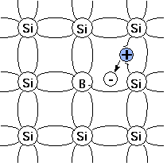Boron for instance can be used for this so-called **p-type doping** (“p” stands for “positive” because in a way the positive holes are causing the conduction). You can think of the unoccupied energy level, the hole, like it was a positively charged particle. So you can consider that in p-typed semiconductors there is a ‘moving hole current’.

But don’t forget that physically electrons are still moving from neighboring atoms filling up the holes and leaving behind on their turn a new ‘to be occupied’ hole.

Which of the figures depicts the p-type semiconductor? Which one the n-type?

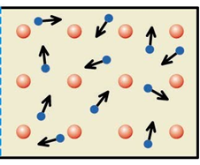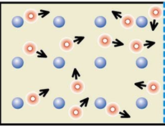

## Diode

Since we can make some current flow in a semiconducting material, we are really off to get more: current devices that can *control* current!

One of the simplest things we can do is building a device where we put a p-type and n-type semiconductor glued to each other (this is called a **pn-junction**). In this way we have built a diode, a sort of **electronic valve** *where the current can flow only in one direction and not in the other*. It makes it for instance possible to hold on a part of the circuit under high tension (a logical one) without preventing the current from flowing back. The start of all electronics! Let us see how it works!

If we merge a p-type semiconducting material beside an n-type, in which part are there more free electrons?

…………………………………………………………………………………………………………………………

In which part are there more holes?

…………………………………………………………………………………………………………………………

What will happen then on the boundary between the two semiconductors?

…………………………………………………………………………………………………………………………



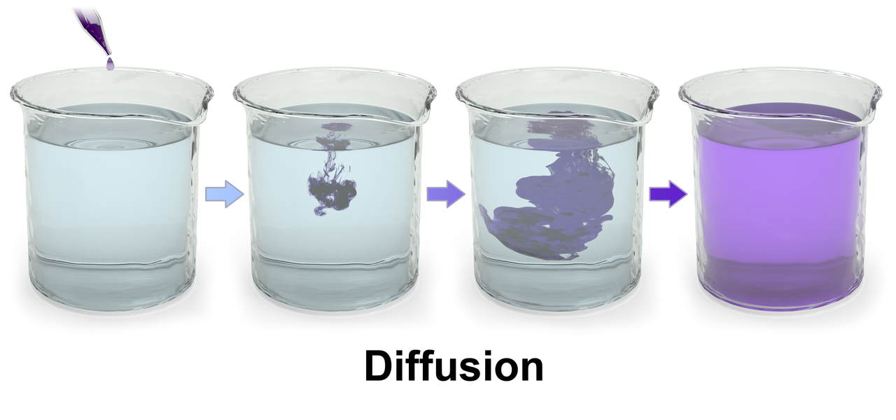  
What happens in the middle looks indeed a bit like what happens when you pour a small drop of ink in a glass of water. What happens to the drop even when you don’t stir? ………………………………………………

*Source Figure: Wikipedia public domain*

The spontaneous spreading out of the drop in the water is called diffusion. Diffusion, but now of charges instead of ink drops, will also take place at the boundary between the two semiconductors. Free electrons from the n-type will move into the p-type to fill in the holes.

As a result in the middle there are no free charge carriers any more. We call it therefore the **depletion zone.**

But if electrons have moved, electrical charges have moved.

If electrons move into the p-zone, this zone gets (Positively/Negatively) charged.

If electrons move out the n-typed zone, this zone gets (Positively/Negatively) charged.

The migrated charges will have created an electric field that decreases the diffusion (see the boundary on the figure of the pn-junction). It makes it harder for new electrons to move. Can you explain why?

…………………………………………………………………………………………………………………………

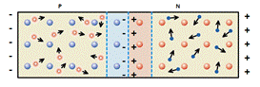If we now attach *a battery* to the semiconductor in such a way *that the negative end of the battery is connected to the p-type* and the positive side to the n-type.

Do you expect a current to flow through the depletion zone? Why?

…………………………………………………………………………………………………………………………

Indeed, the negative side of the battery is attached to the negative side of the depletion boundary (and the positive side to the positive side) and equal charges repel each other: so no charge from the battery will be able to pass the boundary and so no current will flow. We will call this situation “p-n junction in reverse bias”.

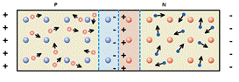If on the other hand the battery is reversed we get the setting below.

Will there be a current now? Explain.  
…………………………………………………………

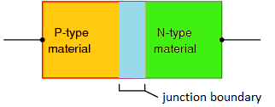Indeed, the positive side of the battery will attracted the electrons that migrated into the boundary on the p-type side. The negative side of the battery will attract so to speak the positively charged holes on the n-type side of the boundary (in fact electrons move in the opposite direction). The migration that was originally stopped by the presence of the charges at the boundary can now start again and thus a current flows through the diode. We will call this situation “p-n junction in forward bias”.

*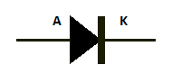Symbol for diode used in circuits*

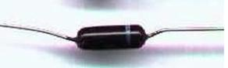

A diode with a stripe that marks the negative cathode. So you know how to switch it in a circuit. *(source: Wikipedia public domain)*

The diode has also simple applications: it is for instance used in almost every device where you have to put in batteries. The diode prevents the current to flow if you put in the batteries with the wrong polarization direction.

Also rectifiers that converts alternating current into direct one, use diodes. But as said before the most advanced applications are to be found in electronic circuits where they prevent the current to flow back.

Diodes in reverse bias are also used for the fabrication of detectors of radiation: these devices are used as well in basic physics research as for radioactivity measurements near nuclear power plants or in hospitals.

## Transistor

It seems a long way from De Broglie probability waves to modern computer and electronic devices. But this is exactly what sometimes in physics happens: just by trying to understand the world new views and possibilities open nobody would ever think of.

So we know how to make a device that allows a current to flow in one direction but not in the other: the diode. What happens now if we sandwich two of these diodes? Let us sandwich a p-semiconductor between two n-types.

Such a device is called a transistor and its importance for virtually all of our electrical devices can hardly be overstated (you can equivalently sandwich a n-type semiconductor between two p-types).

What you get now are two pn-junctions instead of one like with the diode. In a way we have put 2 diodes in opposite directions one after the other. Doing this at first sight seems of no great use since no current can travel through in any direction, as each of the diodes blocks current in one direction.

Indeed in the middle there is p-type material that is negatively charged by the electrons that migrated into it from the outer n-semiconductors. Electrons trying to pass from the left side to the right side are blocked by these negative charges at the pn-junctions. There is no current going through the transistor. It is in the “off” or “reverse” state.

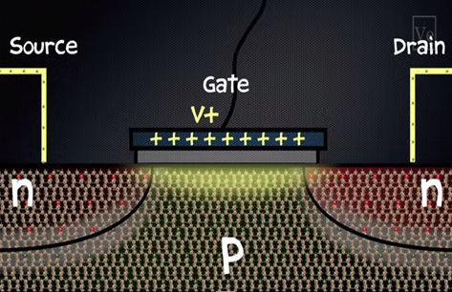

But each of the outer semiconductors is attached to a wire (in the figure these are the n-types). We call the left side wire the source, the right wire the drain, and the p-material in the middle is called the ‘base’ or the ‘gate’.

The goal is now to somehow pass a current from the source (left) to the drain.

Source Veritasium Science Blog: How a transistor work?

What happens if you apply a voltage to the sandwiched semiconductor in the middle (like shown in the figure on the p-type semiconductor)?

If a positive voltage is applied on the gate, the negative charges are attracted by it.The effect of the negative charge at the pn-junctions is negated and the current can flow from the source to the drain. The transistor is in the “on” or “pass” state.

If you take the voltage away, the transistors switches again off. So you made a switch without any moving part! Transistors can be mass produced more easily than mechanical switches. Moreover they can be made on the very small micro scale.

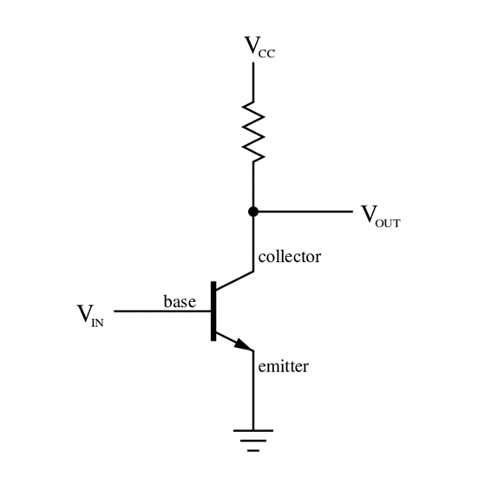It is remarkable that just by exploiting the properties of crystal we are able to build a switch that can be turned on or off by either applying or not applying a current to the gate. Because everything is purely electric in nature (they are no mechanical moving parts) transistors can be switched on and off at such a high speed that many operations can be done in a very short amount of time. Also less energy is needed than if you would work with real mechanical switches or relays.

A transistor has 2 main functions: it works as a switch which can be turned on or off, or it can be switched in a circuit to work as an amplifier. Hereby you see a basic circuit with one transistor in it.

## Application: LED

In a light emitting diode electrons from the higher conduction band lose energy in the form of light. This causes them to ‘fall’ down through the energy gap and emit light while doing so.

Will this expulsion of energy be in bits of a precise amount or can the electrons lose any amount of energy?

…………………………………………………………………………………………………………………………

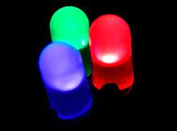Thus, the quantum gap model in solids together with the Einstein Planck relation predicts that the energy gap is (HIGHER/LOWER/EQUALLY BIG) for blue light than it is for red light. Can you explain why?

…………………………………………………………………………………………………………………………

Would a blue led need more voltage then a red one in order to light up? (Yes/No) Why? ………………………………………………………………

Experiment: Take a led and an adjustable voltage source. Measure with a multimeter at which voltage the led starts to shine. (Be sure to apply a direct current in the right direction over the led).

|  |  |
| --- | --- |
| Color of the led | U  (V) |
| Red |  |
| Yellow |  |
| Green |  |
| Blue |  |

Is the prediction by the quantum theory and the band gap model confirmed or not? (Yes/No)

## Application: Solar cell

You know that solar panels can generate electricity.

Can you imagine – in reasoning with the band gap model - what in principle will happen in the solid material of a solar cell so that electricity will be generated?

…………………………………………………………………………………………………………………………

Thus a solar panel works on the basis of the inner photo-electric effect.

Should there be a relation between the magnitude of the band gap and the color of light for which the panel works? Explain.

…………………………………………………………………………………………………………………………

The semiconductors in solar cells are silicon or germanium based. At the moment there is a growing research field on solar panels made of organic semiconductors based on carbon. These could have promising properties like foldability. This will make their application easier on many surfaces like roofs, tents, boats, cars etc. However for the moment their efficiency and stability is still (far) lower than for the non-organic ones.

Organic solar cells, remind us in a way the natural processes like plant photosynthesis, where energy from light is also captured on a molecular level.

*Source: plasticphotovoltaics.org*

## Applications: further outlook

Current research is trying to make transistors at the nano and subnanoscale. These dimensions are on the atomic scale and new physical boundaries come up like current leakage due to quantum tunneling or too slow signal processing due to the limited speed of light. If no other insights and techniques are found these boundaries might slow down the evolution we have been used to in the last 50 years.

Almost 5 billion transistors are on nowadays Intel's 22nm processors (the so-called Xeon Phi processor family). The structures on a chip have even become much smaller than human cells, bacteria or even viruses. Breakthroughs are envisaged precisely in the field of bio-sensors, new applications for healthcare and life science. It becomes possible to replace full lab devices by small, relatively inexpensive, rapid and accurate handheld ‘labs on chip’. In this way cancer or all kinds of diseases can be detected quite early and if necessary continuously. Some measurements that now are done in a doctor’s cabinet are even in an hospital, might be performed from your home or from anywhere.

It becomes clear that semi-conductors applications, still to be developed, could help to overcome modern challenges like health issues, climate change and future sustainable energy supplies.

Concepts in Learning Station VII

**Classical concepts**

……………

**Quantum concepts**

Every energy level of the electronshasa certain number of ‘*states’* where electrons can be. If they are all full, an electron has to be in the next free***.............*** energy level. The prohibition for electrons to be in the same state is indeed known as ***................................................***.

The configuration of allowed energy levels determine the ***…………………………..*** of every element in the periodic table.

In a crystal, the energy levels of the individual electrons of neighbouring atoms ***…………………………….***and form a new common orbital. Due to ***………………………………………*** the electrons are not allowed to be in exactly the same state. The result is that the energy levels of atoms in a crystal are***…………...*** These shifted energy levels form a densely packed set of possible energy states and the energy levels of the individual atoms are no longer distinguishable: they form an ***……………………..***.

Energy bands in a crystal are separated by ***……………………….***.

1. In fact all ‘matter-like’ particles like electrons, neutrons, protons and the like obey the Pauli exclusion principle. Particles that obey Pauli’s exclusion principle are called ‘fermions’. Photons on the other hand can be in the same state. Particles like photons that don’t obey Pauli’s exclusion principle are called bosons.
2. Indeed quantum physics gives understanding for the existence of all the chemical bonds you see around you.