**Table of Contents**

Learning station V: Predicting the hydrogen emission lines with a quantum model 46

1 Predicting the emission spectra of elements? 46

1.a Emission lines of elements: classically not understood 46

1.b Quantum Fields of matter and light 46

2 The enigmatic formula of Balmer 47

2.a Again the integer numbers of Pythagoras in nature 47

2.b The Balmer formula and the hydrogen spectrum 48

3 Waves and integer numbers: standing waves 49

3.a Integer numbers and natural harmonics 49

3.b Integer numbers in the wavelengths of standing waves 50

3.c Integer multiples in the frequencies of natural tones (Eigen frequencies) 52

4 Standing electron waves in the hydrogen atom 53

4.a Fitting the waves 53

4.b Wave and Particle Duality 55

5 Calculation with the Quantum Atomic Model 56

5.a Predicting the size of the hydrogen atom 56

5.b Predicting the hydrogen emission lines 57

6 Interpretation of the Balmer formula 60

7 Three-dimensional generalisation: Orbitals 61

http://i.creativecommons.org/l/by-nc-sa/3.0/88x31.png**Attribution-NonCommercial-ShareAlike 4.0 International** (CC BY-NC-SA 4.0)

Under the following terms:

* Attribution — You must give [appropriate credit](https://creativecommons.org/licenses/by-nc-sa/4.0/), provide a link to the license, and [indicate if changes were made](https://creativecommons.org/licenses/by-nc-sa/4.0/). You may do so in any reasonable manner, but not in any way that suggests the licensor endorses you or your use.
* NonCommercial — You may not use the material for [commercial purposes](https://creativecommons.org/licenses/by-nc-sa/4.0/).

You can:

* Share — copy and redistribute the material in any medium or format
* Adapt — remix, transform, and build upon the material

The licensor cannot revoke these freedoms as long as you follow the license terms.

You have to refer to this work as follows:

Frans R., Tamassia L. , Andreotti E. (2015) Quantum SpinOff Learning Stations. Art of Teaching, UCLL, Diepenbeek, Belgium

# Learning station V: Predicting the hydrogen emission lines with a quantum model

## Predicting the emission spectra of elements?

### Emission lines of elements: classically not understood

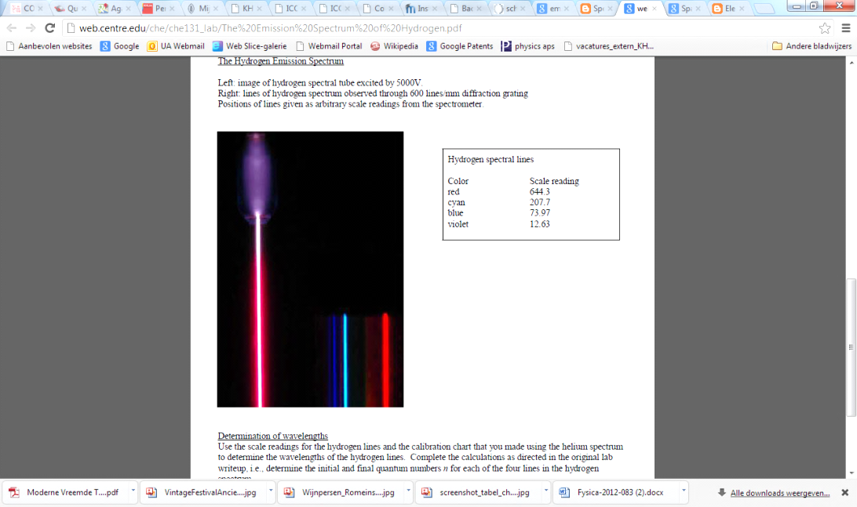It was well-known that atoms can emit light and we can observe that the spectrum of an element is composed by very precise discrete emission lines. However, this phenomenon *cannot* be explained by a classical atomic model, like e.g. Rutherford’s. **Classical physics *cannot* explain how discrete colour lines can be emitted by atoms.** This problem was already tackled a bit in the first learning station.

As we now know the quantum characteristics of light, its double nature of wave and particle, we might go further and explain the phenomenon of the discrete emission lines of chemical elements.

**Niels Bohr** and **Louis De Broglie** were the first to bring Rutherford’s atomic model into discussion and they developed a **quantum atomic model** thattook the quantum properties of matter and light into account. Thanks to their new way of seeing the atomic structure, it became possible to explain not only the emission lines but many important physical and chemical properties of matter and light.

For instance, the thin emission lines of hydrogen or helium give us a glimpse of the fundamental quantum exchanges between matter and light in atoms. Light emitted by atoms, contains precise lines. In learning station I you have seen the beautiful emission lines of some elements and you have measured their precise wavelength.

### Quantum Fields of matter and light

The 2-slit experiment shows that matter particles cannot be ‘just’ particles: how could one particle pass through two separate slits at the same time? And light waves cannot be ‘just’ waves either: they are detected photon by photon on the screen. A crucial feature of quantum theory is this *particle-wave duality both of matter and light*.

But how can one visualize the *particle-wave duality*? In quantum field theory elementary particles like the electron are seen as ***quanta of a field, a matter field.*** The hypothesis of De Broglie, that lives on in quantum field theory, is that some kind of quantum matter field must indeed be connected to a matter particle. Matter particles arise from this matter field. Light particles - photons – similarly, are seen as ***quanta of electromagnetic fields*** and therefore arise from this electromagnetic field.

The particle-wave duality implies that we really can assign a wavelength to an electron. The relation of De Broglie quantifies this correspondence. Write the hypothesis of De Broglie again below:

………

As you can see, you need to know the linear momentum p of the electron (a property of particles) to compute its wavelength (a property of waves). We know that the linear momentum p of a classical particle of mass m with velocity v is given by ………….   
This relationship remains unchanged in the quantum theory.

The central question in this learning station is:

If we model the electron in the hydrogen atom   
*as a wave with the associated De Broglie wavelength*,   
can we then predict the discrete emission lines of hydrogen?

In this learning station we will use *the quantum atomic model of De Broglie*, in order to:

(a) *qualitatively* explain the discrete emission lines of the elements

(b) *quantitatively* predict the discrete emission lines of hydrogen.

This means that we will not only construct a model with which we can explain why discrete emission lines arise, but that we will, with the same model, also be able to compute the precise ***frequencies*** of the hydrogen lines. We will be able to compare the quantitative predictions of our model with the measured values!

Since we are planning to make quantitative predictions with our model, it is useful to first take some time to look at the measured frequencies of the emission spectrum of hydrogen. These frequencies follow a remarkable pattern of ***integer numbers***. It was this bizarre mathematical structure of the measured hydrogen emission spectrum which inspired Louis De Broglie to develop his quantum atomic model.

## The enigmatic formula of Balmer

### Again the integer numbers of Pythagoras in nature

The Swiss mathematics teacher Johann Jakob Balmer was **fascinated by integer numbers** in physical phenomena (like **Pythagoras** 2500 years before). He also investigated the discrete emission lines of the elements and in 1885 he found out that the measured values of the frequencies could all be expressed in a very compact form by one mathematical formula. This formula is *a simple ‘game’ of integer numbers*.

The formula of Balmer is the following:



where n1 and n2 are **two integer** numbers, c is the speed of light and R is an empirical constant (that is, measured by experiment): R = 1,0974 X 107 m-1

By filling in integer numbers, the precise frequencies of the hydrogen emission lines can be calculated! A great result, but Balmer did not know *why* the emission lines could be described by this rather mystic formula with the integer numbers. However, the idea that discrete emission lines have something to do with series of integer numbers, was already the right connection. Quantum theory will explain precisely where these integer numbers come from. And, exactly like 2500 years before, the integer numbers were found, in connection to **musical tones**!

### The Balmer formula and the hydrogen spectrum

In the Balmer formula, two natural numbers appear: n1 and n2 , where n2>n1. For instance, you can take n1= 2 and let n2 vary: n2=3,4,5,6… In this manner you will find exactly the frequencies corresponding to the colours seen in the hydrogen emission lines!

Let us check this!

Take n1=2 and choose n2=3: which frequency f do you get? Calculate ! (Keep 3 significant digits).

Red line: f3->2 = ... .....................................

And if you choose n2=4?

Bluegreen (turquoise) line: f4->2 = .. .....................................

And if you choose n2=5?

Violet line: f5->2 = . .....................................

And if you choose n2=6?

2nd violet line: f6->2 ... ..................................

Compare the values you have computed with the measured frequencies of the four visible lines of hydrogen below (pay attention to the fact that the figure below gives the wavelengths and you first need to determine the corresponding frequencies, look for the relevant formula in a previous learning station)

Violet 2 Violet Bluegreen Red



**λ=656 nm**

**f=………….**

**λ=486 nm**

**f=………….**

**λ=434 nm**

**f=…………**

**λ=410 nm**

**f=…………..**

Does the formula of Balmer give a good description of the hydrogen emission lines?

Yes/No

If you choose n2=7 and still hold n1=2, what do you get for the frequency?

line: f7->2 ...

which gives a wavelength of:

Violet 3 λ = .....

Can we see this emission line? (Hint: Check the spectrum of electromagnetic waves in a previous learning station).

With this last calculation we have actually predicted the existence of a fifth line we could not see! This line does exist and can be measured with an appropriate spectrometer.

When you choose other values of n1 and n2, you‘ll find other existing lines we cannot see either due to the limits of our detector, the human eye! For instance, if you compute the series of lines with n1=1, you obtain lines in the UV-spectrum (shorter wavelengths and higher frequencies with respect to visible lines). They exist too and can be measured by a spectrometer.

## Waves and integer numbers: standing waves

### Integer numbers and natural harmonics

Even if Johann Balmer did not know why his formula worked, it became clear that integer numbers should appear in one way or another in a physical model capable of explaining the discrete atomic emission spectra.

From De Broglie’s quantum theory we know that the electron is a ………………….. of a matter field and we can assign a ……………………. to an electron.

DeBroglie played music and he was well acquainted with the physics of music. Maybe you already know in which kind of phenomenon in music do waves and integer numbers play a central role. Think about this first and write down your answer before reading ahead:

……………………………………………………………………………………………………………………………………………………………………………………………………………………………………………………………………………………

When you play an instrument where you don’t ‘change anything’ - like a wind instrument where you don’t open or close any holes, or a string instrument where you don’t change the tension nor the length of the strings – you can produce a precise series of tones. One can see that in such an instrument there is a possible lowest tone one can produce: the ground tone. The next possible tone has a frequency that is twice the one of the ground tone. And the subsequent tone has a frequency that is three times the ground tone frequency, etc. In such an instrument you can ***only produce tones forming a discrete series*** where the frequency of every tone is an ***integer*** ***multiple of the ground tone***. Other tones are not possible.

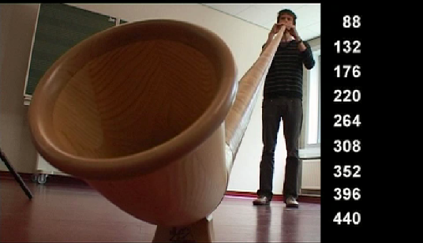

*The series of natural tones of an Alpenhorn.   
The tones you can play with this instrument are integer multiples of the ground tone.*

***De Broglie was well aware of the role of integer numbers in the series of standing waves on a string or in a tube and started to wonder whether the electron waves in an atom could behave as the series of harmonics in such a musical instrument.***

*Would it be possible for, in the same way we hear natural tones produced by a musical instrument, one to see the ‘tones’ of the electron waves in the atoms in the form of emitted colours?*

Even if this reasoning might appear bizarre at first sight, we decide to follow this path of reasoning and see whether electron waves around the atomic nucleus can behave as waves on a string.

### Integer numbers in the wavelengths of standing waves

In an interview in 1963 Louis de Broglie described how he came to the idea of electron waves:

*... it was in the course of summer 1923 - I got the idea that one had to extend this duality to matter particles, especially to electrons. …, in quantum phenomena one obtains quantum numbers, which are rarely found in mechanics but occur very frequently in wave phenomena and in all problems dealing with wave motion. (Source:* <http://www-history.mcs.st-andrews.ac.uk/Biographies/Broglie.html> )

In the following we will investigate whether a similar behaviour could occur for matter waves associated with electrons in atoms. But let’s look at standing waves on a string first.

#### Standing waves on a string:

Let us look at a sinusoidal wave travelling in a cord fixed at one end. Look at the figure on the right. What happens when the wave pulse arrives at the fixed end of the cord?

..........................................................

What is going to happen, according to you, if in the meantime another pulse wave has started from the left side? (Hint: think at what we have seen concerning superposition and interference)

...................

And if we redo the experiment with continuous sinusoidal waves instead of pulse waves, what will happen then?

...................

Check if your idea about this agrees with the theory. Look at <http://www.walter-fendt.de/ph14e/stwaverefl.htm>

**Experiment**. Now do the experiment yourself with a cord fixed at one end. Take a rather long cord. Let one person hold one end of the cord and let the other person move the other end up and down to produce an oscillation as regular as possible. In this way you will produce a good approximation of a sinusoidal wave. The frequency of the up-and-down movement of the hand is also the frequency of the produced wave in the cord. Try with several frequencies. Do you always produce a stable wave?

...................

Depending on the frequency you let the end of the cord oscillate, you will produce a chaotic movement of the cord that fades away very quickly, or you produce a nice stable wave with a big amplitude.

Why are some of the produced waves stable while others fade away so quickly?

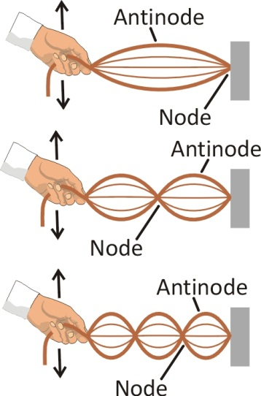**We call the ‘surviving’ waves: *standing waves***. Actually, they are **the waves generated by constructive superposition (summing up) of travelling waves moving back and forth** on the cord. They are ‘standing’ because when you look at them, we get the impression they are not travelling at all.

In the figure hereby you can see the first three standing wave configurations on a cord.

Can any arbitrary wave be produced on this cord (if we do not change length, tension and thickness)?

.................................................................

#### Superposition of waves confined in space: quantisation

Some frequencies give no stable waves indeed. This means that the waves moving back and forth in the cord add up *destructively* and annihilate each other.

As a result, we get only a precise series of possible waves on the cord.

**Which waves add up constructively?** Which frequencies do these waves have? Are these waves not the ones that ‘fit’ exactly in the cord length? To get constructive interference, the wave looks exactly the same when it arrives at the same point. In this way it will add to itself and become stronger.

If the cord has length L, which distance does the travelling wave need to cover to arrive back in the starting point?

...................

Which is the minimal distance a sinusoidal wave with wavelength L must cover to be identical to itself in the beginning?

...................

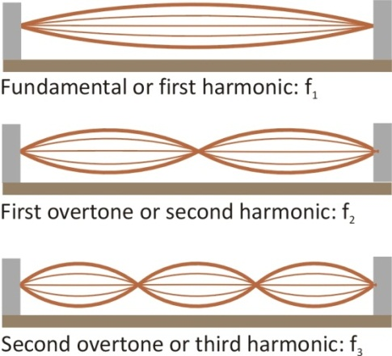After having covered a distance equal to an integer multiple n of the wavelength, is the wave identical to how it was in the beginning?

Yes/No

Then what is the relation between the wavelength λ and the length L ensuring that the wave on the cord interferes constructively with itself?

..................................................................................................... (1)

In the figure above, you can see the first three wave configurations of a guitar string. How long is the wavelength of the first standing wave in terms of the length L of the string?

λ1=......................................................

And the second?

λ2=......................................................

And the third?

λ3=......................................................

Draw the fourth possible wave here below:

To what is λ4 equal in terms of the length L?

λ4=..........................................................................................................

Now write down the **general formula for the whole series of wavelengths as a function of the length L of the string**, by making use of the integer number n:

**λn=** ...................................................................

Is this result compatible with your answer (1) ? In case not, correct your answer.

Note that you have characterized the series of ‘surviving’ standing waves by using **positive integer numbers**!

### Integer multiples in the frequencies of natural tones (Eigen frequencies)

We have theoretically derived that standing waves can only arise for specific frequencies. But is this also true in practice? Watch the video “Natural Tones” (you’ll find it in the media files that go with these learning stations). While watching this, you will realise that you can hear the series of possible tones very well. For this reason physicists speak of a series of *Eigen frequencies* going along with a series of wavelengths. Can we now translate the series of wavelengths of the surviving waves to a series of possible Eigen frequencies?

Let us rewrite the series of wavelengths as a series of frequencies. Assume that the wave travels with velocity v. How can you then rewrite the wavelength in terms of frequency and velocity (go back to a previous learning station if needed)?

fn = .........................................

**These frequencies are the *harmonics* or *Eigen frequencies* of the cord. The first frequency is called fundamental frequency or *first harmonic*. The other frequencies, or *overtones*, are integer multiples of the fundamental frequency.**

Note that when a wave (?) is *not* confined to a fixed space, the wave frequency can be changed continuously. But when the wave is confined to a limited space, for instance on a cord with length L, then the waves in one direction will interfere with the reflected waves moving in the opposite direction. In this way the waves all annihilate, *except for a discrete series of frequencies for which the waves can survive the interference*. Waves with other frequencies disappear after a very short time due to destructive interference.

For confined waves **classical quantisation** arises: a variable (the wavelength, or the frequency) which would normally vary continuously, can now only assume **discrete values** characterized by **integer numbers**.

Watch the video: “NaturalTones_Constructive_DestructiveSuperpositionOnString”   
(you’ll find it in the media files that go with these learning stations)

Try to explain what happens there.

...... ...................

....................................................................... ...................

## Standing electron waves in the hydrogen atom

### Fitting the waves

The experiments of Rutherford have shown that matter is made of nuclei with a positive electric charge and electrons with a negative electric charge. Electrons are found at a certain distance from the nucleus.

Why don’t electrons escape from the nucleus and why do they stay around the nucleus?

............................................................................................................

The fact that the electron in an atom like hydrogen stays at a certain distance from the nucleus, tells us that there must be a *force* exerted by the nucleus on the electron, strong enough to **confine** the electron **to a certain** **volume**. It is an electric field of the nucleus that prevents the electron from escaping: the electron is bound to the nucleus and has to stay and move in a limited space.

But, according to De Broglie, the electron itself can also be considered as a (quantum of a) matter field. This also means that the electron matter field is confined to a certain volume and cannot escape either.

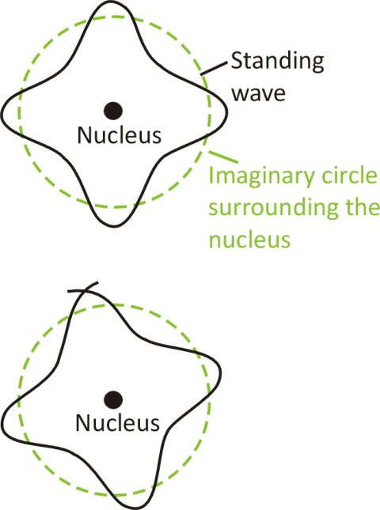***Therefore, the wave of the electron matter field in an atom is a “confined wave”*** *The**wave of this electron matter field can be compared to**the wave in a fixed cord****!***

The quantum atomic model of De Broglie: the music of atoms

Exactly as in the case of the discrete series of standing waves on a cord, De Broglie assumed that the atomic electron matter wave could exist only in a *discrete series of standing wave configurations*. The other wave configurations would, just like on a cord or string, annihilate by destructive interference in a very short time.

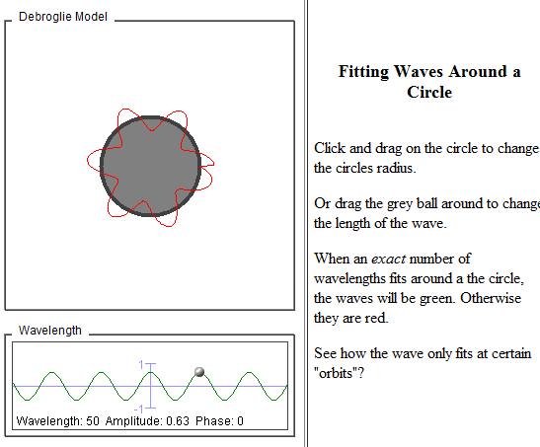Explore the hypothesis of De Broglie that an electron wave must ‘*close on itself*’ in its oscillation along a circle: It must go on where it ended. Use the following applet to find out about this: [www.colorado.edu/physics/2000/quantumzone/debroglie.html](http://www.colorado.edu/physics/2000/quantumzone/debroglie.html)

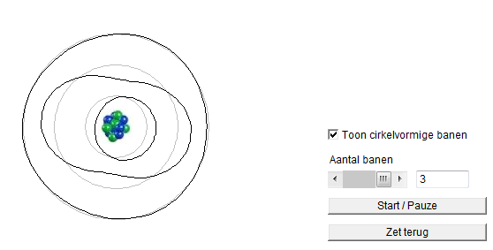  
This is in essence the model of De Broglie for the electron in the atom. **The wave of the electron must close in a circular path around the nucleus.** The *radius r* of the circle is the *average distance* between the electron and nucleus. Investigate this idea of De Broglie with the following applet: [fys.kuleuven.be/pradem/applets/RUG/bohr1/](http://fys.kuleuven.be/pradem/applets/RUG/bohr1/) (Source applet: University of Gent)

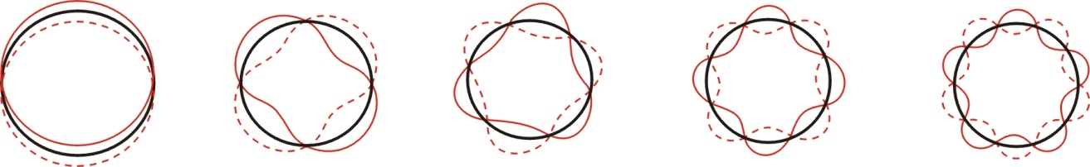

In the drawings above you can see the first five standing wave configurations on a circle. We will now derive a mathematical description that, in the end, will allow us to predict the frequencies (and thus the colours of the hydrogen emission lines!)

**The electron wave of De Broglie is thus confined to a length equal to the circumference of the circle.** How long is this length as a function of the radius?

L(r) = ....................................................................................................

In order to ‘survive’ when it moves on , the wave must *come back to itself* (otherwise it would cancel itself out by destructive interference)*.* In relation to this there is an important difference between the situation of the electron wave *around* the nucleus and the situation on a cord with fixed ends:

*On the circle* the wave has to come back to itself after a distance of (how many wavelengths?). Hint: look back to the drawings of the Eigen waves.

...........................................................

But *on the cord* with fixed ends the wave is already falling back onto itself after a distance of (how many wavelengths?)

...........................................................

Therefore, for a wave to survive destructive interference **on a cord with fixed ends**, the following condition has to be satisfied (Standing waves on a cord with fixed ends):

...........................................................

While for a wave to survive destructive interference **on a circle,** the following condition must be satisfied (Standing waves on a circle):

...................

The last equation you have filled in gives the **quantisation condition** for the electron in the hydrogen atom. *The wavelength of the electron should be an integer number of times the length L of the circle.* Write this condition as a formula

.....................................................................................................

This gives the relation between the possible wavelengths of the electron around the nucleus and the distance r between electron and nucleus:

..........................................................................................................

From this quantum condition we can further calculate the possible discrete energy levels for the electron in the atom and therefore also the possible energies of the emission lights. In this way this quantum condition lets us also predict the size of the hydrogen atom!

to begin with replace the wavelength of the electron in the above formula with the expression of the hypothesis of De Broglie, to obtain the following:

.................................................................................................................... (2)

### Wave and Particle Duality

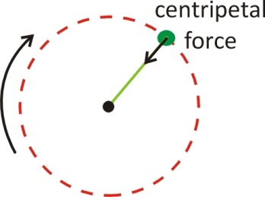The beauty of the hypothesis of De Broglie is that it allows you to consider the electron as a particle and as a wave at the same time. **The electron wave has to ‘fit’ on a circular path around the nucleus.**

But, as the electron as a particle moves in a circle, there must be a force applied to the electron acting as a centripetal force.

In the case of the electron around the nucleus, **which force acts as the centripetal force**? What exerts it?

...................

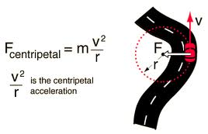We know from Newtonian mechanics for circular motion that centripetal acceleration is inversely proportional to the distance and increases quadratically with the velocity:

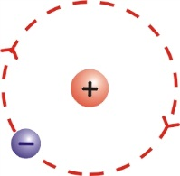

Coulomb had discovered how to express this electric force quantitatively. The magnitude of the force is directly proportional to the product of the electric charges of the two point particles and decreases quadratically with the distance between electron and nucleus.

Write Coulomb’s law below (if necessary, look it up):

...................

The *electric force* exerted by the nucleus acts as *centripetal force* on the electron. This means that the mathematical expressions for these two forces must be equal. Write the equation stating this below:

............................................................................................................. (3)

In the equation above do not forget that the absolute value of the charges of an electron and a proton are both equal to e: the elementary charge in the universe.

## Calculation with the Quantum Atomic Model

### Predicting the size of the hydrogen atom

Time to derive our first concrete result from the quantum atomic model of De Broglie: we can predict now the **size of the hydrogen atom** with this simple model! To derive this result, it is enough to solve equation (3) for the distance r.

Take the square of equation (2) and isolate mv2  at the left side of the equation. You obtain:

................................................................................................................ (4)

Now take equation (3) and isolate mv2 as well. You obtain:

................................................................................................................ (5)

The quantities at the other side of the two equations (4) and (5) must then be equal. This means the following:

.................................................................................................................. (5a)

Now isolate the distance r at one side of equation (5a). You obtain:

r = ................................................................................................. (6)

Check your answer with the result given below



Apart from the integer number n, do we know everything on the right side of the equation?  
Yes/No

If you have answered ‘No’, take a few more seconds to think. The mass and the electric charge of the electron are known and the universal constants h and ε0 are known too.

With our quantum atomic model   
we have been able to make a quantitative prediction   
for the possible distances between electron and nucleus!

These distances are **quantized**, which means that there is only a discrete series of possible distances. The integer number n can be chosen. For which value of n do we get the smallest distance?

n = ............

When the integer n becomes bigger, the distance between electron and nucleus becomes ................................ .

Fill in the value of n leading to the smallest distance in equation (4), together with the values of all constants, and determine the smallest possible distance between electron and nucleus in the hydrogen atom:

r1=.................................................................................................................. (7)

This distance is so important that it has a name: the **Bohr radius**. It gives the most probable distance between electron and nucleus.

Look for the Bohr radius on the internet. Is the result you have obtained correct? (You can find both numerical value and formula for the Bohr radius. Sometimes the formula is written with ‘h-bar’ instead of h: ‘h-bar’ is equal to h/2π)

The Bohr radius gives the order of magnitude in length of quantum phenomena.

We have already obtained a quite impressive result with our simple quantum model, but we have to go one step further to achieve our initial goal: predicting the frequencies of the hydrogen emission lines.

### Predicting the hydrogen emission lines

#### Quantised energies

In our quantum atomic model we describe the electron by the associated field of De Broglie. You have just proven that not all distances between electron and nucleus are possible in this quantum model. Only a set of discrete distances are possible. This means that the size of the atom is quantized.

We now consider the *total energy* of the electron in the electric field of the nucleus. We suspect that the **energy** of the electron in the atom could also be **quantized**. This would mean that the energy cannot assume all possible continuous values, but only a discrete set of values. We are now going to check whether this is true.

When the electron moves in a circular path with velocity v, what is its kinetic energy?

Ek = ..............................................................................

On the one hand, since Ek equals ½ mv2 and thanks to equation (5) which gives an expression for mv2, we write Ek as the half of equation (5)

Ek = ..............................................................................

On the other hand, the electron has potential energy because it is located in the electric field of the nucleus: (Hint: pay attention to the sign!)

Ep = ............................................................................

What is the total energy of the electron then? Insert the equations you have already obtained in the expression for the total energy.

Etot =............................................................................

Now replace r by using equation (6). In this way **the integer number n** comes into play! At the end you should have obtained the following expression:

 (8)

(If your result is not correct, you should go back and find the mistake!)

You have shown   
that the total energy of the electron is quantized   
in the atomic model of De Broglie.

When n becomes bigger, the total energy of the electron becomes…………………………

Choosing n=∞ means considering an electron which is very far from the nucleus (see the expression for r). This is a free electron, and not an electron bound to the nucleus. What happens to the energy when n=∞?

...................

When the distance between electron and nucleus becomes bigger, the total energy of the electron becomes …………………………………………………………

Can the total energy of the electron vary continuously? Yes/ No

We can see the possible quantized energy levels of the electron in the hydrogen atom as a *ladder of possible vibration modes*, with energy ‘bars , steps (klinkt is gemakkelijker) varying according to the value of the integer number n.

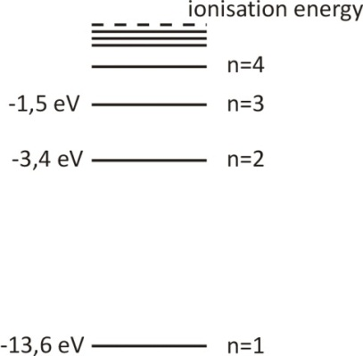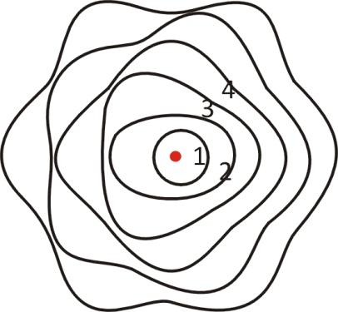

#### Quantised energy transitions

We now consider the possibility that the **electron waves undergo a transition from one discrete oscillation mode to another**.In this way they gain or lose a **quantum of energy**.We suspect these **quanta of energy could be equal to the energy quanta of the photons we observe as emission lines…** In this case, the energy lost by the electron field would have been taken by the electromagnetic field. When the quantum of energy is ‘big’, we would see blue light, and when the quantum of energy is ‘small’, we would see red light. Let us follow this reasoning, compute which values it predicts for the frequency and see whether the result fits the experimental data for the emission lines of hydrogen!

If an electron in the energy level associated with the integer number n2 undergoes a transition to energy level number n1, what is the change in energy for this electron? Give your result here below.

ΔEn2->n1 = ........................................................................................................ (9)

If the electron goes   
from a state with higher energy to a state with lower energy  
a photon is produced with energy equal to the change of energy

*If the frequency of the photon is in the visible part of the electromagnetic spectrum, we will see the photon as light of a certain colour.*

In learning station IV “Wave Particle Duality” we saw the connection between the energy of a photon and the frequency of the connected electromagnetic wave (Einstein-Planck formula). If we assume that the electromagnetic field takes over the energy lost by the electron field, then the energy ΔE the photon gains in relation to the photon frequency is:

ΔE= .....................................

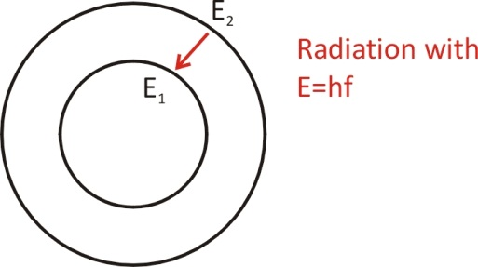

Now you can write the expression for the frequency of the electromagnetic wave emitted as a result of the transition of the hydrogen atom electron between the states associated with numbers n2 and n1:

fn2->n1 = ........................................................................................................

Finally!!! **This is the expression predicting the frequencies of the hydrogen emission lines!**



Check your result with the equation below:



Is your result correct? Congratulations! You have been able to predict the frequencies of the emission lines of hydrogen. (No panic if your result is not correct! Just go back and try to find the mistake.)

## Interpretation of the Balmer formula

Now compare your result to the Balmer formula. You have seen it in the beginning of this learning station.

What is the theoretical expression for the constant R appearing in the formula of Balmer?

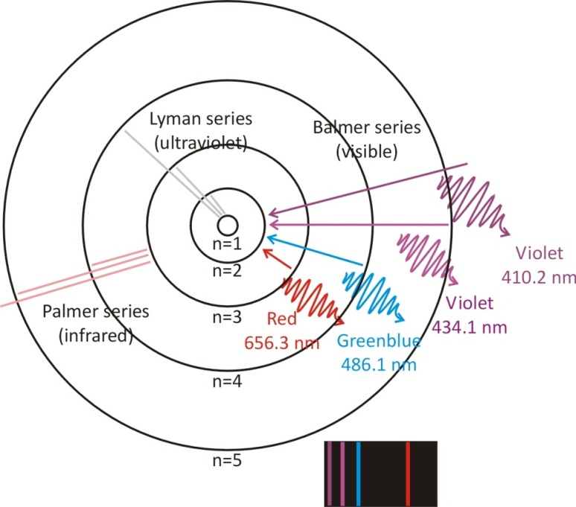R=......................................................................

In the figure on the left you can see the first four possible circles along which the electron wave can move,

for the integer number n = ....... , .......... , .......... , ............ .

The radii of these possible circles are given by the expression: ............................

The further the electron is located from the nucleus, the .................... its total energy will be. When the electron goes from a state of higher energy to a state of lower energy, (or from a circle with radius ................... to a circle of radius ...................... ), a **photon** is produced with energy equal to

ΔE =............................................................................

The integer numbers n1 and n2 identifying a certain transition can be chosen in many different ways. Why do we see only four emission lines of hydrogen?

...................

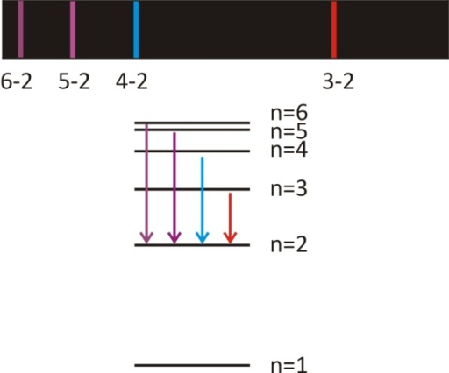

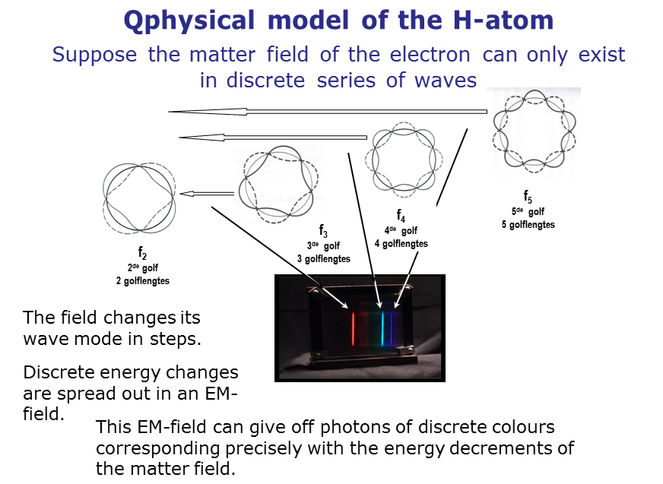

## Three-dimensional generalisation: Orbitals

When an electron is bound to an atom, its **wavelength** must fit **into** a small area. This means that the wave occurs in a limited space: reflected waves should constructively interfere with the original ones. This leads to the quantization of waves, to the quantization of the energies of electrons in atoms.

But De Broglie’s waves are 2-dimensional. In fact the electrons are trapped by the electric attraction of the nucleus which occurs in *three* dimensions. And so the waves must be trapped in 3 dimensions too. It was the Austrian physicist Erwin Schrödinger who started with De Broglie's matter waves, but instead looked for wave solutions in three dimensions. The solutions are 3-dimensional standing waves, which are now known as orbitals. You see the possible electron orbitals of hydrogen in the figure. Schrödinger became famous with what we today call the Schrödinger wave equation.

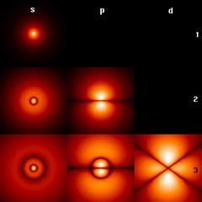

*The first quantum orbitals of the electron around the nucleus of hydrogen. Light colour means a high probability, dark a low one. (Source : Florian Marquardt, Cond. Matter Physics, LMU University München)*

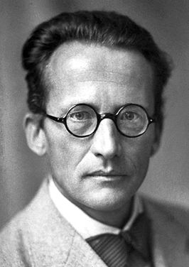The Schrödinger wave equation is a fantastic tool indeed: one can count wave solutions for every chemical element. And so quantum physics is able to explain all electron orbitals of chemistry!. It is even possible to calculate molecular orbitals and thus explain why molecules exist…

*The Austrian physicist Erwin Schrödinger who generalized the De Broglie waves into three dimensional waves, we know today as orbitals. He proposed what we call today the Schrödinger equation which solutions are exactly the possible waves.*

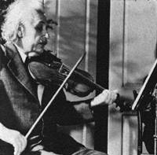

Einstein on the quantum atomic model:

*…discover the major laws of the spectral lines and of the electron shells of the atoms together with their significance for chemistry appeared to me like a miracle and still appears to me as a miracle today. This is the highest form of musicality in the sphere of thought.*

Concepts in Learning Station V

**Complete by adding the missing concepts**

**Classical concepts:**

Standing waves on a string or in a musical instrument.

Discrete series of tones, where the frequency of every tone is an …………… multiple of the ground tone, arise for a confined wave: this is an example of classical quantisation.

Standing waves on a string: the …………………………… (or …………………………) of the surviving waves can only assume discrete values linked to the length of the string by λn= 2 L/ n.

**Quantum concepts**

The wave of the electron matter field in an atom is a “confined wave”. De Broglie assumed that the atomic electron matter wave could exist only in a **……………………** of standing wave configurations.

Quantisation condition for the electron in the hydrogen atom: the …………………………… of the electron should be an integer number of times the length L of its circular path around the nucleus.

Because the electron is also a ………………… according to De Broglie’s hypothesis, and because it moves on a circle, there must be a force exerted on it that acts as centripetal force. This force is the ……………… force exerted by the nucleus.

The quantum atomic model of De Broglie allows making a quantitative prediction of the possible distances between electron and nucleus: these distances are quantized!

The **Bohr radius**, i.e. the smallest possible distance between electron and nucleus in the hydrogen atom, gives the most probable distance between electron and nucleus.

The total energy of the electron is quantized in the atomic model of De Broglie. The further the electron is located from the nucleus, the …………… its total energy will be.

If the electron goes from a state with higher energy to a state with lower energy a photon is produced with energy equal to ……………………………………. The frequency of the photon can be calculated according to the Balmer formula.