Learning station IV: Wave Particle Duality 39
1 Double slit experiment with light of low intensity 39
2 Quantum Theory of light and matter 41
2.a Electromagnetic waves and their energy quanta: photons. 41
2.b Matter waves and quanta 42
3 Quantum Fields 43

Attribution-NonCommercial-ShareAlike 4.0 International (CC BY-NC-SA 4.0)
Under the following terms:
- Attribution — You must give appropriate credit, provide a link to the license, and indicate if changes were made. You may do so in any reasonable manner, but not in any way that suggests the licensor endorses you or your use.
- NonCommercial — You may not use the material for commercial purposes.
You can:
- Share — copy and redistribute the material in any medium or format
- Adapt — remix, transform, and build upon the material
The licensor cannot revoke these freedoms as long as you follow the license terms.
You have to refer to this work as follows:
Frans R., Tamassia L. (2014) Quantum SpinOff Learning Stations. Centre for Subject Matter Teaching, KHLim Katholieke Hogeschool Limburg, Diepenbeek, Belgium

Learning station IV:
Wave Particle Duality

Double slit experiment with light of low intensity
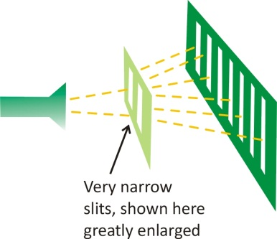
In the 19th century it became clear that light was a wave phenomenon: a wave of electric and magnetic fields. But it soon turned out that this did not exactly revealed the true nature of light. Let us therefore look back to the double slit experiment for light:
We know that light that passes two slits, forms an interference pattern on the screen. As we perceive light as waves, we can explain the formation of that pattern as respectively constructively or destructively superposition due to the different path length to each slit (see learning station II).
In the first learning station we already saw what happens to electrons in a double slit experiment. Can we perceive electrons as particles or should we see them as waves? Why is that?

But let us now consider the double slit experiment for light with very low intensity. We ask ourselves whether it is in principle possible to reduce the intensity of light at a deliberate low level? Einstein gave already an answer on that in 1905: he supposed that there is a physical limit and the intensity of light cannot be reduced without limit: there is a smallest amount of light in nature.
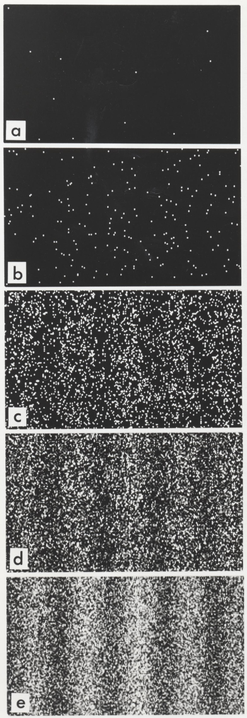
We can observe this if we reduce the intensity of light in the double slit experiment sufficiently (e.g. by using filters): you would expect an ever weakening interference pattern but that isn’t seen. One can observe how the light is arriving spot after spot, quantum after quantum.
At first the quanta of light seems to be arriving totally at random (see pictures a and b). But after a while (typically after a few minutes if you use sufficiently dimmed the light), it becomes clear that an interference pattern is built up. So all the spots, although they arrived one by one, form altogether a pattern!

Can you compare the results of the double slit experiment with electrons (see learning station I), to that of light. Is it comparable or not?

Figure 3 Build-​​up of an interference pattern. The number of detected electrons is 100 (b), 3000 (c), 20000 (d), 70000 (e). (Source: Tonomura, A., Endo, J., Matsuda, T., and Kawasaki, T. (1989) Demonstration of single-​​electron buildup of an interference pattern, American Journal of Physics 57 (2), 117–120)

How can we understand this?
Einstein supposed that the energy of light (or more general the energy of the electromagnetic field) can only be ‘delivered’ in small packets or quanta.
The energy of the electromagnetic field can be issued only in small quanta. In other words the energy of light cannot vary continuously, but only in small discrete jumps, called quanta.
But are these light quanta to be understood as if they were small balls?
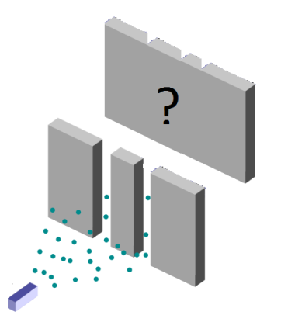
We know already from the first station that shooting little balls or drops through the two slits, causes two "zones of arrival' on the screen. But is this what we observe in the two-slit experiment? Can we perceive electrons or light in the double slit experiment as merely consisting of little balls?
(Yes/No)
Figure 2 The de double slit experiment with particles
(Source: Adapted from Wikipedia Public Domain)

Light does not arrive as particles (which would yield two bands) and not as waves either (which would produce an interference pattern that fades away): the interference pattern is made ​​up particle by particle. It seems that the light particles agree how they will arrive: in an interference pattern of waves. Thus, the light seems to have somewhat of a particle and of a wave at the same time.
Physicists call this unimaginable problem, the wave-particle duality. The strange nature of light is clearly not consistent with the classical view of being either particle or wave.
Wave-particle duality is a fundamental principle of light and matter
In nature, there is apparently a kind of symmetry between light and matter. In quantum mechanics, an electron cannot be viewed as merely a "ball", like in classical physics, and the same holds for a photon. An electron as well as a photon, both have wave and particle characteristics:
Electrons and photons in the 2-slit experiment arrive one at a time,
but the pattern formed by these particles is an interference pattern,
caused by the wave characteristics of these particles!
This wave-particle duality seems to be a fundamental principle in nature. Quantum mechanics has really changed our way of thinking about the nature of the world.
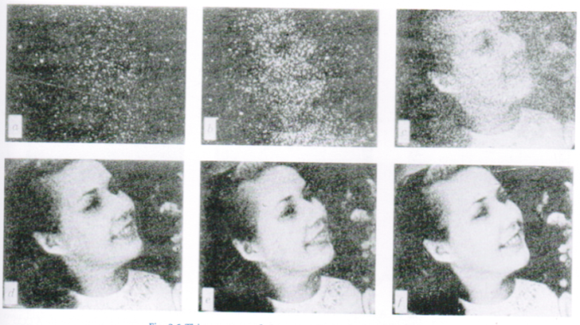
Here you see how a photo is built up also photon by photon (Source: Rose, A (1973) Vision: human and electronic. Plenum Press)

Quantum Theory of light and matter
From the double slit experiment for light in low intensity, it is apparent that light demonstrates wave and .............................. properties.
From the double slit experiment for electrons, it is apparent that electrons demonstrate particle and .............................. properties.
The particle model and wave model are complementary, and the reality is more complex than either of the two models can describe on its own. Wave-particle duality is a new fundamental characteristic of light and matter in physics. It is a characteristic of modern physics as opposed to classical physics.

Electromagnetic waves and their energy quanta: photons.
The energy quanta of light are referred to as photons. Max Planck discovered the precise relationship between the energy of a photon (particle property), and the frequency of the light wave (wave property). With this famous Planck-Einstein relation the size of the energy packages of the electromagnetic field can be calculated:
()
where h is a very small but fundamental constant of nature that indicates the fine granularity of light in quanta: the value of the Planck’s constant h= 6,63 × 10⁻³⁴ J . s

- Calculate the value of the quantum of light for yellow light which has a frequency of f =5 x 10¹⁴ Hz
E =
This is the smallest quantum of energy that can occur in nature for light of this frequency.
- Calculate the energy of three yellow photons:
E =
The energy of yellow light cannot take any arbitrary value but is always a (whole / not entirely) multiple of the photon energy that you calculated above in a). The energy of light is not continuously variable, but is quantized.
But because light consists of an electromagnetic vibrating field, we conclude that the energy of the electromagnetic field itself is quantized. The energy can be issued only by the field per photon, thus in packets.

Matter waves and quanta
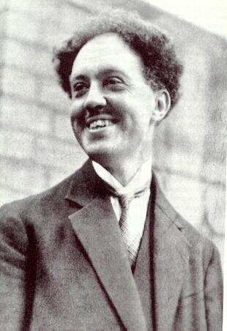
Years before the double slit experiment for electrons was performed, the French physicist Louis de Broglie predicted the wave properties of matter. Louis De Broglie believed in the symmetry of nature: when electromagnetic waves interact in discrete quanta of energy (which we perceive as photons), it was clear to him too that also the opposite will hold: particles of matter, hitherto not considered to be the quanta of a field, should be viewed also in this manner.
The wave of which the quanta we see as particles, he called a ‘matter wave’. De Broglie postulated the existence of such matter waves. In this way he was the first to accept the wave nature of matter. Moreover De Broglie could write down a precise relationship that connected this hitherto unknown matter field to the normal properties of matter like mass and velocity.
In this expression, De Broglie establishes a link between the linear momentum which is also known in classical mechanics as the product of the mass of a particle with its velocity
()
Momentum is a classical property of particles also known in Newtonian mechanics (e.g. a truck at low speed e.g. can have a momentum as large as a small car but with high speed).
On the other hand a property of waves is the wavelength. De Broglie now connects these hitherto incompatible properties of particles and waves in a precise relation:
Wave length
is a property of waves

()
Linear momentum
is a property of particles.

De Broglie's hypothesis connects the particle and wave nature of matter, precisely through the tiny constant of Planck:
The wavelength of (a quantum of) matter is inversely proportional to its linear momentum.
Particles having a large amount of momentum, therefore, have a short wavelength.
For an electron de Broglie relation states: p = h / λ, where p is ......................... of the electron, and λ is the wavelength of the ........................ that is connected to the electron.
How is it that we can observe (e.g. in the double slit experiment) the wavelength of an electron and that we don’t notice the wavelength of a ball? Let us calculate the wavelengths of the two particles with the De Broglie relation.
- Calculate the De Broglie wave length of an electron with a speed of v=6 × 10⁶m/s?
(You need the mass of the electron. Go look it up!) m_{e-}=………………………kg
λ= … ……………
- Calculate the De Broglie wavelength of a ball with a mass m=0,20 kg and a speed v=15 m/s?
λ= …… ……………………
- Compare these two wave lengths with the wavelength of light (look back to one of the previous learning stations where we talked about the electromagnetic spectrum):
The wave length of visible light ranges between ………………
The wave length of a normal ball is ………………than the wave length of visible light.
The wave length of an electron is ……………… than the wave length of visible light.
- What is the reason why we don’t observe the wave characteristics of a normal ball (even not in a sophisticated lab)?

But a matter wave what kind of wave is that? Let’s try to find an answer on that.

Quantum Fields
We saw earlier how scientists felt uncomfortable about the idea of ​​'action at distance' with respect to forces like gravitational or magnetic forces. To make this ‘action at distance’ scientifically sound they introduced the concept of field. Classical fields, such as the electromagnetic and the gravitational field, are considered as "mediators" of forces (or rather energy). In quantum theory, moreover the matter waves (which can be regarded as a matter field) carry energy and the idea of ‘mediator’ of energy stays but is also applied on matter itself which is quite unexpected.
In fact, physicists developed a quantum field theory from which they can derive all we can observe in the universe: matter and forces. Compared to classical fields (like gravitational or the classical electromagnetic fields) quantum fields can issue only energy in discrete packets or "quanta". E.g. all particles measured at particle accelerators like CERN in Geneva, are predicted by quantum field theory.
Quantum fields are, like classical fields, defined in all points of space. They may vary over time as a wave, and in this way they can propagate.
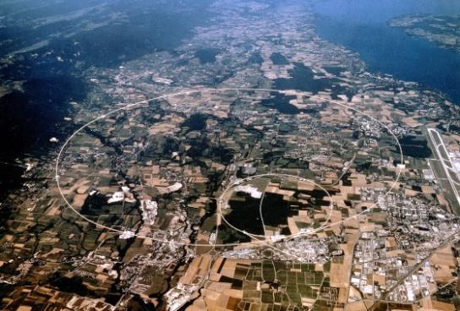
In fact the quantum fields contain energy by vibrating in discrete modes like strings in musical instruments do. Packets of energy are released when the field changes from a higher vibrational state to a lower one. The steps between the modes of vibration are quantised and so only packets can be released when the field changes from a high to a lower state of vibration. The release of such a quantum out of the field is local, and we interpret it by saying that a 'particle' is observed.
For example, a photon may be created as the quantum of an electromagnetic field. But also matter itself, such as electrons and protons are quanta of vibrating matter fields. The electron for instance according to quantum field theory (in English: Quantum Field Theory QFT), is a quantum of the electron matter field.
We can now explain the building up of the interference pattern in the double slit experiment by quantum field theory.
The building-up of a discrete interference pattern in the double slit experiment explained by Quantum Field Theory
The waves of a quantum field can pass through the slits of the double slit experiment and those waves can interfere with itself. Thus, the superposition of both waves (one from each slit) is responsible for the creation of an interference pattern of maxima and minima. Maxima occur on places where the path length difference is such that the wave originating from one slit is in phase with the wave coming from the other gap (constructive superposition). In other places, the path length is such that destructive interference occurs between the two waves.
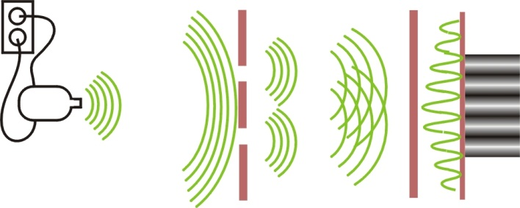
Figure 3 Quantum Field Theory assumes that a field is connected to particles like an electron. The field passes through the slits and interferes (constructively and destructively) on different places. Where the amplitudes are large there is a large chance that a discrete an local energy packet is given off by the field. That is what we observer as a particle.

But where the maxima of the waves are, it doesn’t mean there will be a particle for sure. Here the notion of probability enters quantum theory.
In places where the amplitude of the field is maximal (in the interference maxima), there is just a high probability that an energy packet is released by the field. Thus, in case of the electron double slit experiment, on those maxima there is a high probability that an electron emerges. In the case of a double slit experiment for light, the maxima are places where with high probability a photon can be issued by the field.
The amplitude of the waves are proportional to the probability that a quantum is issued by the field. This fundamental property of probability explains the random appearance of the spots (‘particles’) in the double slit experiments. The precise appearance of an electron cannot be predicted, only the chances.
The wave-particle duality and the probability is treated in Quantum Field Theory as a foundation of new physics where matter and light have symmetric properties. In the modern view of quantum field theory even forces (with remote action, remember) are seen as the result of the exchange of quanta between fields. All these quanta built up the known matter (as we know in Mendeleev’s periodic table) and force fields. In the experiments at CERN this quantum theory of matter and forces is tested and even new physics might be in sight there seeking new answers to unknown phenomena as dark matter and dark energy.
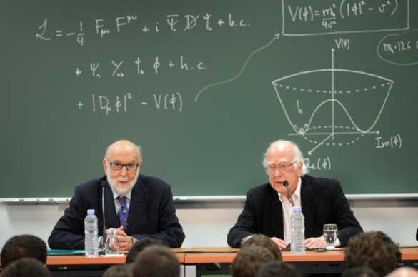
One problem of quantum field theory remains e.g. that the gravitational field (for now) cannot be understood as a quantum field theory, and gravitation is therefore treated as a mere classical field, even in Einstein’s general relativity. Physicists are searching since about 100 years, for a quantum theory of gravity. Everyone hopes that the experimental verification of the Brout-Englert-Higgs boson in july 2012, will give some further look-out on that issue (cf. Nobel Prize in physics for Belgian François Englert and Scotsman Peter Higgs in 2013).
Figure 4 François Englert and Peter Higss after the experimental confirmation of the Brout-Englert-Higgs boson in july 2012 at Cern. They both received nobel prize in December 2013 for physics, for the prediction of this quantum of the BEH-field, they made earlier in the 60’ies. (Source CERN, Geneva)

