Quantum Physics
The physics of the very small
with great applications

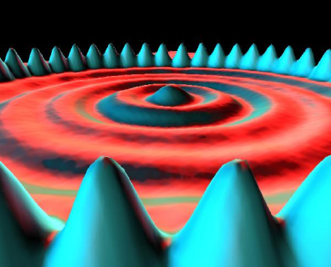

Part 3: HANDS-ON ACTIVITIES
Measuring Planck’s Constant with LEDs

Quantum Spin-Off is funded by the European Union under the LLP Comenius programme
(540059-LLP-1-2013-1-BE-COMENIUS-CMP).
Renaat Frans, Laura Tamassia
Contact: renaat.frans@khlim.be

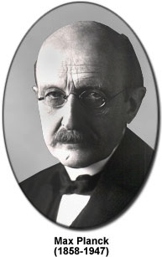
Measuring Planck’s constant using LEDs.

Introduction
Max Planck (1858-1947) was a pioneer in the field of quantum mechanics. Around 1900 he introduced the concept of quantized energy. He postulated that an atom can only absorb and emit energy of certain specific values, given by
$$E=n∙h∙f$$
where n is natural number, f is the frequency and h is Planck’s constant.
In 1905 Einstein used the idea of quantized energy to explain the photo-electric effect. This is the name given to the phenomenon of a metal emitting electrons when light of a specific wavelength is shone on it. He assumed that each of the emitted electrons had absorbed a quantum of energy (called a photon) whose energy is given by
$$E=h∙f=\frac{h∙c}{λ}$$
where f is the frequency of the light and λ is its wavelength. For the electron to be able to free itself from the metal, the energy of the photon needs to be sufficiently high, meaning at least equal to the work done when leaving the metal in question.
Niels Bohr also used Planck’s idea as a basis for a new model of the atom. He assumed that electrons could only move on specific orbits around the nucleus of an atom. When an electron goes from an orbit which is further away from the nucleus to one which is closer to it, it emits light made up of photons whose energy is equal to the energy difference of the orbits.
$$ΔE=h∙f=\frac{h∙c}{λ}$$
Ever since Max Planck postulated the quantization of the energy, there have been many experiments which tried to determine Planck’s constant and corroborate his idea. The current value of Planck’s constant is
$$h=6,6260693∙{10}^{-34}Js=4,13566743∙{10}^{-15}eVs$$
In this experiment you will use LEDs to determine Planck’s constant.
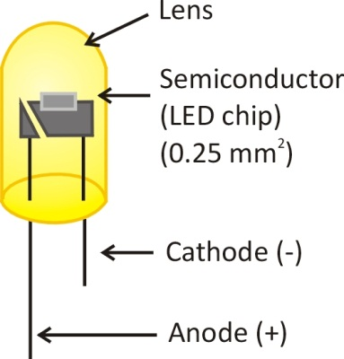
INTERNAL STRUCTURE OF A LED
A LED is made up of two types of semiconductor: p-type and n-type. The n-type has a surplus of free electrons, and the p-type has a surplus of holes. On the boundary where both types of semiconductors meet, the free electrons of the n-type recombine with the holes of the p-type which creates a so-called depletion zone. This zone is negatively charged on the p-type side and positively charged on the n-type side. The recombination causes an electric field on the boundary between the two semiconductors. The electric field in its turn inhibits the movement of free electrons through the depletion zone.
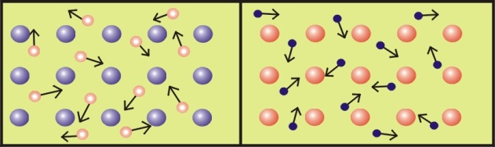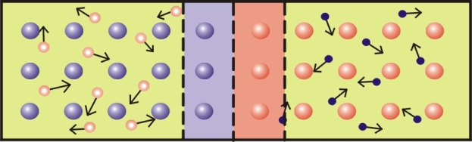
If the LED is connected to a voltage source such that its positive side is attached to the p-type semiconductor and its negative side to the n-type semiconductor AND the voltage is taken sufficiently high to give the electrons enough energy to overcome the electric field in the depletion zone, then electrons can flow from the n-type to the p-type material. There they can recombine with holes.
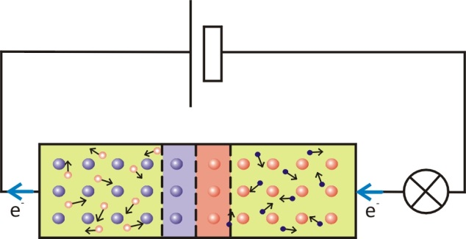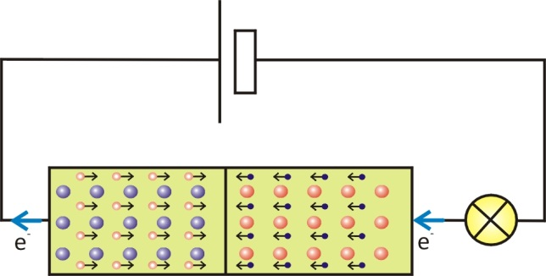

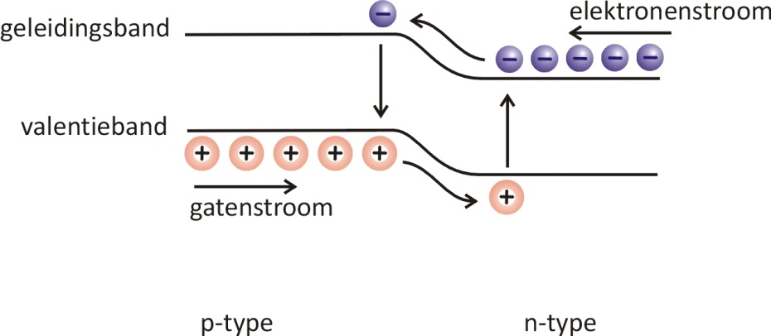
When recombining they go from a higher energy level (the conduction band) to a lower energy level (the valence band), and the energy difference is emitted in the form of light and the LED turns on. The minimal necessary voltage for this to happen is called the threshold voltage.
electron current
hole current
Conduction band
Valence band
The photon which is emitted when the electron recombines with a hole, has an energy $E=h∙f$. This energy corresponds to what the electron received when the voltage source was turned on. During your classes on electricity you learned that this energy is equal to
$$E=e∙U_{0}$$
where e is the charge of the electron $(1,60∙{10}^{-19}C)$ and U₀ is the threshold voltage.
From this it follows that
$$e∙U_{0}=h∙f ⇔ e∙U_{0}=h∙\frac{c}{λ}$$
If you can measure the threshold voltage at which the LED turns on and you measure the wavelength of the emitted light, you now have a formula that you can use to determine Planck’s constant.
Experiment
Research question: How can Planck’s constant be experimentally determined?

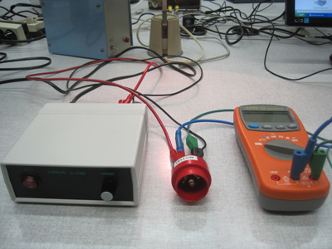
DETERMINING PLANCK’S CONSTANT EXPERIMENTALLY
Materials
- 4 colored LED-lights
- Spectroscope
- Source
- Volt meter
- LED-holder
Question 1:
AT WHAT ENERGY DO THE LEDS TURN ON?
Method
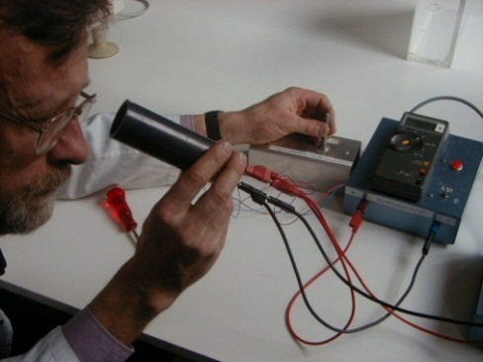
- Connect the source with the volt meter(see figure)
- Place one of the LED-lights in the holder
- Make sure the voltage of the source is 0
- Connect the LED with the source
- Hold the holder close to your eye
- Slowly increase the voltage of the source until you clearly see the LED glowing
- Decrease the voltage until the LED turns off again
- Increase the voltage until the LED turns on again
- This is the threshold voltage necessary to let the electrons pass through the depletion zone. Write down the corresponding threshold voltage for each of the LEDs, and calculate its corresponding energy.

Color LED | Voltage U₀  (V) | Calculate E = U₀.e
blue
green
yellow
red

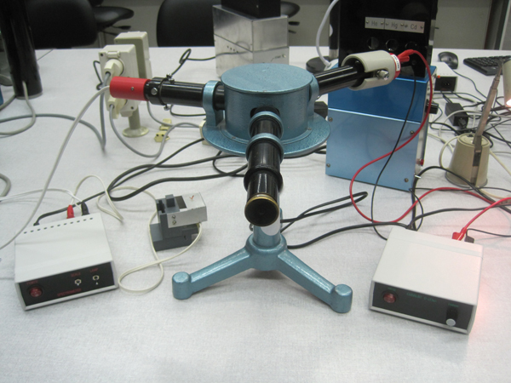
Question 2:
WHAT IS THE WAVELENGTH OF THE LIGHT EMITTED BY THE LEDS?
Method
- Place the lamp with the scale on one side of the spectroscope.
- Turn the source of this lamp on
- Connect the LED with the source
- Place one of the LEDs in the holder
- Make sure the voltage of the source is 0
- Place the LED-holder at the other side of the spectroscope
- Increase the voltage until the LED is on and try to determine its position with respect to the scale.
- Use the calibration curve to determine the wavelength of light emitted by the LED from its position on the scale.
LED | Measurement | Wavelength: λ  (nm)
blue
green
yellow
red

Conclusion questions 1 & 2
We use the formula which was given in the introduction
$$h=\frac{E}{f}=\frac{E∙λ}{c}$$
with $c=3,0∙{10}^{8}\frac{m}{s}$
 | QUESTION 1 | QUESTION 2
LED | E  (J) | $$λ$$  (m) | $$h$$  (Js)
blue
green
yellow
red
Determine the average value for Planck’s constant
h = ___________________________________
Does this correspond to the theoretical value? Do you find the correct order of magnitude?

Conclusion & Reflection
____________________________________________________________________________________________________________________________________________________________________

Bibliography

M.F. Crommie, C.P. Lutz, D.M. Eigler. Confinement of electrons to quantum corrals on a metal surface.Science 262, 218-220 (1993).

This activity is partially based on the “bridge project” of the University of Antwerp, department of Physics (Prof. dr. J. Dirckx, W. Peeters)

