Learning station III: What oscillates with light? 38

1 Mechanical waves 38

1.a Source of mechanical waves 38

1.b Medium needed? 38

1.c Propagation and displacement in the same direction or in a different direction? 39

1.d Do the particles travel along with the wave? 40

1.e The source of light waves 41

2 Light: what’s shaking? 42

2.a Force(fields) that can travel through empty space 42

2.b Fields that change in time: waves of a field 44

2.c Electro*magnetic* waves 45

3 The electromagnetic spectrum 47

4 A sea of electromagnetic waves 47

5 The atomic model of Rutherford will indeed collapse 48

6 Concepts of Learning Station III 48

http://i.creativecommons.org/l/by-nc-sa/3.0/88x31.png**Attribution-NonCommercial-ShareAlike 4.0 International** (CC BY-NC-SA 4.0)

Under the following terms:

* Attribution — You must give [appropriate credit](https://creativecommons.org/licenses/by-nc-sa/4.0/), provide a link to the license, and [indicate if changes were made](https://creativecommons.org/licenses/by-nc-sa/4.0/). You may do so in any reasonable manner, but not in any way that suggests the licensor endorses you or your use.
* NonCommercial — You may not use the material for [commercial purposes](https://creativecommons.org/licenses/by-nc-sa/4.0/).

You can:

* Share — copy and redistribute the material in any medium or format
* Adapt — remix, transform, and build upon the material

The licensor cannot revoke these freedoms as long as you follow the license terms.

You have to refer to this work as follows:

Frans R., Tamassia L. , Andreotti E. (2015) Quantum SpinOff Learning Stations. Art of Teaching, UCLL, Diepenbeek, Belgium

# Learning station III: What oscillates with light?

Light is a wave, you should be convinced by now. But a **wave of what?** We hope to come closer to the true nature of light waves: what kind of wave is light?

First we look at mechanical waves like we see on a rope, in water or the waves that we hear as sound waves. Then we’ll examine the properties of such waves and determine if they can hold true for light as well.

## Mechanical waves

### Source of mechanical waves

To start with, think of a wave on a rope. How can you get a wave on a rope? What is the origin of the wave?

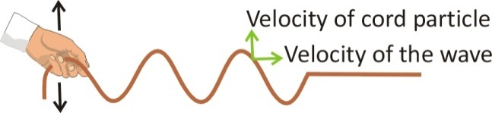  
When you look at a small section of rope, how does it move as the wave travels along the rope?

It is indeed the original vibration that propagates, but the rope itself doesn’t propagate...

Likewise every sound originates in a vibration at its source. For example, what vibrates when you hear the sound of

a guitar?

a piano?

a motor?

But the air particles don’t propagate. It is the vibration of the **sound** that propagates,creating a sound *wave*. Let’s examine this further.

### Medium needed?

The **vibration** can **propagate** through the rope, because the molecules in the rope are connected.

Do you always need a medium through

which the wave can propagate?

Does sound need a medium?

If you were to vibrate a guitar string in a vacuum, would you hear anything?

*Yes/No* Why or why not?

A sound wave can only propagate when the vibrations in the air are passed further from one molecule to the next. Indeed, sound waves need a medium to propagate.

Mechanical waves need a medium

Does light need a medium?

But **light** can travel through a **vacuum**, or not?

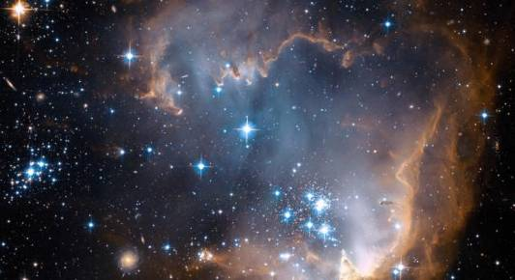Think of the space between the **sun** and the **earth** or the **stars**: there is no air and virtually no matter: it is empty. Yet we can still see light from the sun and stars! Apparently light can travel *through empty space*. But if so, what kind of wave is light?

Think of the many forms of **wireless** **communication** we use on a daily basis, such as Wi-Fi or the signals of our cell phone or gps networks. They carry information from one place to another through waves. Do these waves have the same characteristic as light in the sense they don’t need a medium?

Can these signals also propagate through a vacuum, or do you need air or some other medium?

### Propagation and displacement in the same direction or in a different direction?

When a vibration propagates through a medium or space, there are two kinds of waves. The wave can propagate:

1. perpendicular to the displacement of the vibration

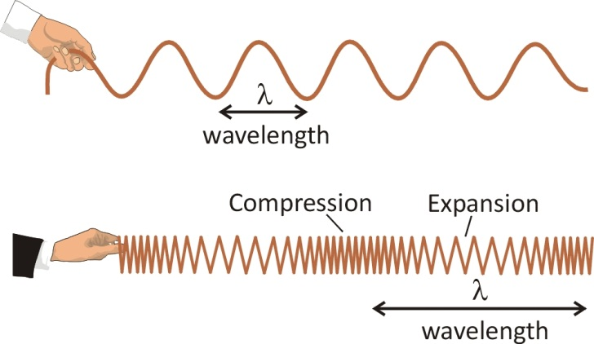

A source vibrates (vertically) and causes nearby particles to vibrate along. You see the wave that is created in the horizontal direction. So the direction of movement of the vibration is (in the same direction as/perpendicular to) the direction of travel of the wave. This is called a **transverse** wave.

1. parallel to the displacement of the vibration

**

This time the direction of movement of the vibration is (in the same direction as/perpendicular to) the direction of travel of the wave. This is called a **longitudinal** wave. It has areas of expansion and compression.

Are sound waves transverse or longitudinal?

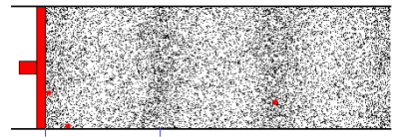

Figure 18:   
A sound wave is produced in the air by particles more or less being pressed together.   
This pressure wave propagates longitudinally.  
(Source: Educational Materials of The Institute of Sound and Vibration Research, Southampton, UK)

Now it’s not so easy to figure out if light, that apparently doesn’t need a medium to propagate, is a transverse or longitudinal wave. So, let’s examine which kind of travelling vibration is light.

### Do the particles travel along with the wave?

Can you tell, for sound waves, if the vibrating air particles actually travel along in the direction the wave is moving?

Check this out in the animations of longitudinal and transverse wave on the isvr website <http://resource.isvr.soton.ac.uk/spcg/tutorial/tutorial/Tutorial_files/Web-basics-nature.htm>

The particles go back and forth locally, but they have no net movement. A wave is a kind of **disturbance** that propagates. It’s the energy of the displacement that is continually transported and indeed the **energy** moves along the wave.

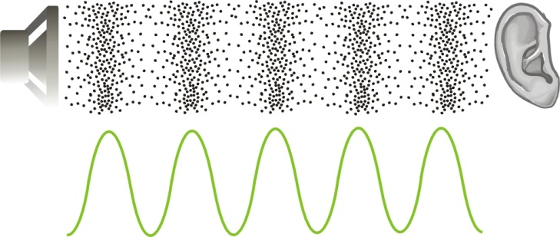

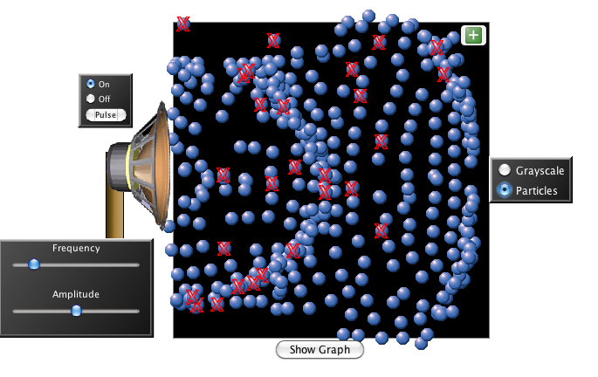For instance in a sound wave, the particles vibrate around their equilibrium position. It is the disturbance that travels: the energy of the vibration is passed on by the air particles and finally causes your eardrums to vibrate. This is illustrated by this Phet-animation. <http://phet.colorado.edu/en/simulation/wave-interference>

### The source of light waves

#### So sound originates from a vibration. And when that vibration travels through the air, you get a sound wave.

If light is a wave, we can assume *that it also originates as some kind of* ***vibration***. But which kind? It’s not that easy to visualize that. But the Dutch physicist Christiaan Huygens realized that – if light is indeed a wave phenomenon – it must also originate from a vibration.

Huygens proposed that light – because it most commonly comes from hot objects (a candle, hot glowing metal, smoldering wood…) originates from the **severe vibrating of the particles** in the hot material.   
He supposed the vibration frequency of light would be much higher than that of sound.

|  |  |
| --- | --- |
|  | http://t0.gstatic.com/images?q=tbn:ANd9GcTq8q2_tNASGPG9THkcmz3w-cVRYQsiUAHc786fQsctEtMmEX4u |
| *A hot object, like the sun or hot metal, shines light.* ***Could the vibrations of particles in the material be the source of the light waves?*** | |

Take for example a metal that you hold in a flame: Does the color tells you if it is hot or very hot?

What can you deduce from the colors of stars?

Red stars are cool, with temperatures of around 3,000 kelvins (K), while blue stars are hotter and can have temperatures over 30,000 K. Our own lovely yellow Sun's temperature is a comforting 6,000 K.

At the upper left of this picture you see the constellation of Orion. The cool red supergiant Betelgeuse stands out from the other, hotter, bluish stars composing the body of the constellation. Bright Rigel, a blue supergiant, is at the lower right of the constellation. Can you find them?

*The Orion constellation above the Nemrut Dagi mountain in Turkey. Source: Astronomy picture of the Day, Nasa*

**Exercise**:

#### What are the vibration frequencies of visible light? (Look it up)

#### Was Huygens correct in assuming that light has a very high frequency of vibration? (Yes/No)

How many times greater is the frequency of visible light compared to that of a tone of 440 Hz (which is a la or A note in music)?

So, hotter objects send out light of a higher (REDDER/BLUER) frequency than cooler ones. Huygens’ supposition that the vibration of some kind of particles in matter causes the emission of light. The hotter the material is, the faster the particles can vibrate.

But once the light wave has left matter,   
what is vibrating in the light wave while it is travelling?

## Light: what’s shaking?

Because light does **not** **need a material medium** to propagate, it can’t be rooted in a mechanical vibration like sound waves or waves on ropes.

You can’t put light in your pocket, can you? So we are looking for physical quantities that are not bound to matter. Physical quantities exist that are not material: *fields*. It might be a good assumption that light could arise from a *changing* field; a vibration of the field. Are you aware of the existence of fields that don’t need a medium, and can they indeed travel through empty space like light does? Let us look around for these fields that can fill space.

### Force(fields) that can travel through empty space

#### The magnetic field

Remember your childhood days, and how fascinating it was to play with magnets. When you hold two magnets a certain distance apart, you can feel the **force** they exert on each other. 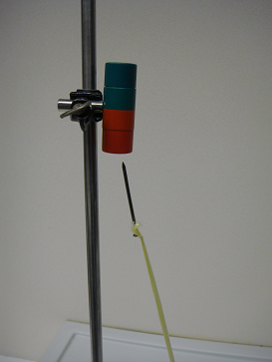  
Do the magnets need to be in **contact** in order to transfer the force??

Will magnets also exert a force on each other if they are in a **vacuum**? *Yes/No*

*A nail attracted by a magnet without contact*

The magnetic force doesn’t need to be transferred through a medium. The magnet induces a magnetic field. The area around the magnet will get a new physical property, the magnetic *field*.

If a nail or such is placed in spot where the field is present, a force will transpire. This force doesn’t need a medium, it is induced by the field itself and the force can be exerted **from a distance without contact**.

#### The electric field

You’ve almost certainly seen how you can attract your hair to a (nylon) comb without making contact. Here we’re dealing with an electric force. This is also a force that works from a distance *through a field*. Your hair doesn’t need to make contact with the comb.

Between the hairs, there is an electric repulsive force that also works without making contact!

There is an **electric field** around the comb and between the hairs. And wherever there is an electric field, an electric force can occur that works *from a distance without making contact*.

#### Other fields: gravitation

Besides the electric and magnetic field, there is maybe the most obvious field of all: the gravitational field.   
Of what force is it the cause?

………………………………………………………………

In 1687, Newton already determined there was a universal gravitational force between masses like the sun and the Earth for example.

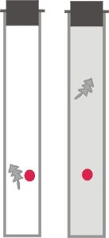Is this also an example of a force that is the result of a field? Yes / No

Does this force work in a vacuum or does it need a medium?

…………………………………………………………………

Do objects still fall in a vacuum?

*……………………………………………………………………………………………………*

#### Field a fundamental concept!

Initially physicists struggled a lot with the idea of “actio in distans”, a force working from a distance through ‘nothing’. But they fundamentally embedded this idea in the concept of a “field”. Since then the concept of field never left physics again and fields are at the center of every physical theory ever since.

Name 3 forces that are the result of a *field*, and that also work in a vacuum:

1. ………………………………………
2. ………………………………………
3. ………………………………………

!

Fields can have sources. For example masses are sources of gravitational fields, charges are sources of electric fields and magnets or electrical currents are sources of magnetic fields.

Around the source you get an area where the field is present. The **force** is the **result** of the presence of a **field**.

### Fields that change in time: waves of a field

So could light be a wave of a changing electric and magnetic field?

Until now, the fields we’ve described don’t vary in time: they are static fields.

**Example: the electric field**

If the source of the field is stationary, the field is static. Here is an example, a representation of the repulsive field around a positive charge. Physicists draw imaginary field lines which indicate the presence of a field.

If you would place a second positive charge in the field, a repulsive force would arise in the direction of the field lines.

**Example: the gravitational field**

If you place a mass in this gravitational field, it will experience a gravitational pull towards the Earth.

But is it conceivable that the strength of a field changes in time? How can this be done? Maybe we have to make the source of the field move?

**Antennas revisited:**

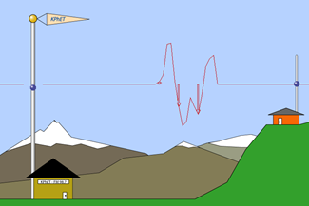An accelerating charge in an antenna, emits radio waves. If needed, look again the Phet applet of the emitting antenna: [phet.colorado.edu/en/simulation/radio-waves](https://phet.colorado.edu/en/simulation/radio-waves).

So what is vibrating in the antenna?

The charge is the source of field. Which kind of field?

Due to the vibration of the charge, the electric field is (static/ not static). So the direction of the field is continuously changing. Now it is this change, that propagates further in space as a wave. A wave of a changing electric field.

**Vibrating charges:**

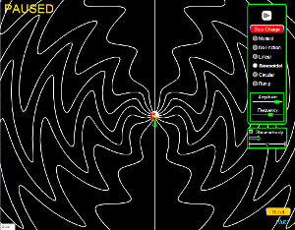Experience further how you can vary a static electric field in time with the following Phet-applet. <http://phet.colorado.edu/en/simulation/radiating-charge>

So vibrating charges can produce *waves* in the otherwise static electric field!

Can you now think of a real experiment to make an electric field that varies in time in order to observe the effects of a ‘waving field’? (Hint: start with some object you can put an electric charge on)

…………………………………………………………… ……………………………………………………………

**Experiment:**

If you move a (negatively) charged comb, back and forth, you can make a piece of paper wobble from a distance!

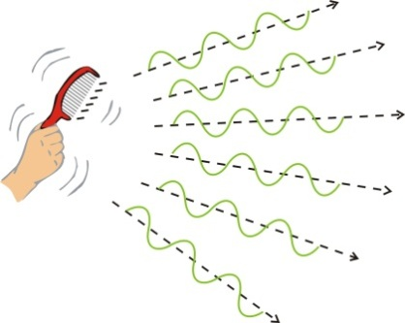

This too can be clarified by assuming the field induced by the charged comb can vary in time. It explains the observed movements of the piece of paper.

An oscillating field is perfectly conceivable:   
the wave of the field can propagate in vacuum,   
because the field itself could already exist in a vacuum.

### Electro*magnetic* waves

Until now, we’ve talked about electric and magnetic fields as if they were two unconnected things. But the Danish scientist Oersted discovered in 1820 ‘by accident’ that a wire carrying an electric current (so a changing electric field) caused a magnetic field around it.

**Experiment:**

Try to verify this by placing fine iron filings on a card and sticking a wire through the middle of the card. When a sufficiently strong DC electrical current is passed through the wire, the iron filings align to show the magnetic field.

Alternatively 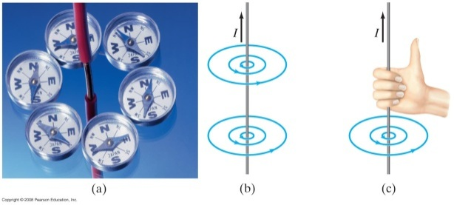you can notice the emergence of a magnetic field around the current carrying wire, by placing small magnets around the wire.

In 1831 Michael Faraday was able to show the opposite: a changing magnetic field could induce an electric field.

**Experiment**:

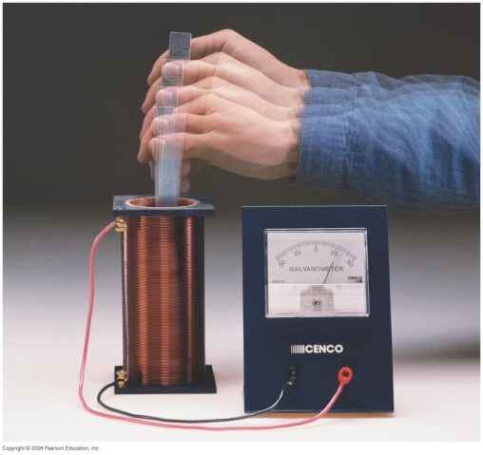You can try this too. Ask for a sensitive amperage meter, a coil and a magnet.

Do you induce a current when you hold the magnet still?

Do you induce a current when you shake the magnet?

An electric field that changes in time   
produces a magnetic field   
and vice versa   
(a magnetic field that changes in time, produces an electric field)

it was the Scottish physicists James **Maxwell** that could affirm this in a theory of electromagnetic waves: *electric and magnetic fields that vary in time actually induce each other* and thus cause each other’s propagation:

Therefore *waves from an* *electric field can’t exist without magnetic waves occurring too* and vice versa.

Physics has also shown that the two fields of an electromagnetic wave (the electric field and the magnetic field) are perpendicular to each other (see figure)

It turns out that light itself is a propagating electromagnetic wave*.*

Newton assumed that variations in the field were instantaneous. Since Einstein's theory of relativity, we know that the propagation of a field occurs at the **speed of light** at the most. The information that a star or a charged particle has changed position is “communicated” through the field, through the changes of the field (and this at light speed!)

Information about a change in a field   
can be transported from one place to another   
by means of **a wave in that field**.

This form of **energy transfer**, **through a field**, is utilized daily when you use Wi-Fi, call on your cell phone or turn on your radio.

## The electromagnetic spectrum

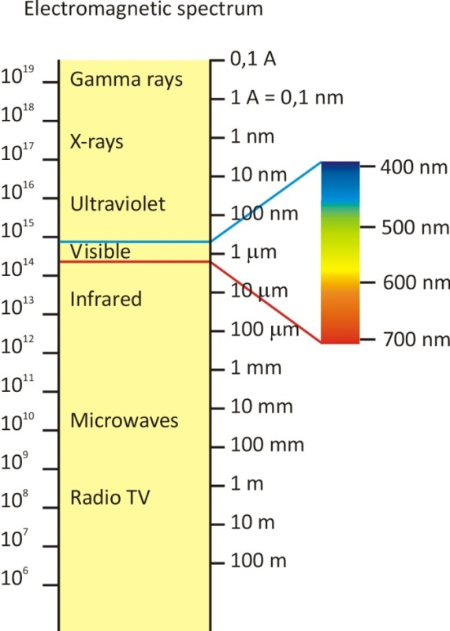In fact visible light turns out to be just a special case of a broader spectrum of electromagnetic waves. The radio waves that carry the music to your radio, the microwaves in your microwave oven, the waves that are used by your cell phone and Wi-Fi networks, these are all electromagnetic waves.

All these waves are physically the same. So then **what is the difference between light, radio waves, microwave**... etc.?

……………………………………………..

Check out the figure, it shows a diagram of all the electromagnetic waves.

Arrange the following wave in ascending order according to the wavelength:

Visible light, radio waves, UV, gamma-rays, microwaves

*…………………………………………………………*

## A sea of electromagnetic waves

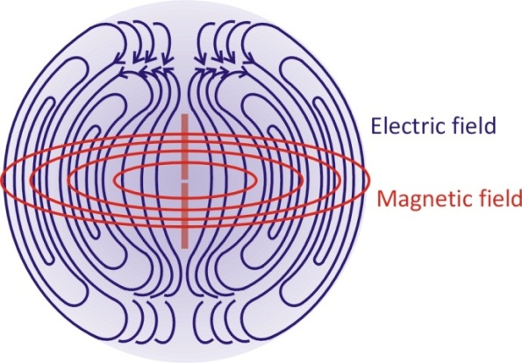We are actually living in a “sea” of electromagnetic waves, most of which we can’t even see or feel. Our detector, the eye, is only sensitive to a specific interval of wavelengths. These electromagnetic waves are therefor called visible light.

Electromagnetic waves can be induced by **shaking** an electrically charged comb for example, but also by an **antenna** where the **charges move back and forth** in a piece of metal wire. 50Hz radio waves are very typical because we are continually surrounded by a 50Hz alternating current.

The following figure shows a sketch of an antenna and how the electric (blue) and the magnetic (red) fields spread out in 3 dimensions due to an alternating current.

*Figure 20:   
An electromagnetic wave is comprised of an* ***oscillating******electric*** *field and perpendicular to it, an* ***oscillating******magnetic*** *field, with the same periodicity.*

Finally we know what’s shaking with light waves... How would you answer the question: What oscillates with light?

Why can light propagate in a vacuum?

## The atomic model of Rutherford will indeed collapse

You know that in the classic atomic model of Rutherford the electron circles the nucleus. As you now better understand : the electron is a charge, and a circling charge is accelerating, or – seen from a distance – vibrating. Vibrating or accelerating charges emit electromagnetic waves. So if electrons were really circling the nucleus, they would be radiating ‘light’ all the time. As mentioned already in learning station I, this is not possible. Why?

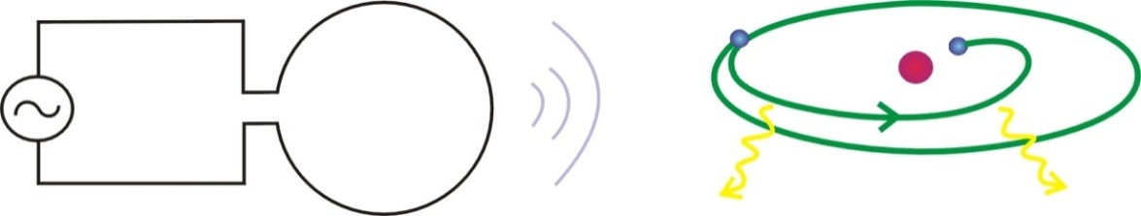

So the very existence of atoms cannot be explained by classical physics. As you will see in the next two learning stations, it is only quantum physics that can explain the existence of atoms and molecules, all be it in some new meaning.

An electron circling around the nucleus in an atom will continuously emit electromagnetic waves.  
(Figure source: EDN, March 2000)

## Concepts of Learning Station III

**Complete by adding the missing concepts**

**Classical concepts:**

A wave is a ……………………. that propagates.

The concept “field”. Electric, magnetic, gravitational fields.

Light is a propagating …………………………… wave.

**Quantum concepts:**

None