Quantum Physics

The physics of the very small   
with great applications

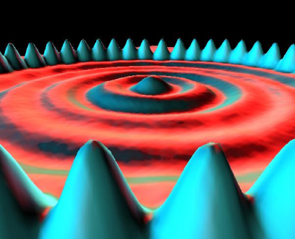

Part 3: HANDS-ON ACTIVITIES

Discrete emission spectra

http://i.creativecommons.org/l/by-nc-sa/3.0/88x31.png

Quantum Spin-Off is funded by the European Union under the LLP Comenius programme   
(540059-LLP-1-2013-1-BE-COMENIUS-CMP).  
Renaat Frans, Laura Tamassia   
Contact: [renaat.frans@khlim.be](mailto:renaat.frans@khlim.be)

## DISCRETE EMISSION SPECTRA

## RESEARCH TOPIC: Determine the wavelengths of the discrete emission lines of He

**Part 1: Introduction  
Maxwell predicted that light was a transversal electromagnetic wave**

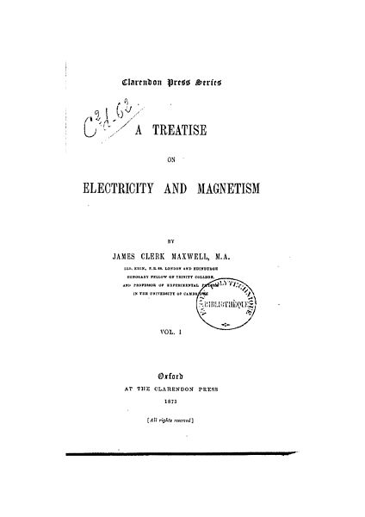A Scottish physicist named James Clark Maxwell made a prediction in the 19th century which at that time was not yet experimentally observed: each electric and/or magnetic disturbance propagates as a transversal wave (and not a longitudinal wave as many of his contemporaries thought). The electromagnetic wave was a solution of his 4 equations which describe the behavior of electric and magnetic fields!

The equations of Maxwell predicted that a change in electric flux would induce a magnetic field which is perpendicular to the electric field. In turn the induced magnetic field would create an electric field, which in turn would create a magnetic field, etc. This is shown in the figure below, where an alternating current is sent through an antenna (first the current I flows upwards and then downwards). The current creates a magnetic field ( points in and out of the surface of the paper), which induces an electric field perpendicular to it. This changing field propagates in space.

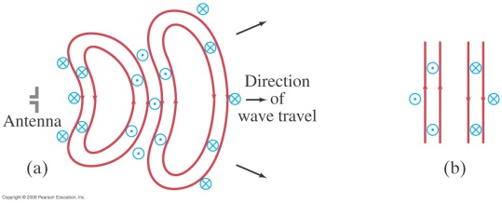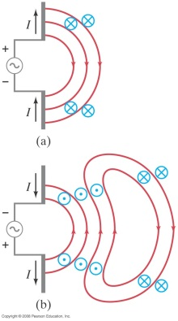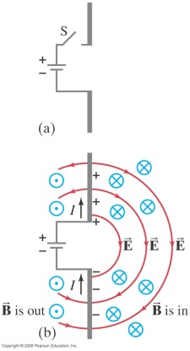

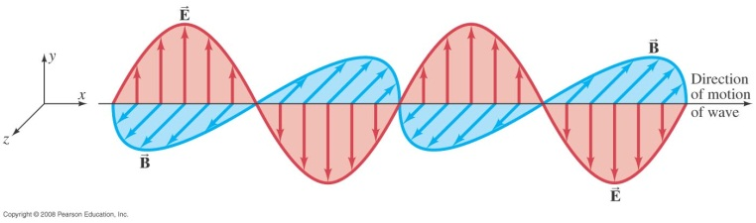

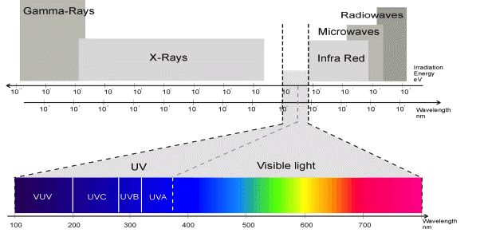It follows from Maxwell’s equations that the waves propagate with the speed of light (approximately 3,0 108 m/s). We thus get a complete spectrum of electromagnetic waves with differing wavelengths (in ascending order of wavelength): gamma-rays, X-rays, ultra-violet, visible light, infrared, microwaves, radio waves. The spectrum is shown below. You can see that that our eyes are only able to observe a small part of the full electromagnetic spectrum.

The wavelength of the visible light determines the color that our eyes perceive.  
Order the colors in descending size of wavelength: yellow, blue, red, violet, green

……………………………………………………………………………………………………………

**Characteristic light of the elements**

It was discovered in the 19th century that the chemical elements from the periodic table like Hydrogen (H), Helium (He), Mercury (Hg), etc. emitted light of colors which were distinctive of that element. The observed color is so unique that just by looking at it you could tell which element emitted it.

This property of the elements is used in the development of gas pressure lamps, fireworks,…

*Lamp filled with the element Potassium  
as used on the Belgian highways*

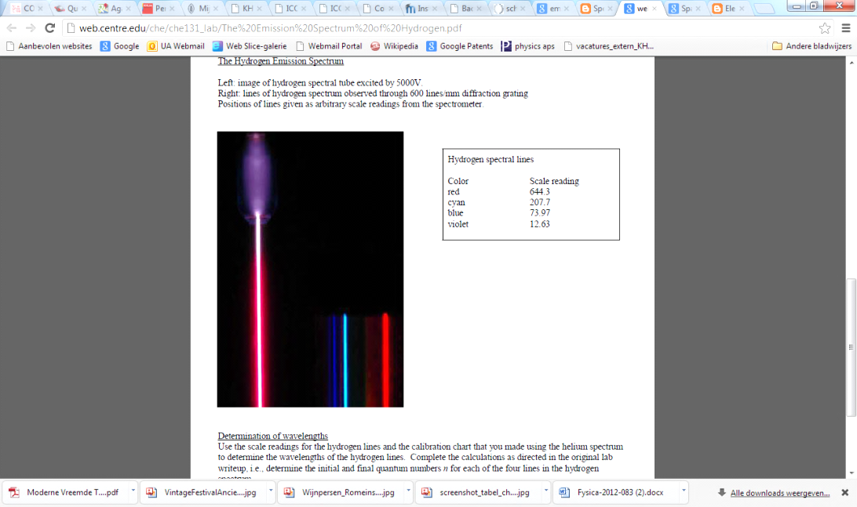By using a prism you can separate the emitted light into its constituent colors and see which wavelengths (colors) are emitted by each element. You are thus measuring the emission spectrum.

*The figure shows a gas pressure lamp filled with Hydrogen H and next to it the measured emission spectrum when the light is separated into its constituents.*

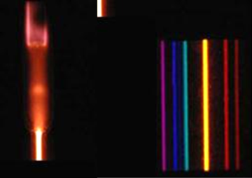 *The figure shows a gas pressure lamp filled with Helium He and its emission spectrum.*

The emission spectrum of each element is unique which allows us to determine the chemical compositions of a material by measuring its emission spectrum. This is for instance used to determine the chemical composition of stars without actually going there, or to determine whether your ‘golden’ ring is really made of gold.

**What is it in atoms that emits light?**

The fact that each element has its characteristic emission spectrum must somehow be related with its unique internal structure: each element has a different number of nucleons (protons and neutrons) in its nucleus and a different number of ………… around it. It is improbable that the nucleus plays an important role in the emission of light. Because light is a propagating electromagnetic wave it seems logical that the motion of electrically charged electrons somehow gives rise to these waves.

Fast motion of electrons could give rise to radiation of high frequency, while slower motion could give rise to radiation of lower frequency.

**Discrete emission lines finally explained by quantum atomic model**

That elements had discrete emission lines was already known in the 19th century. Niels Bohr who worked as a young student in Rutherford’s lab in Cambridge at the beginning of the 20th century, was confused by the inability of Rutherford’s atomic model to explain these emission lines.

It is a remarkable fact that there is no emission in between these emission lines. In Rutherford’s atomic model, the electron moves around the nucleus analogous to the way the planets move around the sun. In such a model an electron would be able to emit electromagnetic radiation with a continuous range of energies. It suffices to increase or decrease the speed of the electron by any amount to emit radiation with energy equal to the change of its kinetic energy. In Rutherford’s model an electron that emits radiation would lose energy. And because of the law of conservation of energy it would move more slowly thus bringing it closer to the nucleus. Such an electron would fall into the nucleus within a very short time span.  
In other words, Rutherford’s atomic model was not only unable to predict the discrete emission lines, but was actually predicting that atoms could not exist in a stable way because the electron would collapse into the nucleus within a very short amount of tile.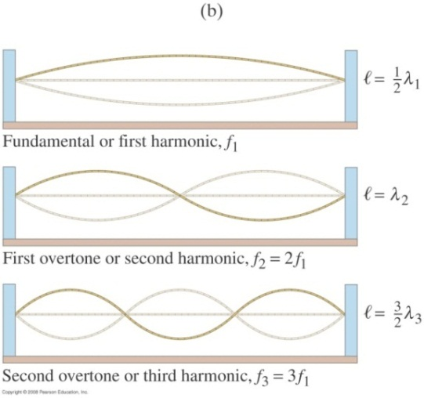

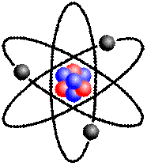

Louis de Broglie was intrigued by the similarity between the emission lines which correspond to a specific set of energies and the discrete possible vibrations mode on a string, the so-called standing waves.

It was only when de Broglie assumed that electrons also behave like waves that it became possible to understand that similarly to vibrations on a string, not all vibration modes of an electron in an atom are allowed, but only a discrete set among them.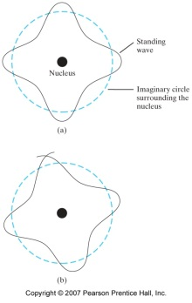

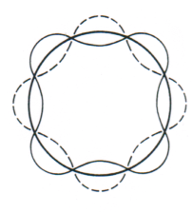The electron wave in de Broglie’s model moves in a circle around the atomic nucleus.   
In the string of a violin there can only exist waves out of a countable set because all the other ones interfere destructively with themselves. So can a bounded electron only exist in a countable number of wave modes around the nucleus.

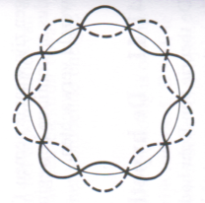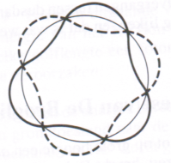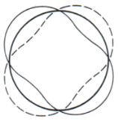

*1 wavelength 2 wavelengths 3 wavelengths 4 wavelengths 5 wavelengths*

*Possible standing electron waves around the nucleaus of a Hydrogen atom in de Broglie’s quantum atomic model: from one full wavelength to five full wavelengths. Any other possibility cannot exist because it would interfere with itself destructively.*

**Discrete emission lines explained by quantum theory**

When an element receives energy (for example by putting it in high voltage as is done in a spectral lamp), the electron waves in the atom will vibrate with a higher frequency and thus have more energy.

The electron waves in de Broglie’s model can only vibrate in discrete modes. As a consequence, the energy of the electrons can only take certain values: it is quantized.

An electron wave which vibrates at a high frequence (i.e. high energy) can give up some of its energy. Because the allowed vibration modes are quantized, it can only give up energy corresponding to the energy difference between the allowed vibration modes. It can for instance go from the 3rd vibration mode to the 2nd, from the 4th to the 2nd or from the 5th to the 2nd. During such a transition the electrons gives away an energy ΔE which is radiated in the form of a vibration of the electromagnetic field: an electromagnetic wave (i.e. light). The more energy is radiated, the higher the frequency is of the emitted light. Indeed, Max Planck discovered that the energy of the electromagnetic wave is proportional to its frequency, according to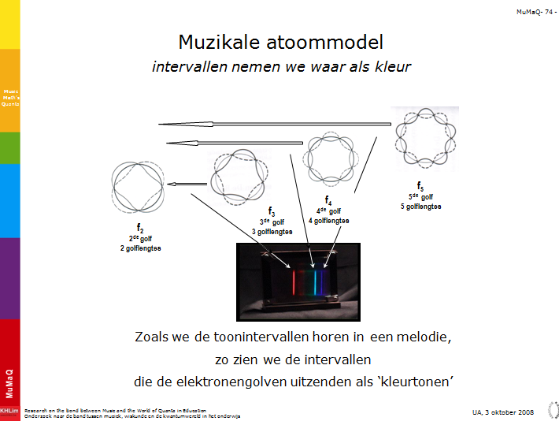

$$ΔE=h∙f$$

Here h is a very small constant of proportionality which is known as Planck’s constant (he discovered it in 1900)

$$h=6,6260693∙{10}^{-34}Js$$

The energy packet emitted by the electron is transmitted as an electromagnetic wave of energy h.f. Because the color of light is determined by its frequency, it is eventually the transition of the electron that determines the color of the emitted light.

If the electron goes from its 3rd vibration mode to its 2nd mode, only a small amount of energy is emitted: a red photon is emitted. The f of red light is relatively (low/high).

Going from the 4th to its 2nd mode a larger amount of energy is emitted, creating a turquoise photon.

The transition from its 5th mode to its 2nd corresponds to an even larger energy and radiates a blue-violet photon.

The energy transitions can correspond to very small or very large amounts of energy such that we cannot observe the emitted photons with our eyes. The electron emits for instance photons in the infrared or in the UV range of the electromagnetic spectrum.

In this way the quantum atomic model can accurately predict and explain the existence of the discrete spectral lines. The assumption that particles such as electrons, protons, neutrons and even whole molecules also behave like waves turned out to be a fundamental property of nature.

In learning station 7 we will calculate the wavelength of the emitted photons up to 4 decimals using de Broglie’s quantum model.

Why does each element have different spectral lines?

Each element has its own “ladder” of energy levels where transitions can occur. Each gas has its own **spectral lines because the energy levels of the electrons are different for every element**.

**PART 2: EXPERIMENT**

## Determine the wavelengths of the discrete emission lines of He

In this experiment we will measure the discrete wavelengths of He.

It is not possible to determine the constituent colors of light with the naked eye. A spectrometer separates a light beam into its constituent colors (using a prism), so that the different wavelengths can be observed separately. The lines are projected on a scale which is calibrated so that it can be read out in nanometers. In this way the different wavelengths of the spectral lines are determined.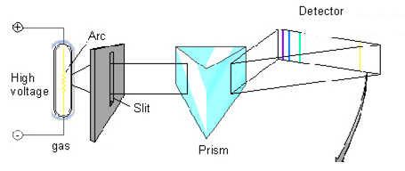

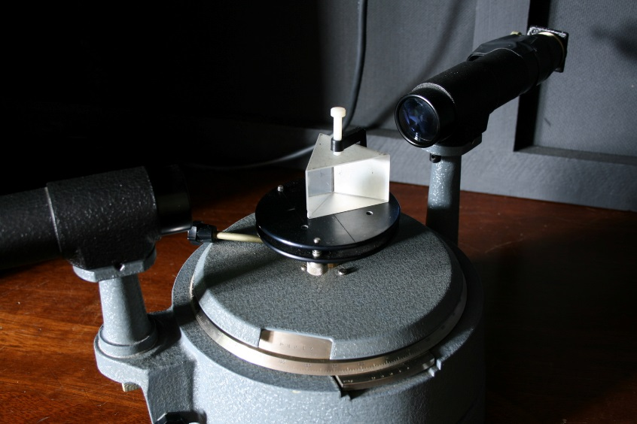The He sits in a tube which can be placed in high voltage.

Spectrometer

http://labs.physics.dur.ac.uk/level1/projects/spectrometer.php **Method:**

1. Turn the source of the lamp on (wait a minute for the lamp to warm up)
2. Look through the eyepiece at all the spectral lines of He
3. Move the eyepiece left and right to be able to see all the lines
4. Write down the position of the lines on the scale. The scale itself is projected in the eyepiece using a lamp. Turn on the source of the lamp.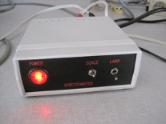
5. Fill in the table
6. Write the corresponding wavelength in nanometer using the calibration graph for your spectrometer. The spectrometers are labeled.

Measurements:

|  |  |  |  |
| --- | --- | --- | --- |
| Color of the line | Relative intensity (1=weak, 3= very strong) | Position on scale | Wavelength *λ* (nm) (Use the calibration graph of the spectrometer) |
| Red  Red  Yellow  Green  Green  Green-blue  Violet  Violet | 1  3  3  1  2  2  1  2 |  |  |