Learning station II: What is light? 22
1 Is light made up of a ray of particles? 22
1.a Newton’s particle theory of light 22
1.b Foucault’s experiment compared the speed of light in air to that in water 25
2 Is light made up of waves? 26
2.a The assumptions of Christiaan Huygens 26
2.b How are light rays able to cross each other? 26
2.c Which type of displacement occurs when separate waves come together? 27
2.d Wave front, wavelength, period 28
2.e Speed of a wave 29
3 How Huygens explained the properties of light 29
3.a The Huygens principle 29
3.b Explaining reflection and refraction using wave theory 30
3.c Explaining diffraction using wave theory 31
4 The 2-slit experiment for light as waves 33
4.a Why do minima and maxima occur in the 2-slit experiment? 33
4.b Different distance, different phase 34
5 Diffraction fringes 35
6 Concepts in Learning Station II 36

Attribution-NonCommercial-ShareAlike 4.0 International (CC BY-NC-SA 4.0)
Under the following terms:
- Attribution — You must give appropriate credit, provide a link to the license, and indicate if changes were made. You may do so in any reasonable manner, but not in any way that suggests the licensor endorses you or your use.
- NonCommercial — You may not use the material for commercial purposes.
You can:
- Share — copy and redistribute the material in any medium or format
- Adapt — remix, transform, and build upon the material
The licensor cannot revoke these freedoms as long as you follow the license terms.
You have to refer to this work as follows:
Frans R., Tamassia L. , Andreotti E. (2015) Quantum SpinOff Learning Stations. Art of Teaching, UCLL, Diepenbeek, Belgium

Learning station II:
What is light?

Is light made up of a ray of particles?
Light is everywhere. Therefore you might expect scientists to easily discover what light is and how it actually works. But as it turns out: light doesn’t simply give up its secrets. Physicists have long struggled with the question: is light a ray of particles or rather a wave phenomenon?
The desire to understand the true nature of light, has driven physics forward until today: from ancient times to modern quantum physics. So let us take you one step further on the journey to discover what light is.

Newton’s particle theory of light
Around 1700 the great Newton, who founded the laws of mechanics on 3 principles and the universal law of gravitation, proposed that light was made up of small particles. These light particles as any other particle, he supposed, would naturally have mass too.
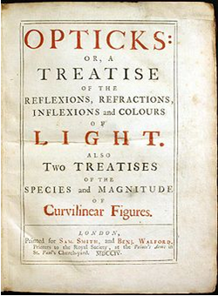

Figure 1
In his work ‘Opticks’ Newton explained the properties of light with a particle theory (1704). But in a later edition he introduced an all-pervading ether which counted for some wave properties. The particles reacted to the ether.
(Souce: Wikipedia Public Domain).

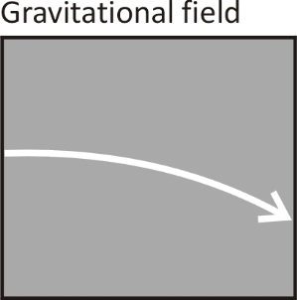
Since light particles have mass in Newton’s particle theory for light, he deduced that a beam of light parallel to the surface of the Earth, would bend downward under the influence of Earth’s gravitational field. This means the trajectory of light would be a parabola and not a straight line. Light would follow a parabola like a cannonball that is shot away horizontally.
The fact that we don’t notice this effect is – according to Newton – due to the speed of light which is very high. The speed of light was indeed unknown in Newton’s time, but Galilei had shown before that it is definitely extremely fast, possibly infinitely fast.
However, Newton was able to explain geometric properties of light very well with his particle theory. Also in your years of secondary school, you described light as ‘rays’ and you explained a lot of properties of light with so-called geometric optics, just as Newton did. Rays – to a certain extent - can indeed be perceived as a beam of particles.

Name at least 3 properties of light (from geometric optics) which you can explain like Newton, by supposing that light consists of a ray of particles.
Name of the property | Draw a schematic of the phenomenon | Can you explain this property of light by using the particle theory?
Light has a constant speed
…
…

But aren’t there properties of light that cannot
be explained by the particle theory of light?
For example the phenomenon called refraction or the bending of light. This occurs when light rays travel from one medium to a different medium.
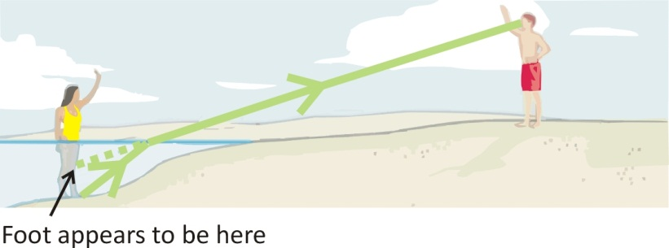
Figure 2
Rays of ligth are ‘bent’ as they change medium.

Can you explain refraction by assuming light is a ray of particles?

Yes/No

But Newton did explain refraction with his particle theory too! Let’s see how he did this.
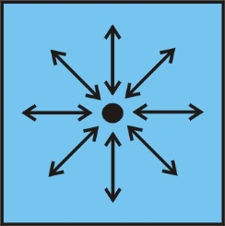
Newton suggested that when particles of light end up in a medium, such as air or water, they are attracted to the particles of that medium due to an attractive force (gravity) between the particles. Inside a medium (e.g. water or air), the particles of light are equally surrounded by particles of the medium. As a result, the attractive force pulls an equal amount on all sides making the net force zero. So there is no net effect on the light particles and therefore the light keeps going on in a straight line, at least as long as they stay inside the same medium.

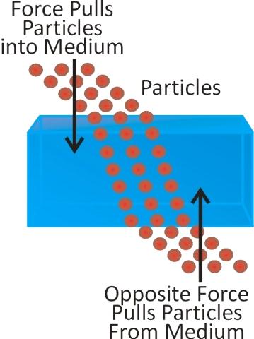
Figure 3
There is no spatial symmetry at the boundary of one medium with the other: i.e. on top there are air particles and on the bottom there are water particles. The denser medium, water in this case, would cause a net acceleration towards the water – according to Newton. The light particles are accelerated towards the water which causes an offset in the ‘ray’ of light.
(Source: olympusmicro)

But there is a difference at the boundary between the media. E.g. in the transition from air to water, as you know the light will break towards the normal (= line perpendicular to the surface). This happens – according to Newton - because there is more matter in the water than in the air and so the light particles are more attracted towards the denser medium. As a result, the beam offsets, makes a sudden bend and refraction is created.
Newton’s explanation seems to work. Who knows. But from this reasoning follows a consequence for the speed of light in a dense medium compared to the speed of light in a thin medium.

What follows from Newton’s reasoning about the speed of light in water compared the speed of light in air?
Choose:

Explain:

One can verify such a prediction with an experiment! Isn’t that great about physics! In 1862 Léon Foucault (the same Foucault who used a pendulum to prove that the Earth rotates) did just that. Foucault set up the following experiment to find out once and for all whether the speed of light is faster in a dense medium than it is in a thin one.

Foucault’s experiment compared the speed of light in air to that in water

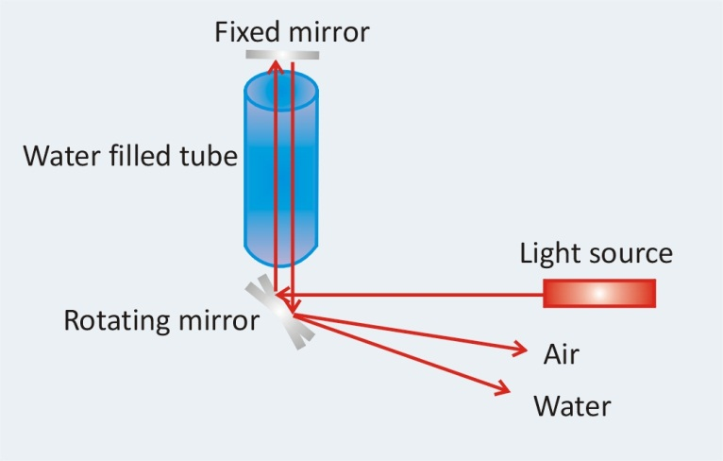
Figure 4
Representation of Foucault’s experiment comparing the speed of light in air to that in water.
The mirror underneath rotates clockwise.
(Source: University of Virginia http://galileo.phys.virginia.edu).
Foucault built his setup in the Observatory in Paris. He rotated a mirror (with help of a steam engine available then!). The mirror turned with a speed of 24.000 rotations per minute!
He shined a light source on the mirror. The beam went up through a tube and reflected onto a fixed mirror above the tube. After reflecting down onto the rotating mirror again (which by now had turned a little further), the light came back a little below the source it originated from (where it says ‘air’ in the figure).
Foucault then repeated his experiment, only now he filled the tube with water. If the speed of light is faster in water than it was in the air-filled tube, the light would return faster to the rotating mirror than before (which would have rotated less) and the reflected beam would come out above the spot where the beam through air came out.
However, the experiment showed the reflected beam through water came out below the spot where the beam through air came out. This formed irrefutable evidence that the speed of light in water is (SLOWER/FASTER) than the speed of light in air!
Foucault’s experiment didn’t allow any escape to Newton’s particle theory of light… It shows perfectly how a brilliant theory, like Newton’s, can get into trouble by predicting something (such as a faster speed of light in solids) that can’t be verified experimentally. This is something typical in science. A physicist like Newton who was successful with his mechanics, turned out to be unsuccessful with his ‘mechanics of light’.
It was clear that light doesn’t merely follow Newton’s mechanics of particles. Could it be true that light was rather a wave?

Is light made up of waves?

The assumptions of Christiaan Huygens
The Dutchman Christiaan Huygens (1629-1695) assumed – contrary to the view of his famous contemporary Newton - that light was a wave. He figured light could arise as a vibration that propagates in space as a wave. Somewhat like a vibrating object that produces sound waves that spread out. Or like a vibration on the surface of water that causes water waves to spread out.
He elaborated on his thoughts in his “Traité de la Lumière” (1690), shortly before Newton’s theory by the way. Huygens relied on the following assumptions:
- The speed of light is very high and so it is unlikely that light consists out of a stream of particles. Particles at such a speed would experience great resistance precisely according to Newton’s 2nd law. This resistance would cause them to stop moving, like a ball rolling on a table stops due to this resistance.
- Two rays of light shine through each other without influencing each other. How can they be made up of particles? Particles would collide with each other.
- The phenomenon of refraction can be explained by assuming that the propagation speed of light changes depending on the medium it travels through: the speed of light decreases in dense media (as opposed to Newton’s increasing)!
Let’s look first at the second property of light, an obvious property however it is often overlooked!

How are light rays able to cross each other?
Every child can see how intersecting beams move on as if they never crossed. You can see this every day and it is exactly this phenomenon that made Huygens profoundly doubt Newton’s assessment that light is made up of a stream of particles. Huygens wondered:
How can 2 rays of light cross each other
without the particles bumping into one another?
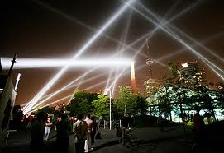
If two beams cross and continue on the same line as before
without impeding one another,
how can they be made up of particles??
Huygens realized that waves and not particles, have the property of being able to pass through each other unimpeded. They travel on their trajectory as if nothing happened.
Look at the animation on the site of the Institute for Sound and Vibration (University of Southampton, UK). You can see what happens when two waves meet up. http://web.bryanston.co.uk/physics/Applets/Wave%20animations/Sound%20waves/Superposition%20of%20Waves.htm

Which type of displacement occurs when separate waves come together?
Ok, they go through each other. But what happens to their displacement at the intersection? Look at the animation again if needed.

Two waves pass through each other. At their intersection, the resulting displacement is the sum of the displacements of the separate waves. This phenomenon is typical for waves and is called superposition or interference. Superposition can cause two waves to amplify each other, or to cancel each other out. Watch how the displacements superimpose.
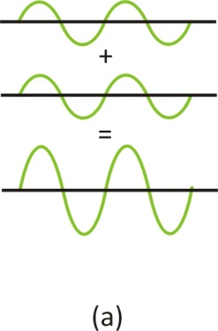
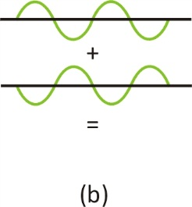

When the crest of one wave meets up with the trough of another wave in the same point, the waves are in ANTIphase in that point. The waves will tear each other down. Can you draw the resulting wave in figure (b)?
What you see in figure (a) is called constructive interference or superposition. In figure (b) you see destructive interference or superposition.
Draw the resulting displacement of the 2 waves below that are running through each other.
Exercise: Can you draw the resulting displacement in every point and therefore the resulted wave?

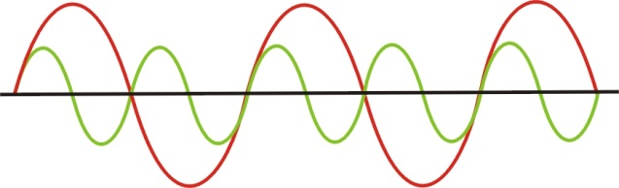

Wave front, wavelength, period
When you throw a stone in still water, circles appear that become bigger in size. These circles are formed by water particles, that start to oscillate. All particles on the same wave front, move up and down at the same time.
There are in fact an infinite amount of wave fronts, however we only draw those wave fronts for the particles that are located on a positive maximum.
Wave fronts can have different shapes:
- Line or planes: these are called plane waves i.e. sound wave in a tunnel;
- circles: these are circular waves, i.e. waves on the water surface;
- spheres: these are spherical waves, i.e. sound waves in space.
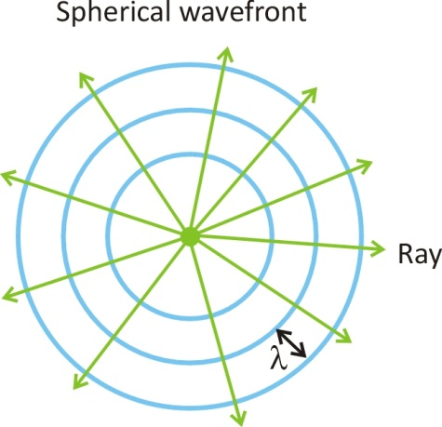
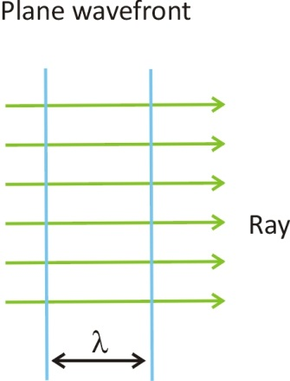

The rays indicate the direction in which the wave front moves. Rays are perpendicular to the wave fronts.
The wave pattern repeats itself after a certain distance, called wavelength λ. The characteristic pattern of a wave stretches out over this distance. Indicate on the image below, the wavelength in 4 different places:
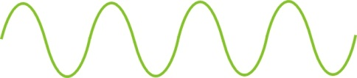
The time the wave needs to propagate one full wavelength, is called the period T of the wave. For example, a wave may need ½ second to travel one wavelength. This wave will pass by … times per second and thus have a frequency of 2 Hz.
A wave that travels one wavelength in 1/10 of a second, will pass by … times per second. This wave has a frequency of ….. Hz. (Hz means ‘per second’)
Frequency and period are thus inversely proportional:
Exercise: If a wave has a frequency of 1000 Hz, how long in time is one period of that wave?

Speed of a wave
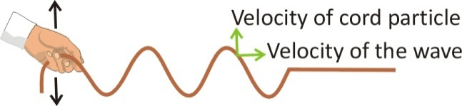

Foucault established that the propagation speed of light in water is (higher/lower) than in air. Huygens used this to explain the phenomenon of refraction.
The speed of a wave v is of course
If we fill in one wavelength for the distance travelled, we obtain a basic relation for waves:
The speed of a wave is its wavelength multiplied with its frequency.
The actual speed of a wave depends on the properties of the medium such as density, compressibility and tension.
Speed of sound in air (at 20°C) is equal to 343 m/s while in water it’s roughly 1500 m/s. The speed of light in a vacuum is (approximately) 300.000 km/s or 3,0 . 10⁸ m/s. The speed of light in solid materials (like glass) is lower than this value.
Question: A radio station transmits radio waves with a frequency of 88,1 MHz. What is the wavelength of these radio waves? (Answer: 3,4 m)

How Huygens explained the properties of light

The Huygens principle
Let’s get back to the thoughts of Huygens. He figured that if one wants to make plane waves in water for example, you can hold a flat sheet in water and make vertical up and down motions.
Now Huygens wondered if one could make such a wave by taking just a few wave sources on that line. Instead of a sheet, one could use for instance some markers to go up and down along a line. Would these wave sources, point sources actually, make up a new wave front? Try this, make sure that you make the markers oscillate in phase (move them up and down together).
Huygens reasoned: all these point sources emit circular waves. The waves fan out and will reach the same spot after a certain distance: they will run through each other (as waves do!) and their displacements will superimpose one on top of another. Half a wavelength behind where the wave front was created (by the vibrating markers), their displacements add up all together to form a new wave front!
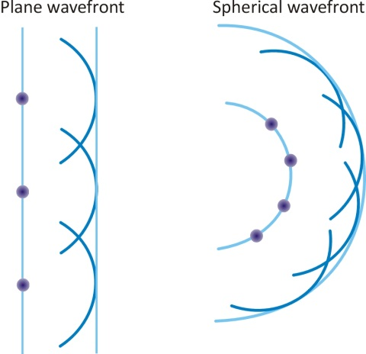
Huygens concluded that this was a new principle for waves:
Every wave front can be seen as a series of point sources that vibrate in phase. Circular waves depart from there and this exactly causes a new wave front to be formed half a wavelength away.
This is called the Huygens principle.

Explaining reflection and refraction using wave theory
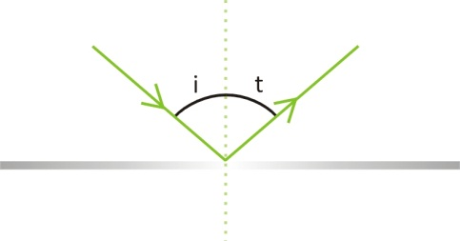
Using Huygens’ principle, you can explain why
- with reflection, the angle of incidence is the same as the angle of reflection.
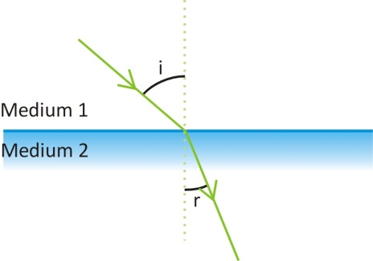
- with refraction, for a given transition between medium one and two, there is a fixed ratio, called the refraction index, between the sine of the incidence angle i to the sine of the refraction angle r. Huygens showed that refraction angles emerge exactly because of the different propagation speeds of light in the different media. Actually he showed that the refraction index n equals exactly the ratio of the wave speeds in medium one to that in medium two.
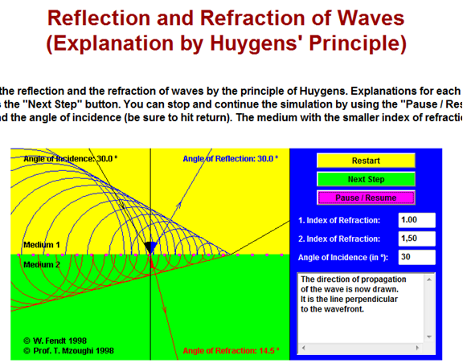
Take a look at this applet to follow Huygens’ reasoning (applet by Walter Fendt):
www.walter-fendt.de/html5/phen/refractionhuygens_en.htm
It is the change in wave speed when entering a new medium,
that is responsible for the refraction of that wave.

Explaining diffraction using wave theory
Waves can reflect, break, but also bend around an obstacle or at an opening. This is called diffraction.
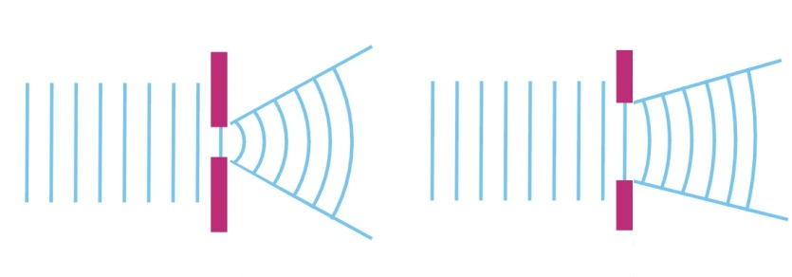
Sound waves clearly demonstrate this: you’re able to hear someone talk in a room nearby if the door is open. Also sea waves can bent around a small opening.

The bending of sea waves at Voidokilia beach in Peloponnesos, Greece

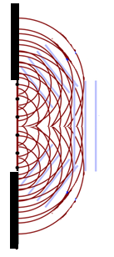
Diffraction can also be explained by Huygens’ principle: every point in the opening behaves like a point source that emits wave fronts in every direction.
The amount of diffraction depends on the proportion of the size of the opening to the wavelength.

Exercise: Can waves also bend around an obstacle (instead of an opening)?
Can you explain this by a drawing?

Exercise:
How long are sound waves?
For example, calculate the wave ength of a sound with a frequency of 440 Hz.
………………………………………………………………………………………………………………………(Answer 0,773 m).
Therefore openings and obstacles with an order of magnitude comparable to that of a sound wave will produce a noticeable diffraction for those waves.
Exercise: How long are the wavelengths of visible light? Visible light has a high frequency compared to that of sound waves. Calculate the wavelength of red light with a frequency of 500 THz (Tera = 10¹², you will need also the speed of light, if you don’t know it, look it up)
………………………………………………………………………………………………………………………(Answer 600 nm).
Will light bent around a window? Why or why not?
……………………………………………………………………………………………………………………….
Will you see diffraction of light around small obstacles or openings? Why?
………………………………………………………………………………………………………………………
Diffraction in daily life:
- Why don’t sound screens along the highway create complete silence behind the screen?
………………………………………………………………………………………………………………………
- Sound waves can be very long and can be the same order of magnitude as the sound screen itself. Therefore they will bend more around the obstacle.
For example, calculate the wavelength of a 1000Hz sounds. Compare to that of a 100 Hz sound. Will sound screens mute low tones better than high tones or is it the other way around?
………………………………………………………………………………………………………………………
(Answer: λ=3,4 m for 100 Hz and λ= 0,343 m for 1000 Hz.)

The 2-slit experiment for light as waves
Let us now return to the double slit experiment for light and explain why fringes of maxima and minima occur for waves. It was not until 1803 that Thomas Young (1773-1829) demonstrated that in a 2-slit experiment light undergoes interference, a typical property of waves! Although it was believed that this experiment finally showed that light was made up of waves, the question of the true nature of light came back in quantum physics. What was really vibrating in the case of light waves? In the next learning station, we’ll discuss the nature of light further.
But first, let’s examine the famous 2-slit experiment for light, considering them as waves.

Why do minima and maxima occur in the 2-slit experiment?
A light source produces light in the form of plane wave fronts. They reach an obstacle with two slits. According to the Huygens principle, a wave front is produced that is bent and can reach points behind the slits.
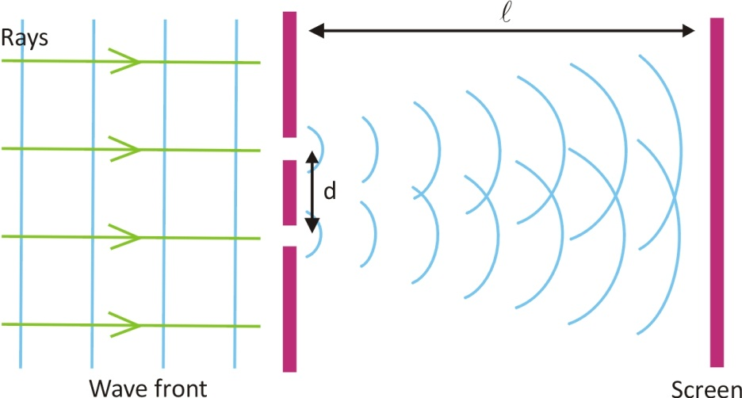
All the elements of the setup are clearly marked in the figure above. Which is why the ratios between the different dimensions and distances are nothing like the two slit experiment in reality. The slits are much thinner in comparison to their spacing d. The slits can be considered point shaped. And the screen is much farther away from the slits.
How can it be that on the screen a pattern of light and no light appears?
Behind the slits, there are two waves with round wave fronts that overlap in a certain region. They will superimpose or interfere. Because these two waves were one before the slit, they are essentially in phase at the location of the slit: they go up and down in unison. But behind the slits, these waves haven’t necessarily traveled the same distance in every point, which is why they might not be in phase anymore.

Different distance, different phase
What will you see in the middle behind the 2 slits? A bright spot or not? Why? (Hint: Think of the difference in distance travelled )
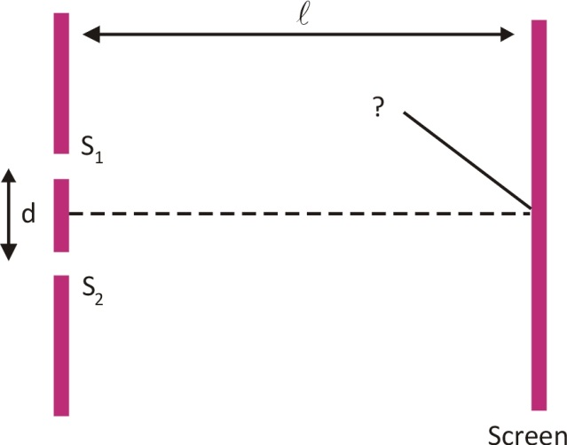
………………………………………….. ……………………………………………

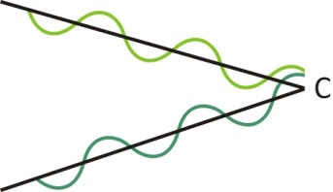
In the region straight in the middle behind the 2 slits (where it says ‘C’), both waves have traveled the same distance. The waves were in phase at the slits but are they still in phase at point C?. (YES/NO) The wave oscillate in unison and the two waves amplify each other: a bright maximum occurs (constructive interference).
A bit to the left (or right) of this point in the middle, the distance to one slit is smaller than that to the other slit. Are the waves in phase there? (YES/NO)
The resulting deviation will be something in between.
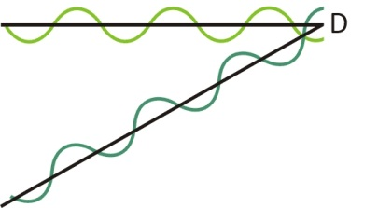
For a certain angle the path length of the light coming from one slit differs exactly half a wavelength from the light coming from the other slit: so one wave goes up while the other goes down. If the amplitude of the waves is the same, the two waves will cancel each other out (see point ‘D’ on the figure). Destructive interference occurs.
For larger angles the difference in distance traveled will be one wavelength again. Both waves are again in phase in these places, they amplify each other : maxima will occur. Increase the angle some more and minima show up again and so on. So a pattern of maxima and minima will emerge.
Practice:
If the wavelength of light decreases, would you see more or less maxima on the screen? Explain why.

Double slit interference fringes obtained with red laser light

Diffraction fringes
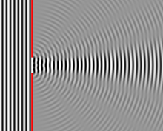
But also in a single slit there is a path length difference between the waves of the different Huygens sources. Therefore waves from different sources, superimpose.
Depending on their phase difference, maxima and minima occur in a single slit diffraction.

Diffraction fringes of light in everyday life?
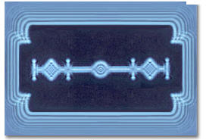
When light waves encounter everyday obstacles, the light will hardly bend at all because the wavelengths of visible light is very small compared to the size of the objects. However in some cases you can also see diffraction in daily life:!).

Diffraction of light at the tiny edges of a r razorblade

Experiment:
Watch the emergences of dark and light fringes when you bring your thumb and indicator close to each other. (Best result obtained against a white background).

Experiment: In the hands-on experiments that go with these learning stations, you can measure the thickness of a hair by means of measuring the distance between the minima

Concepts in Learning Station II
Complete by adding the missing concepts
Classical concepts:
Properties of light explained by particle theory: llight has a constant speed which depends on ................................; surfaces on which light is shone heat up; reflection.
Properties of light NOT explained by particle theory: .......................... of light.
Constructive and destructive …………………………………… of waves.
Diffraction of waves.
Properties of waves: velocity, frequency, wavelength, period.
Huygens principle.
Quantum concepts:
None

