Quantum Physics

The physics of the very small   
with great applications

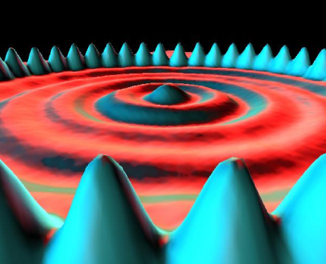

Part 3: HANDS-ON ACTIVITIES

Electron diffraction

http://i.creativecommons.org/l/by-nc-sa/3.0/88x31.png

Quantum Spin-Off is funded by the European Union under the LLP Comenius programme   
(540059-LLP-1-2013-1-BE-COMENIUS-CMP).  
Renaat Frans, Laura Tamassia   
Contact: [renaat.frans@khlim.be](mailto:renaat.frans@khlim.be)

## THE WAVELENGTH OF ELECTRONS

## RESEARCH QUESTION: Check whether the predicted wavelength of the electron - following from de Broglie’s hypothesis – corresponds to the measured value from the diffraction pattern?

## Part 1: INTRODUCTION: The wavelength of a particle?

**The particle properties of electromagnetic waves**

Albert Einstein and Max Planck discovered in the first couple of years of the 20th century that light – which according to the classical theory is an electromagnetic wave – also had some particle properties. The light that could unmistakably be described as an electromagnetic wave seemed to arrive particle by particle! These particles of light were named photons in analagy to the word electron.

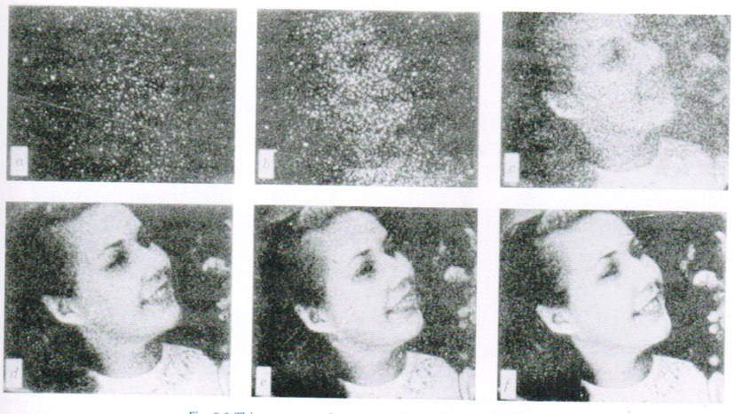

*We usually do not notice it, but it turns out that a picture is constructed one photon at a time. Here you can see how the picture is constructed by more and more photons which can be achieved by changing the exposure time. The least exposed picture contains approximately 3000 photons, the most exposed one contain 30.000.000 photons.*

**The wave charachter of matter**

Louis de Broglie wondered in 1924 if matter could also have wave properties. After all light was known to be a wave and seemed to have matter properties. Maybe the opposite might be true for matter. In other words, maybe there is a fundamental wave-particle duality for any physical system. This thought about the symmetry of nature turned out be correct and has led to a new kind of mechanics for very small “objects”: wave mechanics (just another name for quantum mechanics). Other people like Werner Heisenberg and Erwin Schrödinger developed this theory further after de Broglie. Today we use this theory (or an even more advanced theory known as quantum field theory) to explain properties of matter like its color, stability of matter, chemical bonds etc.

Quantum mechanics is today one of the fundamental theories of physics. The hypothesis of de Broglie is at the base these new insights. He was the first to relate the particle properties with the wave properties with is famous formula:

|  |
| --- |
| $p=\frac{h}{λ}$ (1) |

The equation indeed related the **particle properties**  on the left hand side of the equation (momentum) with the **wave properties** on the right hand side (wavelength). The relation depends on a fundamental constant of nature h, known as Planck’s constant. Its value is very small and equal to:

$$h=6,6260693∙{10}^{-34}Js$$

On the left hand side of the equation we have p. This is the momentum which is a property of particles. A particle which moves has a momentum equal to its mass multiplied by is speed

$$p=mv$$

**Momentum** is a well-known concept from classical mechanics developed by Newton. The change of momentum is equal to the force which is applied on the object[1].

On the right hand side of de Broglie’s hypothesis a **wavelength** is given to a particle with momentum. The wavelength is in the denominator: a particle with a large momentum will have a (short/long) wavelength.

The hypothesis of de Broglie predicts the wavelength of particles like balls and electrons.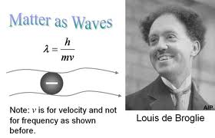

1. Predict the wavelength of a ball of 0,100 kg moving at a speed of 10,0 m/s. Why do we not notice the wavelength of such a ball? (Answer: 6,63 x 10-34 m)
2. Predict the wavelength of an electron moving at 812 m/s. The mass of an electron is 9,11 x 10-31kg (Answer: 897 nm)

**Experimental verification of matter waves**

De Broglie’s particle-wave relation has been tested and verified many times since the 1920’s. The most famous of these experimental verifications is known as the **double slit experiment of electrons** that was done for the first time in 1959 by Clauss Jönsson (University of Tübingen, D). Jönsson was able to show interference of electrons when they pass through 2 slits which irrefutably shows the wave character of electrons.  
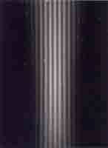

*The original photo of electron interference in a double slit experiment with electrons (Clauss Jönsson, Universität Tübingen)*

**Electron diffraction on a graphite crystal**

Davisson and Germer had already shown experimentally diffraction of electrons by ‘shooting’ electrons on a crystal. Because of their wave character, electrons exhibit diffraction in the ‘slits’ in the molecular structure of the crystal. This is the experiment that we will also do here. We will shoot electrons on a graphite crystal. There will be diffraction due to the molecure slits.

In the experiment electrons are emitted from a hot filament (like in an tv) and accelerated by voltage. They are focused by magnetic fields and they are visible on a screen after passing through the crystal.

1. ***Measured electron waves from the diffraction pattern***

If the electrons are also wave than they must exhibit diffraction with maxima and minima as a consequence of the different path differences from the holes in the crystal. And this is exactly what is observed. We indeed find a diffraction pattern with maxima and minima which is in some way a representation of the distances in the crystal. The diffraction pattern of electrons on a graphite crystal is made of a pattern in which electrons arrive in concentric circles: the result of their wave property!  
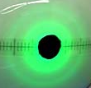 *Fig. The observed diffraction pattern gotten from sending electron waves through a graphite crystal*

A graphite crystal is constituted of many layers. If we just look at one such layer, we see that there are holes between the molecules. These holes play the role of a diffraction lattice. The electron waves go through it in a similar way to how light waves go through a diffraction lattice.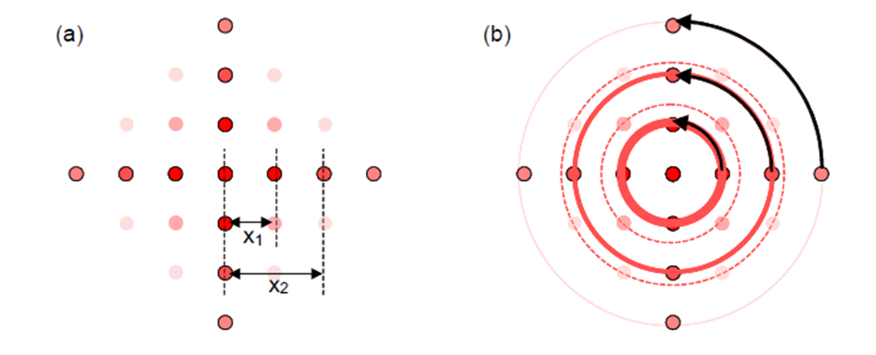

According to Huygens’ principle, every point is at its turn a source of waves that disperse in all directions. But there will be path differences between all these ‘Huygens-waves’. For certain angles the path difference Δs can become large enough to get antiphase. For such distances we get cancellation. No electrons will be observed there. For other angles constructive superposition of electron waves can take place. At these place there will be maxima and many electrons will be observed there.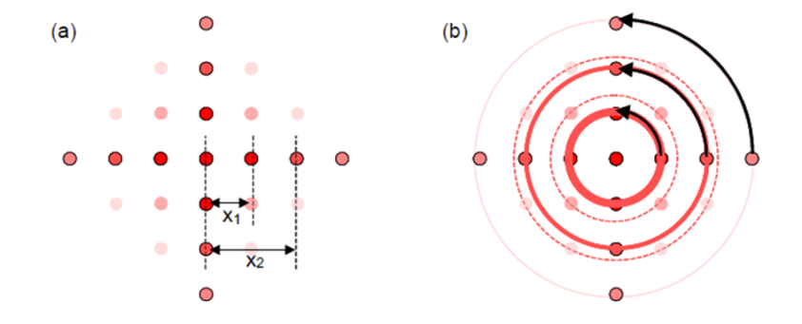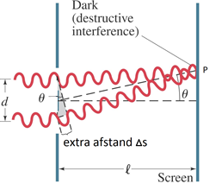

Because the graphite crystal is built of many layers which can be rotated with respect to each other, we get a situation like depicted in (b): the crystal behaves as if there are ‘round’ holes in it. The diffraction pattern at its turn will also be round because the path difference will appear circularly around the central beam.

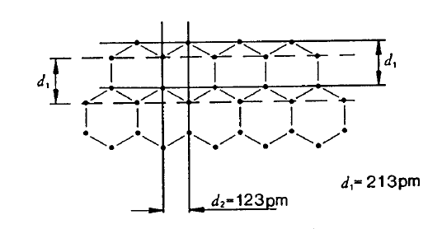

The graphite crystal actually has a nice hexagonal shape structure in which 2 different distance can be observed.

Because the layers are rotated we get circular molecular openings of the following 2 sizes:

d1 = 2,13 . 10-10m  
d2 = 1,23 . 10-10m



Both distances give rise to path differences that can be observed in the diffraction pattern as distance between the maxima D1 and D2

*Fig. Schematic representation of the diffraction rings (maxima) that are visible when sending an electron beam on and through graphite*

**Determining the wavelength of electrons from measurements of the diameter D of the diffraction maxima**

Using geometry it can be shown that the path difference equals 2d sinΘ.

We get **constructive superposition** if the path difference is equal to a whole number of wavelengths (of the incoming electrons):

Constructive superposition if $n . λ=2d.sinθ$ (2)

*n: positive integer  
d: distance in crystal lattice.  
λ : wavelength of electrons*

For small angles this can be simplified to:

  
**constructive superposition if $λ=d\frac{D}{2L}$ (3)**

where D is the measured diameter of the diffraction maximum.   
L is the distance between the crystal and the screen, which in our setup is L = 133 mm.

Because the right hand side of (3) is known (d known, L known, D is measured), **we can determine experimentally the wavelength λ of an electron.**

1. ***Predicted electron wavelength from the De Broglie relation***

We are going to determine the theoretically predicted wavelength of the electron from the hypothesis of De Broglie (so that it can be compared to the measured value afterwards). De Broglie’s hypothesis is: $λ= \frac{h}{p}$ (4)

De Broglie’s relation predicts that the wavelength depends on the momentum that we give the electron. **But how much momentum do the electrons receive?** We know that momentum is given by

$p=mv$ (5)

*But what is the speed of the electrons in our experiment?*

The electrons are being accelerated by a voltage U. This means they obtain electric energy from the voltage (Joule/Coulomb) times the charge. The electric energy the electron receives is

$$E= U.q$$

where q is the charge of the electron q=e. The electron in the experiment is thus accelerated and gets a final speed and consequently a final kinetic energy ½ mv2.

From which it follows that

$v= \sqrt{\frac{2 . e .U}{m}}$ (6)

If we plug this into the momentum of the electron (5) we find the following equation.

$p=mv= \sqrt{2 .m .e .U}$ (7)

*m: electron mass = 9,11 . 10-31 kg  
e: electron charge = 1,6022 . 10-19 C*

The value of the de Broglie wavelength is therefore

$λ= \frac{h}{p}= \frac{h}{\sqrt{2 . m .e .U}}$ (8)

With this expression we can predict the wavelength that the electron must have based on the applied voltage.

## Part 2: Experiment

## Check whether the predicted wavelength of the electron - following from de Broglie’s hypothesis – corresponds to the measured value from the diffraction pattern?

1. ***Measured electron wavelength from the diffraction pattern***

In the experiment the diameters D1 and D2 of the rings is measured for different values of the voltage U (see fig 4.). Take for instance U= 2,0 kV, 2,5 kV etc.

$$λ_{experimental}=d\frac{D}{2L}$$

The distance between the graphite sheet and the screen *L = 133 mm*. The distance in the crystal lattice d1 and d2 are *d1 = 2,13 . 10-10m and d2 = 1,23.10-10m*

|  |  |  |  |  |
| --- | --- | --- | --- | --- |
|  |  |  |  |  |
|  |  |  |  |  |
|  |  |  |  |  |
|  |  |  |  |  |
|  |  |  |  |  |
|  |  |  |  |  |
|  |  |  |  |  |
|  |  |  |  |  |
|  |  |  |  |  |

1. ***Predicted electron wavelength from the de Broglie relation***

We now compare the measured values from the diffraction pattern for the electron wavelength with the values gotten from the formula of de Broglie for the applied voltage.

$$λ_{de Broglie prediction}= \frac{h}{p}= \frac{h}{\sqrt{2 . m .e .U}}$$

*m: mass of electron me= 9,11 . 10-31 kg  
e: charge of electron e= 1,6022 . 10-19 C*

*h: Planck’s constant h = 6,63 × 10-34 J . s*

We now compare these with the measured values λD1 en λD2 from the diffraction pattern

|  |  |  |  |
| --- | --- | --- | --- |
| $$\frac{U}{kV}$$ | $$\frac{λ_{de Broglie}}{nm}$$ | $$\frac{λ_{D1}}{nm}$$ | $$\frac{λ_{D2}}{nm}$$ |
|  |  |  |  |
|  |  |  |  |
|  |  |  |  |
|  |  |  |  |
|  |  |  |  |
|  |  |  |  |
|  |  |  |  |
|  |  |  |  |

**Is de Broglie’s hypothesis about the wave nature of electrons experimentally verified? Do the measured wavelengths from the diffraction pattern sufficiently correspond with the theoretical prediction?  
 Yes/No**

1. If you doubt this, try to change the momentum of a truck and then of a toy car. Even if they both have the same speed, the necessary force will be a lot larger for the truck because its mass is a lot bigger.