

Bridge between research in modern physics  
and entrepreneurship in nanotechnology

Quantum Physics

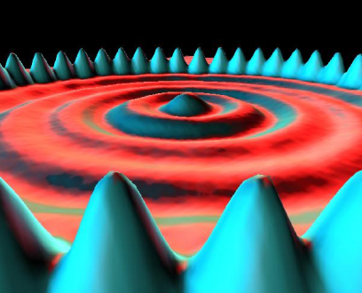The physics of the very small   
with great applications

http://i.creativecommons.org/l/by-nc-sa/3.0/88x31.png

Quantum Spin-Off is funded by the European Union under the LLP Comenius programme   
(540059-LLP-1-2013-1-BE-COMENIUS-CMP).  
Renaat Frans, Laura Tamassia, Erica Andreotti   
Contact: renaat.frans@ucll.be

Source of picture on front page:

M.F. Crommie, C.P. Lutz, D.M. Eigler. **Confinement of electrons to quantum corrals on a metal surface.** Science 262, 218-220 (1993). Crommie, Lutz and Eigler were working at IBM Research Division, Almaden Research Center, San Jose, California, USA

http://i.creativecommons.org/l/by-nc-sa/3.0/88x31.png**Attribution-NonCommercial-ShareAlike 4.0 International** (CC BY-NC-SA 4.0)

Under the following terms:

* Attribution — You must give [appropriate credit](https://creativecommons.org/licenses/by-nc-sa/4.0/), provide a link to the license, and [indicate if changes were made](https://creativecommons.org/licenses/by-nc-sa/4.0/). You may do so in any reasonable manner, but not in any way that suggests the licensor endorses you or your use.
* NonCommercial — You may not use the material for [commercial purposes](https://creativecommons.org/licenses/by-nc-sa/4.0/).

You can:

* Share — copy and redistribute the material in any medium or format
* Adapt — remix, transform, and build upon the material

The licensor cannot revoke these freedoms as long as you follow the license terms.

You have to refer to this work as follows:

Frans R., Tamassia L. , Andreotti E. (2015) Quantum SpinOff Learning Stations. Art of Teaching, UCLL, Diepenbeek, Belgium

**Introduction to part 1: Why Quantum Physics?**

In part 1 of the learning stations we explore the origin of quantum physics, starting with the phenomena that classical physics could not explain. Step by step we try to understand those phenomena qualitatively, but also quantitatively. In the learning stations we find back both classical and quantum concepts, which are put next to each other in order to better understand the fundamental contribution of quantum physics to our understanding of the universe. Because classical and quantum concepts do alternate each other through the learning stations, as classical concepts are necessary to deeply understand the quantum world, we propose at the end of each chapter a summary of the main classical and quantum concepts in the form of an exercise: this is an opportunity for the student to identify the two “types” of concepts and to have a final overview of the learned material.

Before starting working with the learning stations we propose here below an overview of the content of each one. This is meant to clarify the learning line and to keep an eye on the targets and the point from where we started.

**Learning station I**: Inexplicable phenomena with classical physics?

Our trip starts with the double slit experiment for electrons: do small “particles” have a definite trajectory like foreseen by classical physics? Can we explain what we observe by thinking at electrons as being really small particles? We will compare the results of double slit experiments with sand, electrons and light and try to understand the nature of matter and light: can we still clearly separate the world into waves and particle behaviour?

Then we will try to explain features of molecules unexplained hitherto by classical physics. We will look at the emission and absorption spectra of elements and consider whether they can be explained by the classical atomic model of Rutherford or we need quantum concepts.

**Learning station II**: What is light?

In the second learning station we start from the observed results of the double slit experiment and focus on the nature of light. Understanding the behaviour of light will indeed help us further understand the behaviour of all “particles” and the observations we did in learning station I. The basic question here is: can the behaviour of light be explained by considering it as a beam of particles or as a wave? For this investigation we will use classical physics and we will go back into the history of light theories…

**Learning station III:** What oscillates with light?

When light is considered as having a wave nature, then we have to investigate what is that oscillates and propagates light waves. We will make this study by using classical physics and by comparing light with mechanical waves. We will also go into the concepts of “field” in classical physics, a key concept also used later on in our understanding of quantum physics.

**Learning station IV**: Wave particle duality.

In the previous learning stations we have investigated the properties of light, as a wave, using classical physics, so now it is time to make a step further into the quantum nature of light. What happens if we do the double slit experiment with light of low intensity? Does light still appear to only behave as a wave? Or does it appear to have some particle properties? In this learning station we will calculate the energy of a light quantum using the Planck-Einstein relation. On the other hand we will use the De Broglie hypothesis to calculate the wavelength of a particle. In this way we will discover that particle-wave duality is a fundamental characteristic of light and matter.

**Learning station V:** Predicting the hydrogen emission lines with a quantum model.

At this point of the travel we have got the knowledge of the basic concepts necessary to explain a number of phenomena inexplicable with classical physics. We will go back to the discrete emission and absorption spectra of the elements and use the acquired knowledge to, not only explain them, but also to calculate the frequencies of the hydrogen emission lines.

You can find schematic conceptual structures of every learning station on the accompanying website [www.quantumspinoff.eu](http://www.quantumspinoff.eu)

We wish you a lot of pleasure with your own discovery tour through this physics of the very small with the great applications!

**Table of Contents**

**Part 1: Why Quantum Physics?**

Learning station I: Inexplicable phenomena with classical physics? 6

1 The end of classical mechanics 6

2 Loss of the concept of trajectory: the double slit experiment 7

2.a Double slit experiment with sand 7

2.b Through which slit does the electron go? 8

2.c Double slit experiment for waves 9

2.d Double slit experiment for large molecules 10

2.e Double slit experiment with light 11

3 Discrete emission and absorption spectra of the elements 13

3.a Typical colours of a chemical element 13

3.b Atomic discrete emission lines 14

3.c Discrete absorption lines 15

4 Explaining discrete spectral lines? 16

4.a Accelerating electrons in atoms, sources of light? 16

4.b Emission of light explained by the classical Rutherford Atomic Model? 17

4.c The collapse of the emitting Rutherford atomic model 18

5 Concepts of Learning station I 20



**Quantum Spin Off**

*The physics of the very small with great applications*

Part 1  
Why Quantum Physics?

Who ordered this?

http://i.creativecommons.org/l/by-nc-sa/3.0/88x31.png

# Learning station I: Inexplicable phenomena with classical physics?

## The end of classical mechanics

If you kick a ball, you expect it to follow a precise trajectory given its initial position,mass and the force acted upon it. That’s also how we launch a rocket from the earth into outer space.

In classical mechanics, if you know the initial position, the initial velocity and the forces acting upon a mass, you can predict its trajectory.

That we can predict the trajectory given initial conditions and forces, follows from Newton’s mechanics formulated in 1687 in his ‘Principia Mathematica Philosophae Naturalis”.

Until early 20th century Newton’s so-called Classical Mechanics was without question the basis of all physics. But when physicists explored the world on a small scale, it became more and more clear, that the trajectories we observe on a large scale are not fundamentally there. They are just a practical approximation of a more fundamental mechanics, named quantum mechanics, where small things don’t really have fixed trajectories.

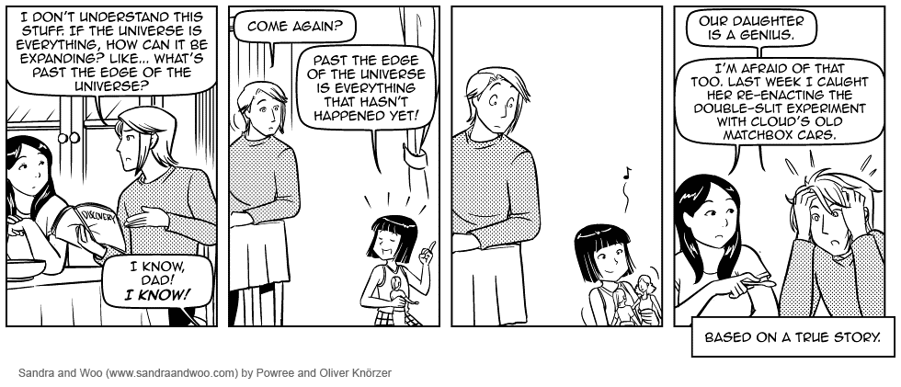

Figure 1 Matchbox Cars and Quantum Physics   
(Source: Sandra and Woo comic strip by Knörzer and Powree published under Creative Commons Attribution-NonCommercial-NoDerivs 3.0 License.)

.

Let us try to understand, like Sandra, what is really going on here. The designated experiment to see what we mean, is the famous double slit experiment. The brilliant American physicist Richard Feynman described the double slit experiment for electrons as a phenomenon ‘which has in it the heart of quantum mechanics. In reality, it contains the only mystery.’ So let us take a look at that one.

*Classical mechanics:*

*Given the initial position, the initial speed and the forces acting on a mass*

*↓  
You can predict the trajectory of the mass*

## Loss of the concept of trajectory: the double slit experiment

### Double slit experiment with sand

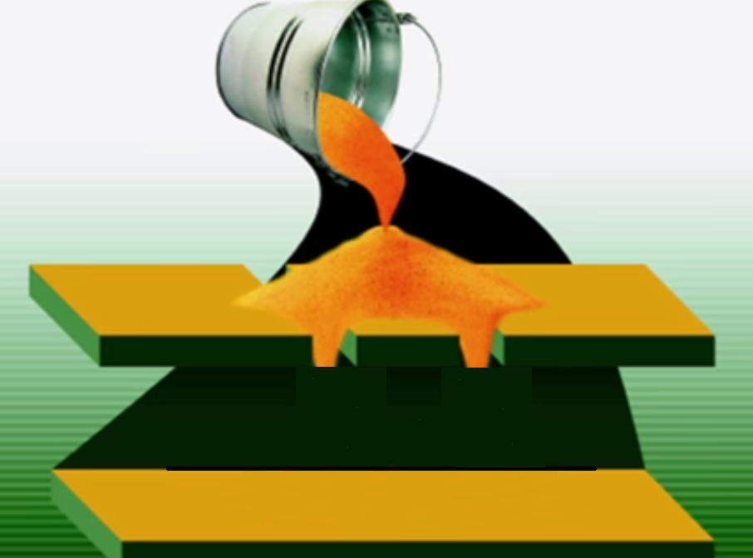

Before we do the double slit experiment with electrons. Let’s try one with sand. We have 2 slits in an upper wall through which we pour sand.

What will you see on the wall below?

*Please draw your expectations!*

Figure 1 Double slit experiment with sand   
(Adapted from Professor Jim Al-Khalili’s lecture at the Royal Institution, see: <https://www.youtube.com/watch?v=A9tKncAdlHQ>)

.

Did every grain of sand followed a certain path through one of the slits?  
(YES/NO)

Can you say that every grain of sand followed a certain trajectory?  
(YES/NO)

Is the pattern formed on the lower floor a result of all the individual trajectories of the grains?  
(YES/NO)

### Through which slit does the electron go?

Let us now look at electrons. 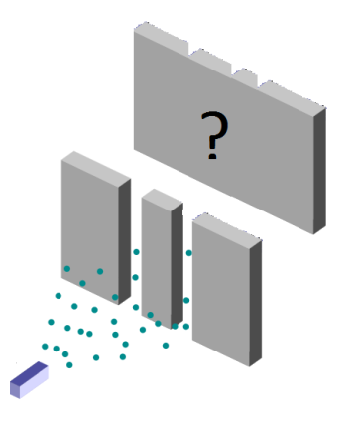 When you shoot electrons on a target with 2 thin slits close to each other, what pattern would you expect to see on a screen behind the slits?

Figure 2 Schematic representation of the double slit experiment with electrons   
(Source: Adapted from Wikipedia Public Domain)

.

In Newtonian mechanics you consider electrons as tiny particles, like tiny ink droplets coming out of a spray can. If you spray the paint on a sheet with two slits and hold a screen behind it, what pattern would you observe on the screen? Make a drawing of what you will see on the screen:

*The classical expectation for the pattern of the double slit experiment for electrons*

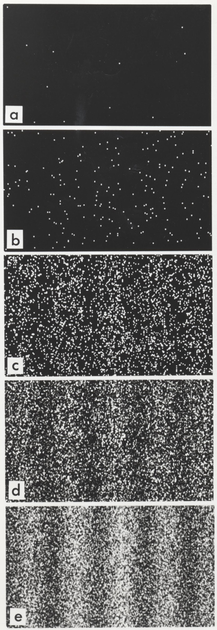

Look to the double slit experiment with electrons that researchers of Hitachi Labs have conducted successfully. They shot electrons one by one through two very narrow slits and recorded where they arrived on the screen. Look at the pattern build-up: [www.youtube.com/watch?v=oxknfn97vFE](http://www.youtube.com/watch?v=oxknfn97vFE)

It’s clear that in certain spots more electrons arrive than in others. Compare the final pattern the researchers obtained with your prediction based on classical mechanics: is the pattern the same?  
(Yes/No)

After having seen the results of the real experiment, can you still **claim that a single electron passes through one slit or the other**?  
(Yes/No)

Can you still talk about the **trajectory of an electron** if you can’t assume that the electron has passed through one slit or the other?   
(Yes/No)

Figure 3 Build-​​up of the pat­tern on the screen for the double slit experiment for electrons. The number of detected elec­trons is 100 (b), 3000 (c), 20000 (d), 70000 (e). (Source: Tono­mura, A., Endo, J., Mat­suda, T., and Kawasaki, T., 1989). Demon­stra­tion of single-​​electron buildup of an inter­fer­ence pat­tern, Amer­ican Journal of Physics 57 (2), 117–120)

.

The Concepts of exact trajectory and position seem to disappear. Classical mechanics falls short. Watch also the animation of dr. Quantum[1]: [www.youtube.com/watch?v=DfPeprQ7oGc](http://www.youtube.com/watch?v=DfPeprQ7oGc)

Electrons arrive one by one on the screen, but you can’t tell through which slit they passed. They do not seem to follow the predictions of classical mechanics. The pattern they build up is more like a pattern produced by waves. Are electrons no longer particles then?

### Double slit experiment for waves

Let’s look at the double slit experiment for waves, for example water waves(see picture). Crests appear clear, troughs appear dark, flat areas appear grey. Notice how the waves form behind the slits.

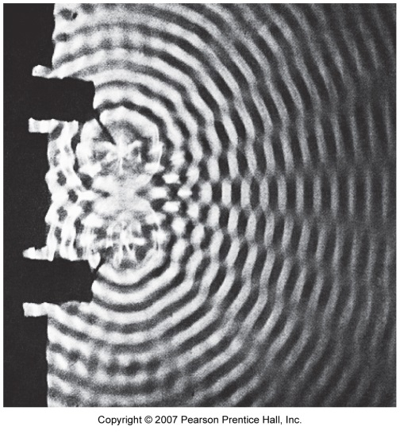

Figure 4 *Interference of water waves (Source: PSSC Physics Haber-Schaim, Dodge, Gardner, Shore. Kendall/Hunt, 1991.)*

Are there areas with no disturbance at all?  
(YES/NO)

Where do you see crests and troughs? Write down the corresponding number of the area(s):…………….  
Where do you see flat areas? …………………….

The pattern of fringes with waves in certain places and none in other places, is called **an interference pattern.** The development of such an interference pattern is typical for waves. The pattern emerges because in the places where two crests meet or two troughs meet, high waves are formed. But in the places where a crest meets a trough, they cancel each other out. In these spots there are no more waves. We will come back to that in learning station II ‘What is light?’

Let us return now to the results of the double slit experiment for electrons and compare them to the experiment with waves. Do you see an interference pattern with fringes on the screen caused by the electrons? (YES/NO)

So can you say that electrons have a wavelike behaviour? (YES/NO)

Electrons arrive one at a time, but the pattern formed by these particles is an interference pattern,   
due to the wave features of electrons!

### Double slit experiment for large molecules

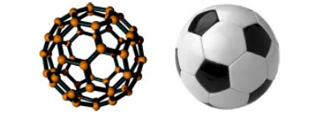Electrons are extremely small particles and you might think that the particle-wave duality only applies to them.

Do you think the behaviour of an electron is exceptional, or will larger molecules also produce a similar interference pattern in the double slit experiment?

Figure 5 The fullerene C60 molecule is the smallest soccer ball in the world (from: O. Nairz, M. Arndt and A. Zeilinger, "Quantum interference experiments with large molecules")

.

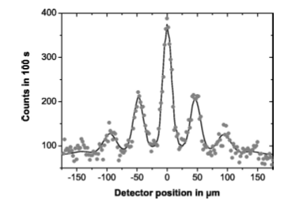The double slit experiment has also been performed with fullerene molecules, C60, also called **bucky balls**. These molecules are made from 60 carbon atoms bound together in a shape similar to a soccer ball. A molecular soccer ball if you will, the fullerene molecule is the smallest soccer ball in the world. The result of the experiment is shown in figure 7.

Figure 7 Fullerene interference pattern (from: O. Nairz, M. Arndt en A. Zeilinger, "Quantum interference experiments with large molecules")

The larger ‘things’ become, the smaller their wavelengths are (we will come back to that with the De Broglie relation - learning station IV). Therefore the experiments keep getting harder to perform (you need smaller slits with smaller separation for larger ‘stuff’…)

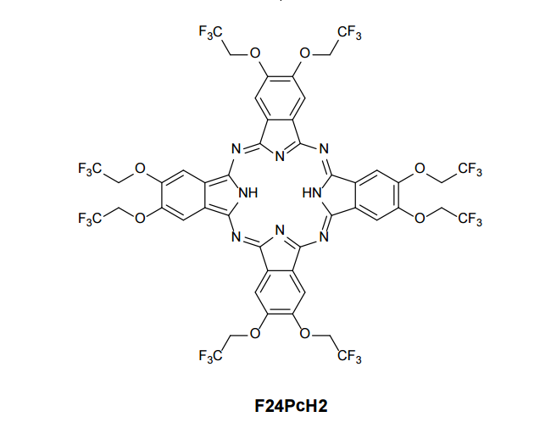Recently the 2-slit experiment was performed with large dye molecules with masses from 500 times up to 1000 times heavier than Carbon. Large massive molecules, interfere as a wave also and build up a pattern molecule by molecule on a screen.

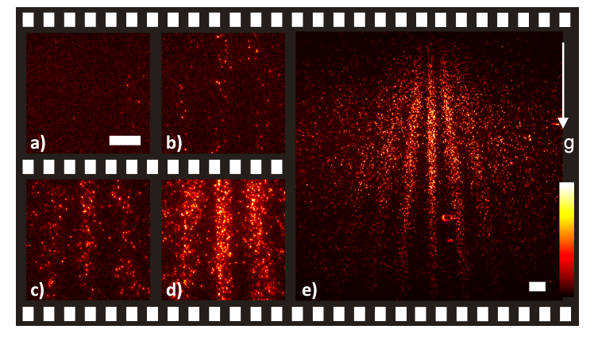Not only do such experiment demonstrate the wave-particle duality, they further investigate the boundary between quantum and classical physics.

Watch the short Quantum Molecular Movie [www.nature.com/nnano/journal/v7/n5/extref/nnano.2012.34-s3.avi](http://www.nature.com/nnano/journal/v7/n5/extref/nnano.2012.34-s3.avi)

Figure 8 Quantum Interference pattern made by large dye molecules, some frames out of the recorded ‘Quantum Molecular Movie’.   
(Juffmann, T., Milic, A., Müllneritsch, M., Asenbaum, P., Tsukernik, A., Tüxen, J., ... & Arndt, M. (2012). Real-time single-molecule imaging of quantum interference. Nature nanotechnology, 7(5), 297-300)

At the beginning of quantum mechanics in the early 20th century, these wave-particle features seemed very theoretical. But they are becoming more and more experimentally accessible. Large molecules containing thousands of protons, neutrons and electrons are found in nature also. So when the first double slit experiment with a virus?

Moreover the very fine equipment needed to perform these experiments, will eventually contribute to nanotechnology devices which could be of further use in new fields like quantum computing or –who knows where it all leads to - medical devices. Fundamental research creates new knowledge and new possibilities for mankind.

So, what should we conclude: Is the electron “special” or is particle-wave duality a fundamental characteristic of all matter?

### Double slit experiment with light

Now when we perform the double slit experiment with light, at first sight nothing special happens: we see an interference pattern of a series of fringes with and without light on the screen. So light is a wave, isn’t it (we will come back to that question in learning station II ‘What is light?’)

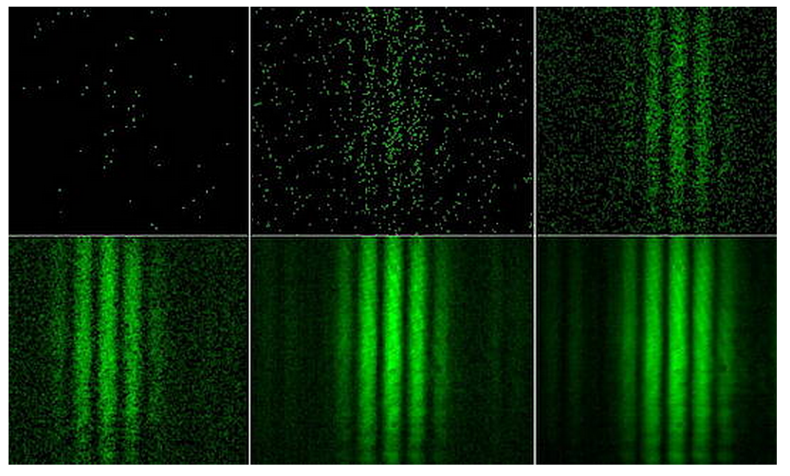But when we significantly decrease the intensity of the light, we see that the light – which we thought was a wave – arrives as little balls of light. These particles of light are called photons.

Figure 9 Light arrives as individual photons in a double slit experiment recorded by a single photon imaging camera (image intensifier + CCD camera). The single particle events pile up to yield the familiar smooth diffraction pattern of light waves as more and more frames are superposed (Recording by A. Weis, University of Fribourg)

So there seems to be something wrong with the way classical mechanics sees the world. Tiny things like electrons are molecules, which we consider as balls, build up an interference pattern as waves do. Light on the other hand, exhibits interference like a wave but arrives particle by particle.

This ***wave-particle duality*** is one of the new key concepts of nature that came in with quantum mechanics as opposed to classical mechanics. In quantum mechanics there will be certain fundamental indertermination on trajectories. We will come back on that in learning station IV ‘wave particle duality’

**Exercise with applet**:

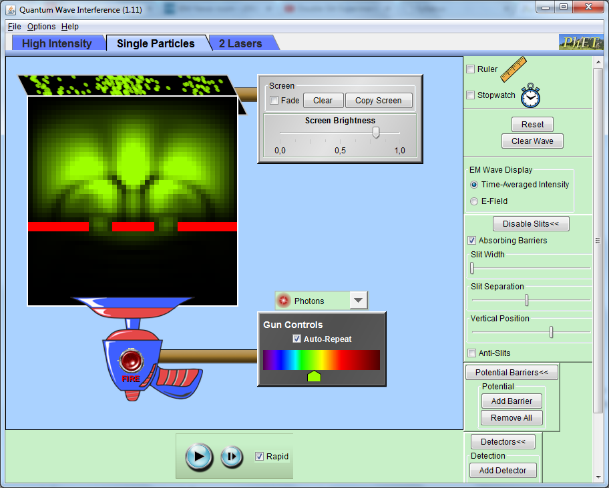You can play with a simulation of the double slit experiment from Phet “Quantum Wave Interference”

Try to fix the settings on the 2-slit experiment for photons. You get the best results if you fire with ‘repetition’. You might have to alter your slit separation and slit width to get a clear interference pattern.

*Source:University of Colorado, Boulder   
phet.colorado.edu/en/simulation/quantum-wave-interference*

Answer following conceptual questions:

1. When observing the high intensity light beam, can you explain the observed pattern by classical wave theory?  
   (YES/NO) because…..
2. When observing 2-slit experiment for single photon, can you explain this by classical theory or do you need quantum theory?  
   (YES/NO) because…..

Switch now to the 2-slit experiment for electrons

1. When observing the high intensity electron beam, can you explain the observed pattern by classical wave theory?  
   (YES/NO) because…..
2. When observing 2-slit experiment for single electron, can you explain this by classical theory or do you need quantum theory?  
   (YES/NO) because…..

## Discrete emission and absorption spectra of the elements

Wave-particle duality and the loss of trajectory for the very small is one of the new key concepts of Quantum Mechanics as opposed to Classical Mechanics. Let us see if this new mechanics of the very small is also needed to explain features of molecules previously unexplained by classical physics.

### Typical colours of a chemical element

At the end of the 19th century it was already well known that chemical substances send out characteristic colours when heated. If you hold a sample of the chemical substance in a flame, you will see a colour that is typical of that substance. This effect can be used to recognize a chemical substance!

Figure 10 Sodium (Na) held in a flame gives a characteristic yellow colour. If one does the same with copper (Cu), one gets a typical blue colour.

**Experiment: 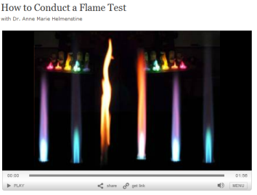conduct some flame tests yourself**.

#### The video “How to conduct a flame test” explains how to do the experiment: [video.about.com/chemistry/How-to-Do-a-Flame-Test.htm](http://video.about.com/chemistry/How-to-Do-a-Flame-Test.htm)

#### If needed, ask your chemistry teacher for advice. Conduct the flame tests. How is it possible that each chemical substance sends out its own characteristic colour? Write down the chemical substance you used and the corresponding flame colour in the table below.

|  |  |
| --- | --- |
| Chemical substance | Flame colour |
|  |  |
|  |  |
|  |  |
|  |  |

**Experiment with discharge lamps:**

The typical colours sent out by chemical substances can be seen even better in a **gas discharge lamp**. These lamps are transparent tubes filled in with a specific gas. When you apply avoltage to the ends of the lamp tube, the lamp lights up with the typical colour of the gas present in the tube.

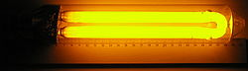*Sodium lamps* are often present along motorways and give off a typical yellow colour.   
*Mercury lamps* can be seen for example in car head lamps and give off a typical white-blue light.

*You can watch the emission lines by using a spectrometer. Maybe you have one in your physics lab or you can make a pocket spectrometer (See Learning Station XI for building instructions).*

### Atomic discrete emission lines

So you observed the characteristic colour of your substances. Sodium whether in a flame or in a discharge lamp gives a typical yellow colour. When a substance is heated up in a flame or put under a voltage, the molecules actually split up and as a result the substance is present in its **atomic state**.

But then it must be the atoms themselves that send out the characteristic colours!

The question that physicists in the beginning of the 20th century wanted to answer was:

How can an atom send out such precise colours?

Physicists in those days did not expect that this question would lead to the end of classical physics! In these learning stations we will follow more or less this path together with you. Our quest starts with the characteristic colours of emission spectra. The characteristic light that we observe when heating up a substance or when an atomic gas is put under a voltage is actually the superposition of a ***discrete number*** of sharp colour lines. In order to observe these we have to use a prism or a diffraction grating to split up the light into its different colours. A diffraction grating is a diaphragm with many parallel thin slits cut into it.

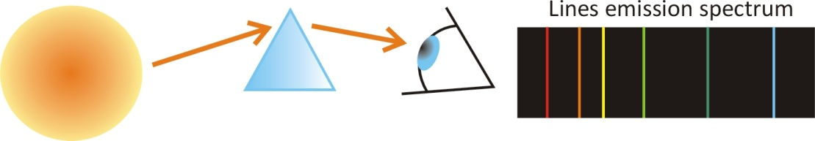

Figure 11 An atomic gas emits light that can be split in the colours of which is it composed with a prism or a diffraction grating. In this way one can see that the observed colour is actually made out of a **discrete** **number** of sharp colour lines. These discrete emission lines are typical of the element present in the lamp.

For instance 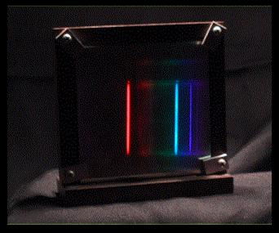we can look at the emission spectrum of hydrogen, the first element in the table of elements and the simplest and most common chemical substance in the universe. If you have a hydrogen gas discharge lamp and a spectroscope in your physics lab at school, you should go and see the emission spectrum with your own eyes. Ask your physics teacher for help!

Figure 12 The characteristic line spectrum of atomic **hydrogen** is composed out of 3 sharp lines: a red, a blue and a violet line.

In Learning station V, you will be able, like the great fathers of quantum physics, to *predict the* *wavelength of the emission lines* with a precision of 4 digits!

#### Experiment: Determine the elements present in 4 different gas discharge lamps

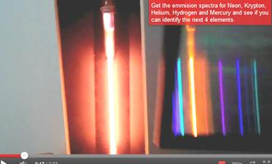In the following video the light produced by four gas discharge lamps filled with different elements is split into the composing colours by using a diffraction grating.

Look up the emission spectra of Neon, Krypton, Helium, Hydrogen and Mercury. Compare these emission spectra to the spectra of the different lamps. Then determine which chemical substance is present in each lamp.

Figure 13 Atomic Spectra - Name that element [www.youtube.com/watch?v=1gT7hlYvKg0&feature=related](http://www.youtube.com/watch?v=1gT7hlYvKg0&feature=related)

|  |  |
| --- | --- |
| Lamp | Which element is inside? |
| 1 |  |
| 2 |  |
| 3 |  |
| 4 |  |

#### Analyse the light sent out by stars

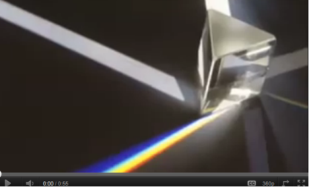In measurements of the spectrum of the sun or other **stars**, one can recognize the characteristic lines of mainly H and He. From this we learn that those stars are mainly made out of hydrogen and helium. A further analysis of these spectra also gives us information on the age of stars and even on how they move.

Watch the video ‘The Spectrum of Stars’ at [www.youtube.com/watch?v=l4yg4HTm3uk](http://www.youtube.com/watch?v=l4yg4HTm3uk)

Atoms send out precise discrete emission lines, which allows us to see the signature of chemical elements in stars at a distance light-years from us. But the opposite is also possible: light can be absorbed by clouds of atomic gases. These atomic clouds absorb only specific discrete colour lines from the light passing through them.

### Discrete absorption lines

When the light from a star passes through a cold gas cloud on its way to the observer, specific colours can be absorbed by the cloud, resulting in a series of black absorbed lines in the spectrum of the star as seen by the observer. These lines are called absorption lines and the associated spectrum is called an absorption spectrum.

The analysis of the absorption spectrum reveals which chemical elements are present in the gas cloud.

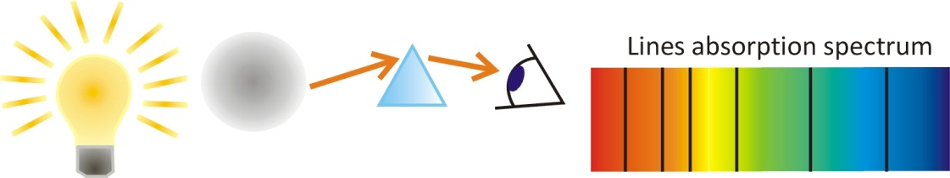

Figure 14 When ‘white’ light goes through an atomic gas, specific colour lines are ‘blocked’ by the gas and never arrive at the observer. The atoms in the gas have absorbed these colours that disappear from the light emerging from the gas, resulting in a **discrete** absorption spectrum seen by the observer.

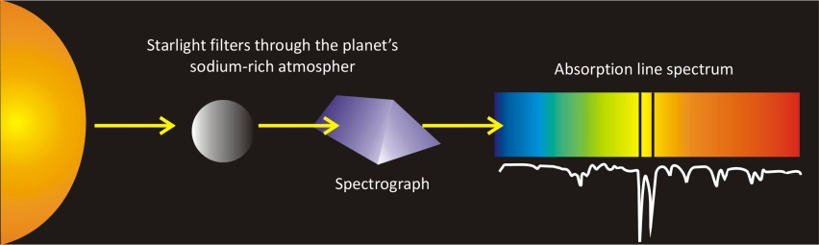For example, one can determine the chemical elements in the atmosphere of a planet by measuring the absorption spectrum of sunlight that has gone through the atmosphere of that planet.

The absorption of light for specific colour lines takes place when light has been absorbed by a specific element:

Emission and absorption spectra are   
the signature of the presence of specific atoms or molecules.

## Explaining discrete spectral lines?

### Accelerating electrons in atoms, sources of light?

Ok, atoms emits discrete emission lines. But why?

How can an atom send out specific colours?

The answer to this question must be sought, first of all, in the atom itself.

How can an atom send out light?

How can an atom absorb light?

At the end of the 19th century, it was discovered that light is an electromagnetic wave.

**Be inspired by emitting antennas:**

An accelerating charge in an antenna emits an electromagnetic wave. Then couldn’t it be reasonable to hold acceleration of charges in matter, electrons, responsible for the emission of light out of matter?

So moving, or better *accelerating* electrons could be the source of light in matter.

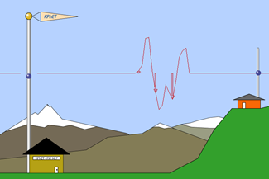Electrons are indeed moving charges in the atom. They can be seen as atomic ‘senders’. Due to their movement, they emit an oscillating electromagnetic wave: light.

Try the Phet applet on emitting radio waves on [phet.colorado.edu/en/simulation/radio-waves](https://phet.colorado.edu/en/simulation/radio-waves)

Figure 6 An accelerating charge in an antenna, emits an electromagnetic wave. Then couldn’t it be reasonable to hold acceleration of charges in matter, electrons, responsible for the emission of light? (PHet applet, University of Colorado, Boulder)

Thus, classical physics can explain the general phenomenon of the emission of light by atoms as a consequence of the very fast acceleration of electrons in the atom.

### Emission of light explained by the classical Rutherford Atomic Model?

But can classical atomic models explain  
why atoms can emit or absorb *discrete* line spectra?

How is the movement of electrons in atoms so perfectly organized   
that only specific discrete colour lines will be emitted?

To investigate this, we have to inspect the **classical atomic model of Rutherford** more closely. The atomic model of Rutherford was the last classical atomic model before the advent of quantum mechanics.

#### Sketch the classical ‘planetary’ atomic model of Rutherford:

#### Look up in which period Rutherford worked in Cambridge:

You certainly know the Rutherford atomic model: the electrons circle around the nucleus like planets around the sun.

Did you ever realise that in order to send out red light (with a lower frequency) the electron should move slower, on the other hand for sending out blue light (with a higher frequency) the electron should move faster. A specific circular motion of the electron would then produce a specific colour.

The hydrogen atom, for example, which definitely has 3 sharp emission lines, should then have 3 corresponding electron orbits where the electron would turn at three different and very specific speeds in order to explain the red, the turquoise and the blue line.

Do you think it’s possible for one electron of hydrogen to travel in 3 different orbits, at three different speeds around the nucleus in order to produce these 3 different colour lines?  
(YES/NO)

And if so why would the electron do so?

**Be inspired by satellites in orbit:**

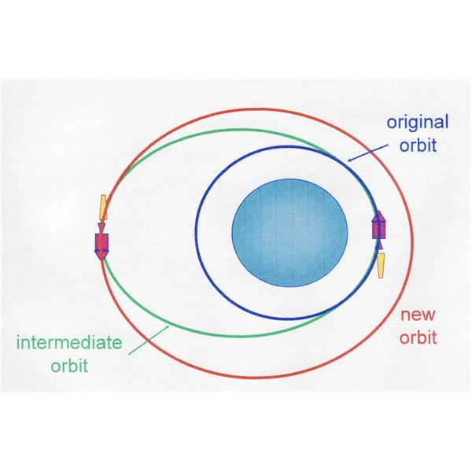Like planets or satellites who go around the earth or the sun, a satellite can be brought to a ‘higher’ or a ‘lower’ orbit if energy is added or removed. Ok, so far so good. So maybe that is what is happening to the electron in the atom too. It goes from lower to higher orbits and back again in order to emit the ‘requested’ lines.

But the question remains:

why should only a few orbits be allowed,   
those associated with the frequencies of the observed colour lines?

In the classical picture, like for a satellite, all possible energies are allowed and a circling electron could emit light of all possible frequencies, and thus of all possible colours.

Is an hydrogen atom emitting all sorts of colours?  
(YES/No)

But apart from that there is an even worse problem with the classical atomic model.

### The collapse of the emitting Rutherford atomic model

Even worse, a circling classical electron, like an antenna with an alternating current inside, sends out electromagnetic waves all the time,

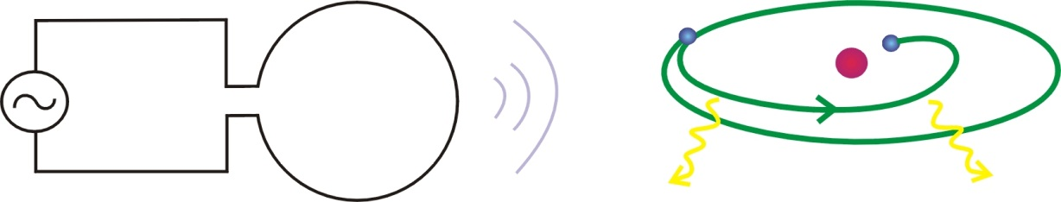

Figure 13 Just like an alternating current in an antenna, an electron circling around the nucleus in an atom will continuously emits electromagnetic waves. Niels Bohr realized that such the electron should by consequence lose energy and, as a result, would just fall on the nucleus. According to classical physics, stable atoms simply cannot exist. And electrons circling exactly and only with the few discrete frequencies associated to the observed emission lines, could in no way be modelled in classical physics.  
(Figure source: EDN, March 2000)

But while energy keeps being added to an antenna, nobody adds energy to the atom. So from where will the energy, sent out by the moving electron in the form of electromagnetic waves, come?

....

So what would happen to the circling electron?

…

The emission of electromagnetic waves by the atom could only take place at the cost of the movement energy of the circling electrons. This means that the circling electrons would keep losing energy while emitting the electromagnetic field.

It was the Danish physicist Niels Bohr who realised that electrons, due to this continuous energy loss caused by of the emission of light, would continuously keep on losing orbit velocity, and in very short time they would just fall right down onto the nucleus. With other words, Niels Bohr understood that a planetary atom with circling electrons, physically, could not exist at all. But we do exist, then how is this possible?

According to classical physics,   
the ‘planetary’ atomic model of Rutherford does not make any sense

and matter cannot exist.

Classical physics cannot explain

the observed emission and absorption lines of chemical elements.

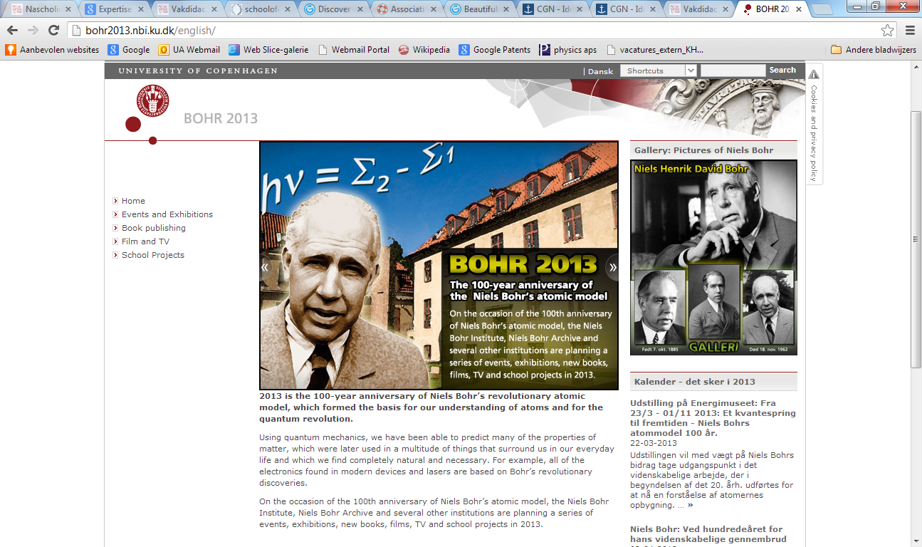

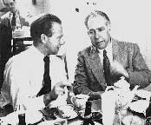In 2013 it was exactly 100 years since Bohr proposed the first quantum atomic model.

Figure 12 Heisenberg and Bohr in Copenhagen in 1934

(Source: AIP, American Institute for Physics,   
photo taken by Paul Ehrenfest)

In the following learning stations we will take you with us on a quest to understand the emission of light by matter and how this can be explained using quantum mechanics. Because the behaviour of light and matter **cannot** be explained using classical mechanics nor classical electromagnetism. Therefore a deeper theory than Newtonian Mechanics was gradually developed, a theory we call now and ‘quantum mechanics”. In learning station V, you will be able, exactly like the great fathers of quantum physics Niels Bohr and Louis De Broglie, to *predict the* *wavelength of the emission lines*, with a precision of 4 digits!

In the following chapter we continue our investigation with the question: **what is light**?

## Concepts of Learning station I

**Complete by adding the missing concepts**

**Classical concepts**

Given the initial position, the initial speed and the forces acting on a mass …………………………………………………………………………….

Interference pattern of classical waves (e.g. double slit experiment for water waves).

An accelerated electron, being an accelerated charged particle, creates ………………………………………. This is also valid for atomic electrons: they can emit light as they are accelerated charges.

Atomic model of Rutherford.

**Quantum concepts**

Trajectory of particles is not defined.

All “particles”, like electrons, have ……………………………………. nature. ………………………………….. is a fundamental characteristic of matter.

Atoms emit and absorb ………………………. colour lines, which are characteristic of the element. This is linked with the structure of the quantum atomic model of Bohr.

1. The video of dr. Quantum shows the electron being “split” in two in front of the slits: note that this is not true according to quantum physics! It is not matter that is smeared out over the slits but the wave of the electron that passes through both slits and interferes with itself. We ‘ll come back to that later.