Quantum Physics

The physics of the very small   
with great applications

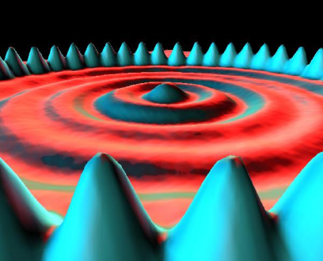

Part 3: HANDS-ON ACTIVITIES

Determine the thickness of a human hair using diffraction of light

http://i.creativecommons.org/l/by-nc-sa/3.0/88x31.png

Quantum Spin-Off is funded by the European Union under the LLP Comenius programme   
(540059-LLP-1-2013-1-BE-COMENIUS-CMP).  
Renaat Frans, Laura Tamassia   
Contact: [renaat.frans@khlim.be](mailto:renaat.frans@khlim.be)

## Research topic: How can the width of hair be determined?

**DIFFRACTION OF LIGHT: INTRODUCTION**

Whenever light passes a small obstacle or goes through a small opening diffraction occurs.

An obstacle and a slit give the same diffraction pattern. And because it is easier to do the calculation with a slit, we will think of a hair as if it was such a slit with the size of the hair.

The diffraction pattern comes about as a consequence of (1) the Huygens principle, which states that every point acts as a source of light waves (2) the path difference between the different light waves passing through the slit.

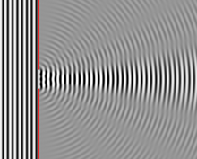

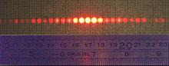

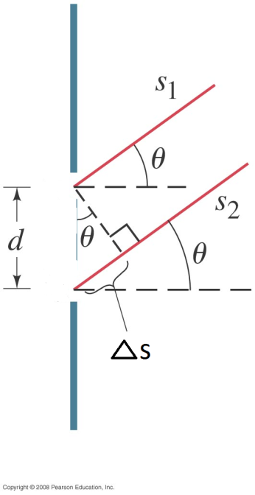 This path difference causes a phase difference in the waves arriving at the screen depending on the angle they arrived by.  
  
For certain angles the waves arrive in anti-phase; for these points there is cancellation. For other angles the waves are in phase; there is amplification. In between these places there are transition areas.  
  
The propagating light waves superpose. We say they interfere. Consequently, there will be light not only right behind the slit, but also next to it in a pattern of maxima and minima.  
  
The smaller the slit or the object is, the larger the angle needs to be so that the path difference becomes sufficient to cause cancellation. The larger the slit or the object, the smaller the necessary angle is for cancellation. **In other words, small objects or slits give rise to a wide diffraction pattern where the distance between consecutive minima (and maxima) is large. Large objects or wide slits give rise to a narrow pattern of alternating minima and maxima.** If the slit is too large, the diffraction pattern simply disappears and you just get light behind the slit.

Because the width of the pattern depends of the dimensions of the slit or the obstacle, diffraction gives us a method to determine the size of small object like a hair or a blood cell.

In this hands-on activity we determine the width of a hair.

Because hair is quite thin they give rise to a wide diffraction pattern, so that its size can be measured relatively accurately using a regular ruler.

**Determining the dimensions of objects from the diffraction pattern using geometry of triangles**

How can we derive a formula to determine the size of the object from the measured distance between the minima in the diffraction pattern?

The path difference Δs (see figure) is what determines whether there will be cancellation or amplification. Is it possible to relate this Δs using a trigonometric formula to the angle θ and the slit size D? (Do you see the right triangle that should be used for this?)



**What condition should Δs obey to get cancellation?**

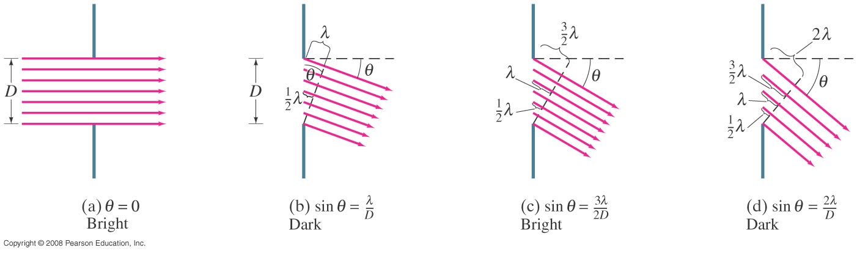

First we consider the beams that go straight through. They are all in phase (Δs = 0) so that straight in front of the slit there is a maximum.

Next we consider an angle for which the path difference of the upper ray and the lower ray is exactly one wavelength (Δs = λ). The ray which passes exactly in the middle of the slit will then differ precisely by half a wavelength (and thus be in antiphase) with the upper ray. These two rays will then interfere destructively on the screen. Also a ray passing a bit below the middle will be in antiphase with ray passing a bit under the top of the slit. In other words, for the angle for which the path difference is one wavelength λ, the rays will cancel each other pairwise and so form a minimum on the screen.

If Δs = λ there is a minimum, so the condition for a minimum is given by



Also, if Δs = 2λ,the same argument can be used to realize that there will be pairwise cancellation of the rays. So that the condition for having a minimum is given by

 (1)

where m= 1,2,3

and D the width of the slit, *λ*  the wavelength of the used light and *θ* the angle between the line straight ahead and the direction of the “mth” minimum

If the goal is to determine D it is better to rewrite this as



Because small angles are hard to measure we can take advantage of



And



with L the distance between the object and the screen and A the distance to the minimum. (Draw the right triangle) such that

 (2)

The width of the hair D will be determined from the measurement of An to the first (n=1), 2nd (n=2) or nth **diffraction minimum**. In the regular diffraction pattern we can clearly see a spot of low intensity in between the diffraction maxima.

**EXPERIMENT:** Using diffraction to measure the width of a hair

MATERIALS

* Sample holder
* Laser (wavelength = 632.8nm)
* Screen (use a sheet of paper as a screen)
* Tape measure
* Ruler
* Pencil

METHOD

1. Attach a sheet of paper on the screen.
2. Place the sample holder exactly 1m from the screen.
3. Place the laser approximately 20cm away from the sample holder
4. Turn on the laser
5. Move the laser slowly until it shines on the hair such that a diffraction pattern appears
6. Measure the distances An between the bright spot of the central light beam and nth minimum (for n=1 to n=5). Mark the positions of the minima on the sheet of paper with a pencil.
7. Turn off the laser and take the paper off the screen
8. Measure the distance (A) and complete the table below
9. Use the formulae to calculate the witdh of the hair (b)

EXPERIMENTAL SETUP

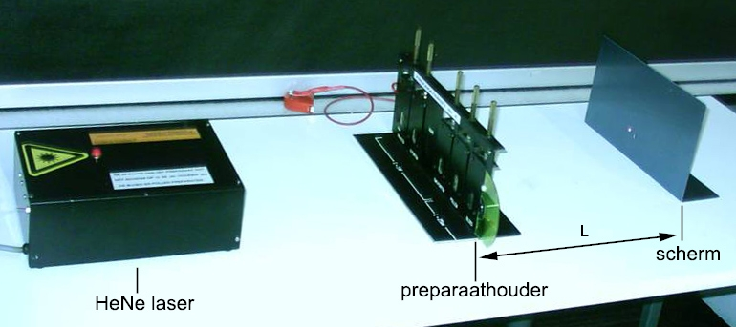

TABLE

|  |  |  |  |
| --- | --- | --- | --- |
| m  (number of the minimum) | A  distance center to minimum  (cm) | D  width of the hair  (µm) | <d>  average width (µm) |
| 1 |  |  |  |
| 2 |  |  |
| 3 |  |  |
| 4 |  |  |
| 5 |  |  |

CALCULATION



CONCLUSION

From the experiment we can determine that the ‘average’ width of the measured hair is given by

________________________________ μm

In the literature the width of a hair can be found to be between 9 and 100 µm.