

Bridge between research in modern physics  
and entrepreneurship in nanotechnology

Quantum Physics

The physics of the very small with great applications

Part 2  
QUANTUM PROPERTIES & TECHNOLOGY

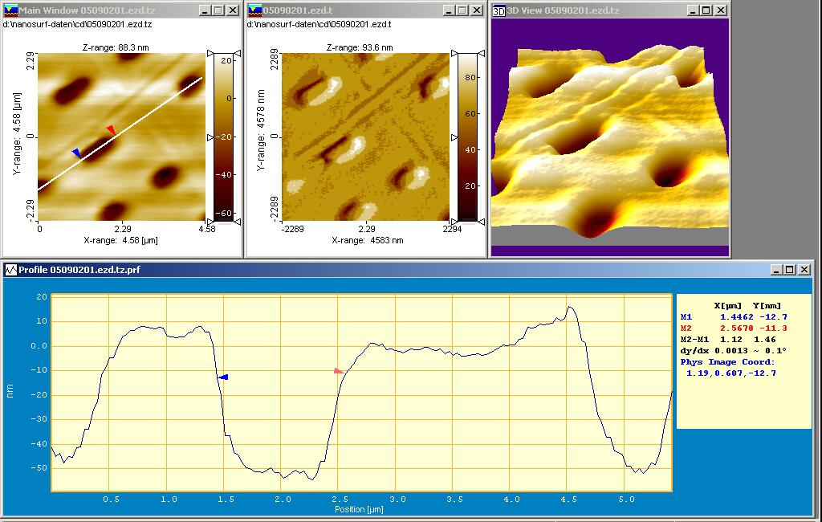

*Learning station X:****Atomic Force Microscopy***

TRANSLATION BY:



www.scientix.eu

http://i.creativecommons.org/l/by-nc-sa/3.0/88x31.png

Quantum Spin-Off is funded by the European Union under the LLP Comenius programme.

 (540059-LLP-1-2013-1-BE-COMENIUS-CMP).  
Ernst Meyer  
Contact: [ernst.meyer@unibas.ch](mailto:ernst.meyer@unibas.ch)

**Table of Contents**

Learning station X: Atomic Force Microscopy (AFM) 3

1 General 3

2 Functional principle of the AFM: 3

3 Solutions: 6

http://i.creativecommons.org/l/by-nc-sa/3.0/88x31.png**Attribution-NonCommercial-ShareAlike 4.0 International** (CC BY-NC-SA 4.0)

Under the following terms:

* Attribution — You must give [appropriate credit](https://creativecommons.org/licenses/by-nc-sa/4.0/), provide a link to the license, and [indicate if changes were made](https://creativecommons.org/licenses/by-nc-sa/4.0/). You may do so in any reasonable manner, but not in any way that suggests the licensor endorses you or your use.
* NonCommercial — You may not use the material for [commercial purposes](https://creativecommons.org/licenses/by-nc-sa/4.0/).

You can:

* Share — copy and redistribute the material in any medium or format
* Adapt — remix, transform, and build upon the material

The licensor cannot revoke these freedoms as long as you follow the license terms.

You have to refer to this work as follows:

Meyer E. (2015). Quantum SpinOff Learning Stations. Department of Physics, University of Basel, Switzerland.

# Learning station X: Atomic Force Microscopy (AFM)

In learning station VIII we presented the scanning tunnelling microscope (STM) and its working principles. A further development of STM is the atomic force microscope, in short AFM. In this learning station you will understand what the advantages of the AFM are compared to the STM.

References to papers (used in Switzerland) about nanomechanical investigations of tissues such as breast with an AFM are included in the teacher guidelines. This method has opened new ways to better understand and diagnose diseases like cancer. This subject could be especially interesting for girls, because girls and women appear to be more attracted by new technologies if they recognize them as a benefit for society, as for example in the health sector.

## General

The conductivity of most materials used in daily life is rather poor. The surfaces are insulating in particular because they are covered with oxides or organic coating.

**Task 1:**

Using a measuring instrument (e.g. Fluke Digital Multimeter or a comparable current and voltage meter) try to measure the resistances of surfaces, e.g. desktop, gold ring or gold jewellery, metal frame of tables and chairs etc. Increase the pressure with the measuring probe or make small scratches on metal surfaces. Do you notice a difference? How is the resistance related to the conductivity?

The tunnel current[1] required for the operation of the STM must flow through the sample. This is only possible if the samples have a sufficiently high conductivity or low resistance.

## Functional principle of the AFM:

Instead of measuring a current, the atomic force microscope (AFM) is based on measuring forces. To this end a leaf spring[2] with a tip is used which scans the surfaces with a defined contact pressure.

**Task 2:**

Try to estimate the size of the forces between the individual atoms.

Hint: The chemical bonding energy of molecules is in the range of 10 -19 J. The typical size scale for compounds is in the range of 10-10 m.



Figure 1:   
Functional principle of the AFM

sample

tip

As shown in figure 1, the leaf spring, also called cantilever, is brought close to the sample. As with the STM, a signal is measured when the leaf spring is in the immediate vicinity of the surface: the leaf spring is deflected by interaction forces The deflection of the leaf spring is then measured with a laser beam deflection. To this end a laser beam is reflected from the leaf spring. The reflected beam is caught by a 4 quadrant detector (four adjacent photo diodes[3]). By measuring the differential signals[4] it is possible to determine the deflection of the cantilever.

**Task 3:**

Build a model cantilever with a paper or metal tip. Watch how the strip bends if the tip approaches the surface perpendicular. What happens if the tip is moved parallel to the surface?

**Task 4:**

In task 2 you estimated the forces between the atoms. What size of spring constant k of the leaf spring in N/m would you chose if you knew that the laser beam deflection can still measure deflections in the range of 1 nanometre (10-9 m)?

The atomic force microscope is the most successful member of the scanning probe microscope family. As an application example look at the AFM image of a compact disc (CD).[5] What makes the AFM better than STM? Main drawback of STM: The tunnel current must flow through the sample to be measured. This is only possible if the samples have a sufficiently high conductivity or low resistance, this is not often the case. Advantage of AFM: AFM pictures are based on measuring forces between the tip of the cantilever and the surface of the sample. This allows a high precision in determining the shape of the surface of the samples, i.e. AFM resolution is better than the resolution of STM.

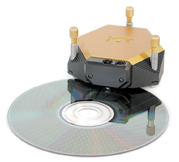

Figure 2: AFM measurements of a compact disc. The estimated time to get the 3-dimensional picture is 10 minutes.

**Task 5**

Try to determine the length, width or depth of the bits (holes) from figure 2.

## Solutions:

**1:** With the digital multimeter resistances can be observed in the range of a few ohms on highly conductive samples. Most surfaces (wood, plastic) have a too high resistance which is not measurable. In oxidised surfaces (steel, aluminium) the oxide coating can be reduced by scratching the surface allowing smaller resistances in the kilo-ohm or ohm range to be observed.

**2:**

The relationship between energy and the typical bond length provides a very good estimate of the forces between atoms:

F=dE/dx = 10-19 J / 10-10 m= 10-9 N = 1nN

E.g. the forces in cooking salt (NaCl) between the Na atoms and Cl atoms are in the range of one nano-newton. Other bond types have smaller forces. For hydrogen bridge bonds the forces are in the range of

10-12N=1pN.

**3:**

The strip bends when approaching a surface. If the strip is moved parallel to the surface, torsion of the strip can also be observed which is due to friction forces.

**4:**

If a force of 10-9N=1nN is to be measured and a deflection of

10-9m can be measured, then the spring constant should be chosen as k=F/x=1N/m or lesser values. Typically spring constants of k=0.05-1N/m are used in static operation. In dynamic operation (oscillating leaf spring) larger spring constants of k=10-30N/m can also be used, because the sensitivity is improved by the resonance magnification.

**5:**

The length of the highlighted bit is 1 micrometre and the width approx. 0.5 micrometre. The depth can be determined from the profile and is approx. 50-70 nm.

Concepts in Learning Station X

In this learning station no completely new concepts are introduced. We have mostly made use of the concepts already introduced in learning station VIII.

1. Tunnel current: According to quantum mechanical calculations a tunnel current flows through an insulating layer if the thickness of the insulator is within the nanometre range.
2. Leaf spring: A thin strip (approx. 5-10 micrometre thick) that is some 100 micrometres long and clamped on one side
3. Photo diodes are light-sensitive electronic components. They are typically made from silicon with a doped surface layer causing a separation of charges.
4. Differential signals are generated by the subtraction of signals from adjacent photo diodes. For the measurement of the standard force the difference is determined between the upper and lower photo diodes.
5. Another common method to measure the dimension of holes in CD and DVD is based on the diffraction of laser light on the surface of these devices.